2025 Staff with Disability and Allies’ Network (SDAN) Conference

Full Summary Report

Design to thrive: Attracting and retaining WA Health staff with disability

17 June 2025
Classification: Official
Contents
Part 1: Introduction 1
Part 2: Actions for inclusion 3
Part 3: Conference overview 11
Part 4: Event evaluation and lessons 18
Appendices 24

Join SDAN
The Staff with Disability and Allies’ Network (SDAN) is a space for people with disability and allies alike. Connect with us on MS Teams or contact us via email at SDAN@health.wa.gov.au

Join NeuroKin
NeuroKin is a peer support group for WA Health staff who self-identify or are diagnosed as Neurodivergent. This means anyone with a brain difference, including but not limited to: ADHD, autism, dyslexia, mental health conditions, dementia, cognitive or intellectual disability, epilepsy, and more! Contact NeuroKin via email at Neurokin@health.wa.gov.au

Acknowledgement
We would like to acknowledge the conference organising committee and event volunteers who took time from their busy schedules to plan and deliver a spectacular event. Without the help from our SDAN volunteers we would not be able to bring this conference to life. It is a privilege to work with talented and dedicated people to create a safe environment for everyone to participate, actively contribute, and bring the voices of staff with disability to the forefront of conversations about workforce culture and change.

Part 1: Introduction
The Staff with Disability and Allies’ Network (SDAN) conference was held on 17 June 2025 at the Bendat Parent and Community Centre. Registrants could also attend online via MS Teams Town Hall for the keynote speech and panel discussion. The theme of the conference was “Design to thrive: Attracting and retaining WA Health staff with disability”. The purpose was to provide an opportunity for WA Health staff to listen to the lived experience of people with disability, learn from their stories, and discuss ways to improve the culture and inclusion practices across WA Health for staff with disability.
The event included:
- Keynote speech by Dr Dinesh Palipana, an Emergency Department doctor with quadriplegia who works at Gold Coast University Hospital.
- Panel discussion on hidden disability from staff with a range of hidden disability and managers who support staff with disability, led by Sarah Savill.
- Disability Workplace Inclusive Innovation Lab (Innovation lab) led by Chloe Binder, where attendees could discuss the current unmet needs and challenges for staff with disability and managers, and identify ways to improve inclusion, recognition, and understanding of disability in the workplace.
A program of events and speaker profiles can be found in appendix 1. A video of the keynote speech and panel discussion is available on the WA Health YouTube channel: https://www.youtube.com/watch?v=tTS5bnT_W_s.
The Disability Health Network (DHN) worked in partnership with the SDAN organising committee to plan and run the conference. A list of organising committee members can be found in appendix 2.

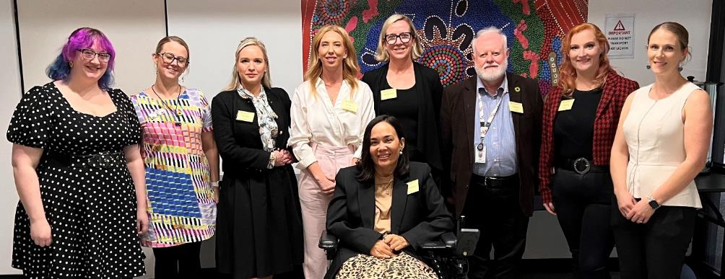
Figure 1: Some members of the organising committee and panel. From left to right: Evie Anderson, Kathryn Boon, Chloe Binder, Holly Bootsma, Stephanie Coates, Dr Ettore Guaia, Sarah Savill, Whitney Darlaston-Jones. In front: Jocelyn Franciscus.

The Conference was for all staff working in WA Health. Attendees covered a wide variety of identities and roles, including staff with disability, family members and friends of people with disability, health professionals, policy and administrative staff, and managers and executives.

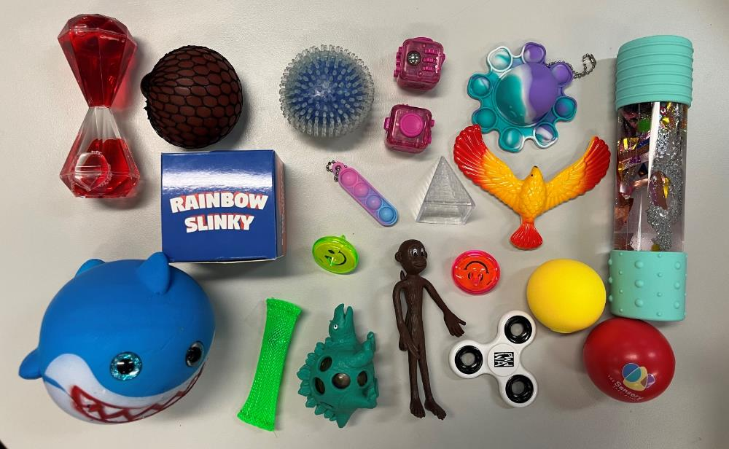
Figure 2: Selection of sensory supports which were available for participants to use in the sensory regulation space.

It was designed as a disability inclusive event. Strategies used to support this included:
- Using plain language in all communications and making sure there was enough white space and balance between written and visual elements to reduce visual over-stimulation.
- Asking at registration if attendees needed any of the following:
  - Auslan interpretation.
  - A service animal or support person with them.
  - Any other adjustments or access need to support them to fully participate at the event.
- Directly following up with registrants if more information was required about their accessibility needs.
- Using social stories to provide information to attendees about how to get to the venue and use the MS Teams Town Hall features.
- Designing the program to have longer break times than a standard conference.
- Arranging the room with tables and chairs with large gaps around the tables to allow people to move freely.
- Giving clear guidance at the beginning of the event that people should feel free to stand, move, or leave the room at any point during the event to support their regulation needs.
- Providing a quiet room for the duration of the event with sensory regulation tools.
- Designing a low-cognitive load Innovation Lab to support participation of all attendees.

Part 2: Actions for inclusion
Discussions from the Innovation Lab have been themed and summarised into the points below, including key areas for action to improve inclusion. For an outline of the workshop activities see Part 3. Links to existing resources and information about disability employment can be found in appendix 3.

The case for inclusion
The WA Public Sector has an aspirational employment target of 5% for people with disability. As of March 2025, people with disability made up just 1.7% of the overall public sector workforce.
Inclusive workplaces:
- Improve mental and emotional health of all staff.
- Promote staff retention.
- Increase productivity, innovation, collaboration, and customer service.
- Reduce staff experiences of discrimination and harassment.

“We can have sometimes inaccessible places and things, but if there's a willingness to troubleshoot and just to give it a try, I think the attitude matters more than the environment sometimes.”
– Dr Dinesh Palipana

Priority actions
The follow priority areas have been pulled from the information themed from the Innovation Lab (see Key action areas, challenges, and opportunities). All priorities are intended to be designed, developed, and delivered in collaboration with relevant teams across WA Health and staff with disability.

Priority | Enablers | Timeframe
- Executives from each Health Service Provider (HSP), Heath Support Service (HSS) and Department of Health (the Department) commit to supporting disability inclusion by actively engaging with SDAN and creating clear plans to reach the 5% employment target for people with disability. | - Commitment from each HSP Chief Executive and the Director General.  - WA Health Disability Access and Inclusion Plan, with local action plans (see priority 2). | 12-18 months
- Develop a statewide co-designed Disability Access and Inclusion Plan (DAIP) with local action plans from all HSPs. | - Agreement from the Health Executive Committee.  - Establish a statewide working group. | 12 months
- Implement the Hidden Disability Sunflower initiative across all WA Health entities. | - Agreement from the Health Executive Committee. | <12 months
- Create and implement a WA Health standardised suite of resources on inclusive recruitment and onboarding for use across WA Health, working with HSS to integrate into existing processes where possible. | - Commitment from each HSP Chief Executive and the Director General. | <12 months
- Include Section 66R of the Equal Opportunity Act (preferential appointment of successful candidates with disability) in all WA Health job advertisements. | - Commitment from each HSP Chief Executive and the Director General.  - Fulfilment of priority 4. | 12 months
- Standardise the use of co-designed training on diversity and inclusion as a component of induction and onboarding for people in managerial or leadership roles. | - Commitment from each HSP Chief Executive and the Director General. | 18-24 months
- Introduce key performance indicators for leaders on:  - Safety (particularly psychosocial safety).  - Completed training on diversity, inclusion, and intersectionality.  - Implementation of strategies to support diversity, inclusion, and psychosocial safety. | - Commitment from each HSP Chief Executive and the Director General. | 18-24 months
- Create an inclusive process for supporting staff with disability to request adjustments in the workplace that is not part of the Fitness for Work process. | - Commitment from each HSP Chief Executive and the Director General | 18-24 months

1. Leadership and Advocacy
Challenges and barriers
- Understanding disability
A limited understanding of disability, the social model of disability, and the benefits of inclusive workplaces has the potential to lead to bullying, social isolation, adjustments being rejected, or inappropriate processes being followed in different workplaces.
- Managerial and executive training
Managers and leaders receive limited formal training in leadership, inclusion, and disability support. Additionally, quarantining time for professional development is not explicitly encouraged in some instances or is currently seen as unrealistic, particularly for leaders in clinical or high demand areas, as time is prioritised for business priorities. This leads to inconsistent application of policies and inequitable staff experiences.
- Executive champions
Practical and demonstrable executive commitment to championing disability inclusion remains limited, hindering meaningful cultural change.

“This silence comes at a personal cost and a cost for the system; when disclosure feels dangerous, inclusion becomes impossible.”
– Dr Ettore Guaia
Key Actions
- Culture change
  - Executives to model inclusive behaviours.
  - Normalise open conversations about adjustments during recruitment, onboarding, and professional development and review discussions.
  - Normalise open conversations about workforce inclusion during team and staff meetings.
  - Authentically celebrate and support leaders with disability.
- Education and training
  - Standardise the use of co-designed training on diversity and inclusion as a component of induction and onboarding for people in managerial or leadership roles.
  - Implement the Queensland Health’s ‘See me. Hear me. Respect me.’ Campaign across HSPs and the department to reduce stigma around disability: https://www.health.qld.gov.au/public-health/groups/people-with-disability/see-me-hear-me-respect-me-campaign (contact Disability Health Network for information on the Deed of License).

“How do we as an organisation embrace that culture of ‘yes, we can’ versus there has to be X, Y, and Z to go through before we can?”
– Holly Bootsma

2. Physical Space
Challenges and barriers
- Staff with disability are often excluded from decisions on workplace design and upgrades (e.g. elevator upgrades and consultation on size and location of buttons).
- Accessibility is sometimes deprioritised in favour of financial or ‘majority rules’ considerations.
- Many buildings are outdated and there is inconsistent accessibility across WA Health sites, restricting employment options for some staff.
- For example: flight decks in clinical areas accessed via steps, manual doors, limited access to ergonomic equipment, limited access to quiet spaces, inappropriate number and location of ACROD bays.
- Workspaces often provide limited sensory flexibility and are not suited to varied access needs, impacting wellbeing and productivity.
- For example: no control over lighting or temperature, standardised furniture, open plan offices with no quiet work areas.

“We need to stop seeing adjustment as a special treatment and start reframing them as inclusive design… until we have this conversation openly and backed with real accountability, we will continue to lose talent and burn people out and miss out on the real value that people with hidden disability bring to the healthcare industry.”
– Dr Ettore Guaia

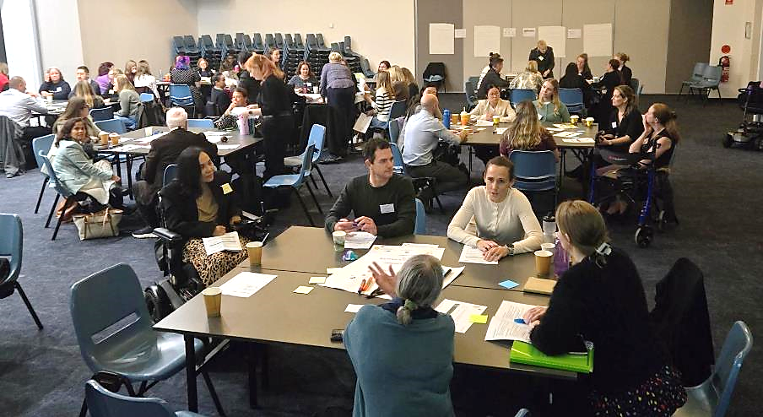
Figure 3: Groups workshopping the topics during the Innovation Lab.

“How many people with hidden disability are in decision making roles in WA Health? Inclusion is not just about support at the individual level, it is about changing the system so that people with lived experience help shape the policy, teams, and priorities from top down.”
– Dr Ettore Guaia
Key Actions
- Managers and executive take responsibility for identify opportunities to improve accessibility as a component of staff safety.
- Establish designated sensory spaces at all WA Health sites with clear guidelines on usage.
- Consult staff with disability on all builds and refurbishments.
- Conduct regular accessibility and safety audits, using feedback from staff with disability to guide improvements.
- Standardise adjustable lighting where possible and move towards lighting sources that mimic natural light more closely.
- Offer a range of ergonomic equipment and processes where necessary, including but not limited to desk lighting and noise cancelling headphones.
- Encourage teams to regularly discuss physical and psychosocial accessibility.

3. Legal, Ethical, Compliance, and Policy
Challenges and barriers
- WA Health has limited consistency in policies supporting staff with disability making it difficult to share information, approvals, and equipment across HSPs when staff move positions. This leads to repeated adjustment requests which might get rejected.
- Existing procedures are often compliance-driven and provide limited practical guidance for inclusive conversations and actions.

“Inclusion means… making workplace adjustments the norm, not the exception.”
– Dr Ettore Guaia
Key Actions
- Develop a statewide co-designed Disability Access and Inclusion Plan (DAIP) with local action plans from all HSPs.
- Introduce key performance indicators for leaders on:
  - Safety (particularly psychosocial safety).
  - Completed training on diversity and inclusion.
  - Implementation of strategies to support diversity, inclusion, and psychosocial safety.
- Tools and resources:
  - Introduce and normalise the use of personal care plans for all staff (e.g. Template – Workplace Preferences – Australian Public Services Commission).
  - Standardise co-designed inclusive recruitment tools and processes.
  - Co-design guidance for staff and managers on reasonable adjustments.
  - Implement the Public Sector Commission resources in standard processes for recruitment, manager training, and onboarding (see list of resources here: https://www.health.wa.gov.au/~/media/Corp/Documents/Health-for/Disability/2025-Disability-Inclusion-Workforce-Resources.pdf).
- Workforce processes:
  - Include Section 66R of the Equal Opportunity Act (preferential appointment of successful candidates with disability) in all WA Health job advertisements.
  - Prioritise flexible work arrangements for all staff where industrial relations agreements allow.
  - Appoint Workforce Disability Liaison Officers using Section 66S(c) of the Equal Opportunity Act (quarantining positions specifically for people with disability) to support staff on issues related to disability inclusion.
  - Allow flexibility in job design through adjustments to JDFs and role descriptions, where possible.

“It’s about empowering a person’s strengths a little bit better and then supporting the things that are a little bit trickier, and I think navigating it with nurture.”
– Holly Bootsma

4. Communication, Technology, and Tools
Challenges and barriers
- Equipment and technology often have limited accessibility, reducing the ability of staff with disability to work effectively.
- Limited system integration between HSPs and the inconsistency in understanding of disability across the workforce places the burden on individuals to repeatedly explain and request their adjustments.

Key Actions
- Purchase accessibility tools (e.g. voice-to-text, AI notetaking) that can be used across WA Health.
- Provide safe spaces for staff with disability to access support and advice.
- Implement the Hidden Disability Sunflower initiative across all WA Health entities.

Part 3: Conference overview

Attendance
One hundred and sixty-six people registered to attend the conference either in-person or online; approximately 131 people attended on the day. Attendees came from a variety of roles including:
- Staff with disability and carers.
- Front line staff across nursing, medicine, allied health, and hospital support service.
- Executive staff.
- Policy and project staff from HSPs and Department of Health.

Structure
The conference included:
- Keynote featuring Dr. Dinesh Palipana OAM, renowned Emergency Department doctor, lawyer, and disability advocate. Dr. Palipana is the first medical graduate with quadriplegia from a spinal cord injury to graduate in Queensland.
- An engaging Q&A session with Dr. Palipana, led by Lisa Burnette, Clinical Information nurse, Midland Public Private Health.
- Panel discussion about supporting people with hidden disability in the workplace, led by Neurokin Lead Sarah Savill and featuring Kathryn Boon, Erin Mansell, Dr Ettore Guaia, and Holly Bootsma.
- Disability Inclusive Workplace Innovation Lab led by Chloe Binder and supported by Zoe Warwick where participants discussed practical opportunities to support staff with disability to thrive in the workplace.

Dr Dinesh Palipana
Key points of interest from Dr Dinesh Palipana’s keynote speech include:
- We cannot assume a person’s needs by looking at them; even visible disability has hidden elements (e.g. spinal cord injury comes with issues in body temperature regulation, nerve pain).
- Quote from Viktor Frankl: “A person who has a ‘why’ to live, can bear almost any ‘how’”. Supporting people with disability is about supporting them to live their ‘why’.”
- Inclusion of people with disability in all spectrums of life is critical for our learning and understanding:
  - “When I was a medical student, I wouldn’t have known or understood what it’s like to use a wheelchair, what it's like to get burnt by a heater, what it’s like to experience all these things. And so it’s by having more of us internally that we can reflect the one in six people with disability in this country.”
- Work together with an attitude of “let’s give it a try”. Most of the barriers to including staff with disability are about peoples’ attitudes and mindsets:
  - “We can have sometimes inaccessible places and things, but if there’s a willingness to troubleshoot and just to give it a try, I think the attitude matters more than the environment sometimes.”
  - “I started figuring out all these things, and I realised… a lot of the challenges were in our own minds. We thought all these things would be a barrier, but it’s actually not.”
  - “I think yes, accessible infrastructure is important. But what’s most important, what overcomes anything, is actually attitudes. And I think if we all have a welcoming, inclusive, open-minded attitude, I think we can build a beautiful society.”

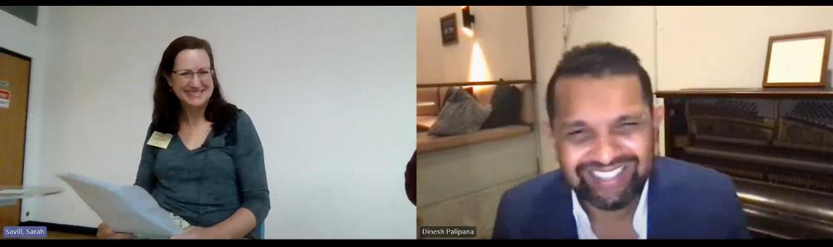
Figure 4: Lisa Burnette interviewing Dr Dinesh Palipana via MS Teams

- Patients never questioned Dr Palipan’s ability as a doctor or requested to have another doctor see them, and in some cases valued his disability because they knew he would understand their needs and they would be heard:
  - “What I’ve learned from that is that… a lot of the challenges that we put up are in our own minds, and we should probably take the approach of Richard Branson, who said: ‘say yes and figure out how to do it later’. And secondly, perhaps our community’s a lot further ahead than we are as health systems and as institutions, and maybe we need to adapt and keep up. And this is not just with disability... I think we see this in a lot of areas perhaps where the community is expecting more of us.”
  - “One of the most poignant interactions that I had was one night. It was probably maybe 1am or something and there was a patient with a genetic condition which had to do with the bone development, and they used a wheelchair...They were quite ill and they came in and I went to see them. And then about halfway through they said, you know I was so glad when you wandered into my bedside because I knew that you’d understand what I’m going through.”
- Disability inclusion requires everyone to advocate for change, not just the person with disability:
  - “I think it’s important to be an upstander and not a bystander and there were people who stood up for me when I couldn’t. There were people who advocated for me. There were people who fought for me to get a job. And that’s why I'm here nine years later.”
- Staff with disability can bring unexpected benefits to the team; Dr Dinesh Palipana reflected on his first year in medicine when they kept data on his progress and demonstrated he was 25% more efficient than his counterparts because he had to make more use of technology and other strategies to do his job.
- Healthcare services are still not designed to cater for people with disability:
  - “Statistically people with disability are more dependent on the healthcare system, especially hospitals, but they also report worse satisfaction with their health, and even have shorter life spans in some cases.”
  - “One of my friends who has a spinal cord injury, she needed to get a mammogram, and she went from place to place to place, trying to get a mammogram and said you gotta(sic) be able to stand to do this, but she… uses a wheelchair... And so it took her a while to get her mammogram and took her some challenges, but eventually she got it, only to find that she has breast cancer.”
  - “If we can get on top of things quickly, it not only gives someone a lot of life back, but it’s better for our healthcare systems too.”
- Move towards a focus on outcomes and support people to use methods that are safe and efficient that fit their requirements to achieve the necessary outcome.

Panel on hidden disability
Key points of interest include:
- The most powerful thing to change is create a psychosocially safe culture where disclosure of disability is not met with risk, fear, or stigma but with curiosity, respect, empathetic support.
  - “This silence comes at a personal cost and a cost for the system, when disclosure feels dangerous, inclusion becomes impossible” – Dr Ettore Guaia.
  - “Where it should start is creating safety for that particular staff member and making sure that they know… their job is secure, we’ve all got bills to pay and everything, but also that they are a valued member of the team… You’re trying to work with them collaboratively… to work to strategies together… It is not the employee’s responsibility to work out reasonable adjustments on their own” – Kathryn Boon.
  - “If night duty is a contraindication for whatever you’ve got going on, that is not favouritism, that is putting them on a more even level” – Kathryn Boon.
  - “Many of us has experienced, as soon as you say you have a particular condition or disability, people automatically assume what you can’t do. What part of that condition, before they have even met you, is not suitable to their workplace and their workload” – Erin Mansell.
  - “We need to stop seeing adjustment as a special treatment and start reframing them as inclusive design. So the question then shouldn’t be what is the minimum we have to do, but is about: how do we design our team and system so that people with diverse cognitive and emotional needs can thrive? So until we have this conversation openly and backed with real accountability, we will continue to lose talent and burn people out and miss out on the real value that people with hidden disability bring to the healthcare industry” – Dr Ettore Guaia.
- A safe culture starts with leaders who model inclusion:
  - “We don’t need a perfect system overnight, but we need to signal from the top that our workforce is made stronger not weaker by supporting disability” – Dr Ettore Guaia.
  - “Having to explain yourself over and over and over again and having to justify why… it gets really tough” – Kathryn Boon.
  - “From a leadership point of view, we need to start asking this conversation ‘what do you need to work in a comfortable space?’ It’s not that we have to ask people to disclose… it needs to be part of a normal conversation, not only at the point of hiring but when I have, for example, to performance review of my staff it’s: ‘what can we do to make you feel more comfortable, what is important for you, what adjustments do you think you may need?’” – Dr Ettore Guaia.
  - “It’s a template… It’s not going to work in every workspace… but particularly in office environment it would work very well: it’s your work preferences, it’s not even your accommodations, it’s how do you like to work, how do you work best… Things like your values, what’s important to you about the work you are doing, the work environment, flexible work arrangements…and having them up around the office so people could see how their teammates worked, to work more collaboratively” – Kathryn Boon.
  - “How many people with hidden disability are in decision making roles in WA Health? Inclusion is not just about support at the individual level, it is about changing the system so that people with lived experience help shape the policy, teams, and priorities from top down” – Dr Ettore Guaia.

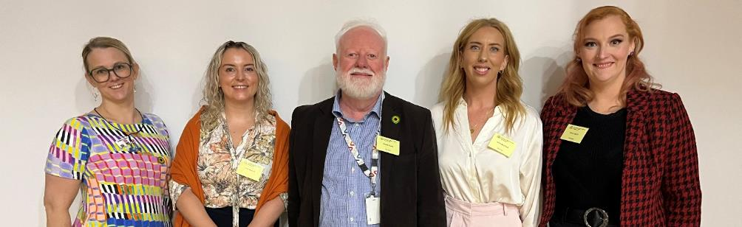
Figure 5: Panel members. Left to right: Kathryn Boon, Erin Mansell, Dr Ettore Guaia, Holly Bootsma, and Sarah Savill.

- Intersectionality is an essential component to understanding the needs of staff with disability:
  - “We don’t talk enough about intersection and how disability interacts with other aspects of identify and systemic barriers. Being neurodivergent or from a culturally and linguistically diverse background or managing a mental health condition or working in a rural or high-pressure clinical setting: all of these layers create compounding challenge which are often invisible to policy” – Dr Ettore Guaia.
- Adjustments in employment allow people to reach their potential and achieve success:
  - “When I first graduated as a nurse, I was struggling to get through the employment process where you have to fit in a very definitive box… I found a disability charity that had a support-to-work program that had a one-to-one coach that worked with me to ask for adjustments… Suddenly I was successful at every interview that I went to and then I had a choice” – Erin Mansell.
  - “It’s about empowering a person’s strengths a little bit better and then supporting the things that are a little bit trickier, and I think navigating it with nurture” – Holly Bootsma.
  - “How do we as an organisation embrace that culture of ‘yes, we can’ versus there has to be X, Y, and Z to go through before we can?” – Holly Bootsma.
- Procedural barriers prevent essential adjustments being implemented:
  - “The software can be recommended and are essential, for my job at least, but there are barriers within the hospitals that mean they can’t be implemented. So from a cybersecurity perspective each software has to go through a process and each one has an individual form. You can’t fill out the form before you have bought the software. The software can be up to $3000 so you’ve got this chicken and egg situation where do we pay for the software if we don’t know they can be put on the system?” – Erin Mansell.
  - “The cost is the emotional drain of the person finding a way around, finding a solution” - Dr Ettore Guaia speaking about the barriers of some WA Health technology and how people with disability are required to do extra work to find the workarounds so they can use or interact with the software.
  - “I call the HSP lottery, because the HSPs are different” – Dr Ettore Guaia talking about the differences in support experienced across different HSPs.

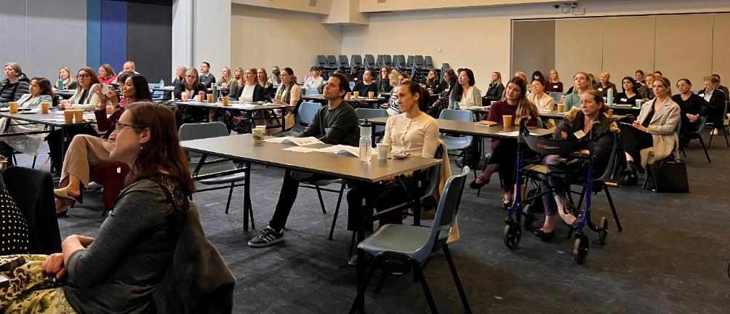
Figure 6: Conference attendees listening to the panel discussion on hidden disability.

- Fitness for work is not an appropriate avenue for assessing the needs of a person with disability to identify methods, processes, or adjustments to support them to thrive in their job:
  - “Sending someone to do a fitness for work sound like you are sending some to see if they are fit to do the job they are doing… It didn’t really feel right to me… There’s concern that they’ll get discriminated against, so coming to your line manager and then getting sent for a fitness to work cause a lot of distress” – Holly Bootsma.
  - “It is definitely not the first step at any manager should take when approaching a staff member about potentially disability issues that are causing… concern amongst staff… It feels like your job is under threat, that you’re going to lose your job, or that you are going to get demoted… It shatters you, it destroys you, and all it made me do was roll into a shell and I was made to feel like I was… in the too hard basket” – Kathryn Boon.
- People with disability can bring benefits to a team because of their disability:
  - “Three out of five of us are neurodivergent and it is seen as a real asset, we are all really different… Two of us have big time management chatting issues but also that is something that is a real asset in our work as well because we empathise with our patients and we can get them to open up to us and discuss substance use issues that they might not feel comfortable with other people” – Kathryn Boon.
- There are different attitudes towards adjustments for people with disability as opposed to adjustments for other groups such as parents, breastfeeding mothers etc:
  - “There are already lots of things that we do reasonable adjustment for that is built into policy and it is around equal opportunities, so we probably need some… WA Health structure to support that same thing with hidden disability” – Holly Bootsma

Innovation Lab
The Innovation Lab was designed as a low cognitive load activity that allowed all people to participate in a way that worked for them. Strategies that were put in place to support this included:
- People were asked to pick any table they wanted; they were not allocated to a topic.
- Participants were supported to move around the tables and join any discussion throughout the course of the Lab.
- There was no structure or timed components; conversation was allowed to evolve around the table topic as the participants wanted it to, with subtle guidance from the table facilitator if conversation stalled or was moving away from the rules of engagement.
- All participants had access to pens and sticky notes so they could add their ideas to the conversation without speaking if they wanted to.

The innovation lab aimed to provide:
- Safe, open conversations about navigating disability as a WA Health staff member.
- Brainstorming insights and ideas into accommodations that may work in clinical and non-clinical environment.
- Outputs that will help inform guides for staff members and leaders.

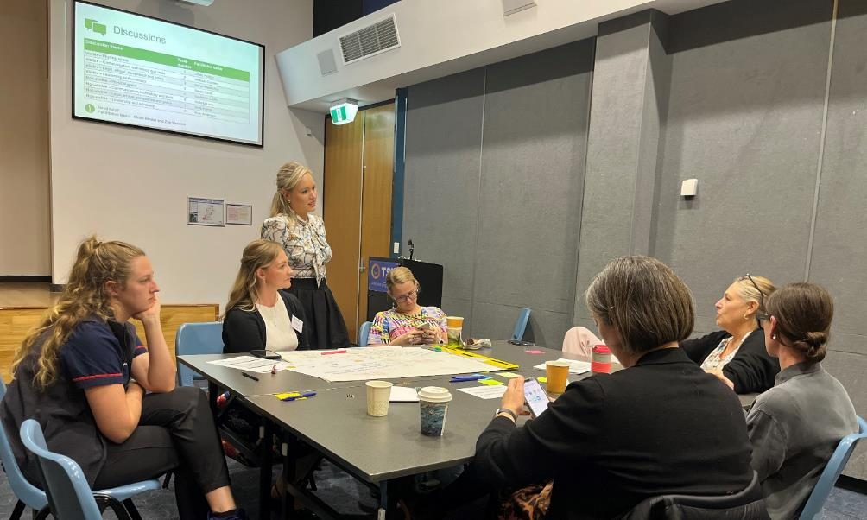
Figure 7: Chloe Binder supporting conversations on a table during the Innovation Lab.

There were 8 tables each with a table facilitator and they focused on 4 discussion topics (see list below) across 2 domains: hidden disability and visible disability.
- Leadership and advocacy.
- Physical space.
- Legal, ethical, compliance and policy.
- Communication, technology, and tools.

Participants were asked to consider the relationship between three key elements:
- What is the unmet need?
- What challenges does it create?
- What accommodations could support?

At the conclusion of the group discussions, each table facilitator provided a summary back to the audience about what was discussed.

Part 4: Event evaluation and lessons
Note: statistics in this section are represented as pie charts; see appendix 4 for the same information displayed in bar charts for people who prefer that visualisation.

Overall, the conference was very well received with 97% (n=29) of evaluation survey respondents stating they were very satisfied or satisfied with the overall event. Dr Dinesh Palipana’s keynote speech was the most successful component with 77% (n=23) of respondents stating they were very satisfied.

The purpose of the conference was to:
- Increase the audience’s awareness and understanding of disability.
- The strengths of people with disability.
- The value that diversity brings to the workplace.
- How to support staff with disability in the workplace so they can thrive.
The majority of respondents self-identified they had a medium level of knowledge about how to support staff with disability in the workplace in an inclusive way and how to make adjustments in the workplace for people with disability.

Despite this existing knowledge:
- 94% (n=28) agreed or strongly agreed that the keynote address by Dr Dinesh Palipana increased their understanding of the benefits gained from a diverse and inclusive workforce.
- 83% (n=25) agreed or strongly agreed that the panel discussion increased their understanding of the impact of making adjustments.
- 94% (n=28) agreed or strongly agreed that the event helped their understanding of how to create a more inclusive workplace.

From the free-text responses the elements that were enjoyed most from the event were:
- Embedding lived experience throughout the event and hearing from a diverse group of staff with disability.
- The collaborative approach and discussions during the Innovation Lab.
- Networking with other likeminded staff and sharing experiences and knowledge.
- The varied and thought-provoking conversations from the panel members.
- Dr Dinesh Palipana’s presentation.
We asked survey respondents “As a result of coming to the event, what is one thing you feel your organisation can focus on to create a more inclusive workplace for staff with disability?” Some common responses included:
- Using more appropriate language and processes such as workplace assessment instead of fitness for work.
- Creating more open discussion of adjustments in teams and with management.
- Implementing Staff Care Plans which provide staff with a consistent space to record adjustments, cultural needs, or other considerations (such as carer or parental duties) that require flexibility in the way they work and having an appropriate process of sharing this with management and potentially across the team, so everyone is part of the conversation.
- Offering adjustments or flexibility to everyone rather than waiting for people to disclose they have disability.
- Mandatory education and training in diversity, inclusion, and supporting staff with disability, especially for managers and executives.
- WA Health guidelines for the use of Section 66 of the Equal Opportunity Act in recruitment, reasonable adjustments, and templates such as an adjustment passport or Staff Care Plan.
- Refocussing language from ‘accommodation’ to ‘belonging’.
Areas we can improve future events:
- Shortening the sections and making the entire day slightly shorter.
- Discussion of practical tools, tips, and processes to supporting staff with disability in the workplace.
- Including intersectionality in the conversation.
We are considering shorter half-day or lunch and learn style events in the future.
While current resources and processes from other organisations were circulated before and after the event via email, it would have been helpful to have some available during the event for people to look at.
A discussion on intersectionality will be a focus at the next SDAN event.

Appendices

Appendix 1: Program and speaker profiles

Staff with Disability and Allies Network (SDAN) Conference 2025
Tuesday 17 June 2025, 9.15am – 4.00pm
Bendat Parent and Community Centre, 36 Dodd Street Wembley
Design to thrive: Attracting and retaining WA Health staff with disability
This conference brings together health staff with disability and allies to work together to make the WA health system a more inclusive workplace. In support of this, a sensory regulation room will be available on the day for anyone who needs to use it.
Time | Topic | Presenter / facilitator
9.00 am | Registration and doors open
9:15 am | Welcome to Country | Ingrid Cumming
9:30 am | Conference welcome | Sarah Savill
9:45 am | Keynote address: Navigating disability in an emergency department | Dr Dinesh Palipana OAM
10:15 am | A conversation with Dr Dinesh Palipana OAM | Lisa Burnette
11:00 am | Break
11:20 am | Panel discussion: Hidden disability in the workplace  A conversation with Kathryn Boon, Dr Ettore Guaia, Erin Mansell, and Holly Bootsma | Sarah Savill
12:50 pm | Lunch break
1:50 pm | Disability inclusive workplace innovation lab  This lab has been designed as a low-cognitive and sensory demand session | Chloe Binder
3:50 pm | Closing remarks | Sarah Savill
4:00 pm | Close event | Sarah Savill

Presenter overview
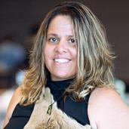 | Ingrid Ngoorlak Cumming (she/her)  Welcome to Country  Ingrid is a is a proud Whadjuk Balardong Noongar woman from Fremantle, Western Australia. Ingrid was given the name “Ngoorlak” by her Elders which is the name for the Carnarby Cockatoo, the bringer of rains, healing, and change. She is a recognised young leader in the First Nations community and across many sectors.
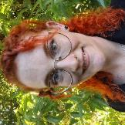 | Sarah Savill (she/her)  Host  Sarah has worked in healthcare for 12 years, currently at Department of Health, and is studying a Bachelor of Health Services Management. She’s currently on an ongoing journey of self-discovery and acceptance after joining the ranks of late-diagnosed neurodivergent women.
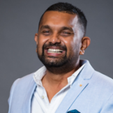 | Dr Dinesh Palipana OAM (he/him)  Emergency Department Doctor, Gold Coast University Hospital  Dr Dinesh Palipana OAM is a registrar at the Gold Coast University Hospital. Despite facing numerous barriers, he became the first quadriplegic medical graduate and medical intern in Queensland. He was recently admitted as a lawyer. As co-founder of Doctors with Disabilities Australia, Dinesh has worked with the Australian Medical Association to create first-of-a-kind national policies for inclusivity in medical education and employment. Dinesh has also contributed significantly to scientific advances in treating spinal cord injury and restoring function to people with paralysis. His national and global impact has been recognised with numerous awards, including Junior Doctor of the Year and the Order of Australia Medal.
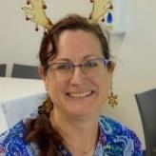 | Lisa Burnette (she/her)  Clinical Information Nurse, SJOG Midland  Lisa Burnette (RN, MPH, CHIA) has worked in and around hospitals for thirty years. After acquiring a physical disability five years into her nursing career, Lisa moved to non-clinical nursing roles including research and information technology. Lisa is a former president of People with Disabilities WA and currently works at Midland Hospital as a Clinical Informatics Nurse.
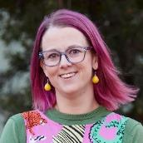 | Kathryn Boon (she/her)  Clinical Nurse, Alcohol and Drug Service, NMHS  Kathryn Boon is a Clinical Nurse in Alcohol and Other Drug services and a founding member of Neurokin. A neurodivergent leader with ADHD, dysgraphia, and hypermobile Ehlers-Danlos Syndrome, she advocates for inclusive, trauma-informed care and staff support, using lived experience to influence healthcare systems and culture.
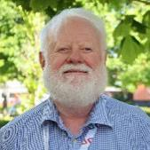 | Dr Ettore Guaia (he/him)  Consultant Child and Youth Psychiatrist and Medical Co-Director for Youth Mental Health and Eating Disorders Services, NMHS  Dr Ettore Guaia is a FRANZCP Child and Adolescent Psychiatrist Medical Co Director at NMHS Mental Health, Public Health, and Dental Services. He is a person with albinism who has worked in health care since 1981. Dr Guaia is a member of Stanford Medicine Alliance for Disability Inclusion and Equity (SMADIE).
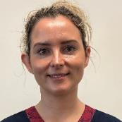 | Erin Mansell (she/her)  Clinical Nurse Specialist (Clinical Research), Fiona Stanley  Erin is a Clinical Nurse Specialist in Cardiology Research at FSH. She has a Master’s degree in occupational health and lived experience of disability. She is passionate about using her personal experiences and formal training to support people to thrive in the workplace while living with disability, and advocates for equitable employment processes.
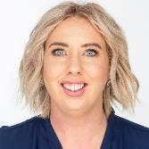 | Holly Bootsma (she/her)  Nurse Unit Manager Acute Medical Unit (AMU)  South Metropolitan Health Service Fiona Stanley Hospital  Nurse Unit Manager at Fiona Stanley Hospital since 2022, with over a decade in WA Health. A passionate advocate for neurodivergent staff, informed by lived experience as a parent. Committed to inclusive leadership, empowering strengths, and creating workplaces where all individuals feel respected, supported, and seen.

Appendix 2: Organising committee members and event volunteers
The SDAN Conference was made possible through the dedication and support of our incredible volunteer organising committee and helpers:
Organising Committee
Name | Position
Evie Anderson | Program Officer, Strategy and Governance, Department of Health
Chloe Binder | Project Manager, Procurement and Contracting, Department of Health
Darcie Boelen | Senior Project Officer, Data and Information Systems, Department of Health
Lisa Burnette | Clinical Information Nurse, Clinical Governance, Midland Public Private Health
Kathryn Carver | Registered Nurse, East Metropolitan Health Service
Stephanie Coates | Co-Lead, Disability Health Network and Head of Occupational Therapy, Fiona Stanley and Fremantle Hospitals Group
Whitney Darlaston-Jones | Principal Policy Officer, Health Networks Directorate, Department of Health
Dr Ettore Guaia | Medical Co-Director, Youth Mental Health and Eating Disorders Service, Graylands Hospital
Jocelyn Franciscus | Co-Lead, Disability Health Network
Erica Rojas Wood | Data Project Officer, The Kids Research Institute, Perth Children’s Hospital
Sarah Savill | Senior Policy Officer, Office of Medical Research and Innovation, Department of Health
Event helpers
Name | Position
Nick Marsh | Coordinator, Talent Acquisition, North Metropolitan Health Service
Renae Clement | Librarian, King Edward Memorial Hospital, Women’s and Newborns Health Service
Heather Stewart-King | A/Manager, Emergency Management Unit, King Edward Memorial Hospital, Women’s and Newborns Health Service
Colette O’Dea | Assistant Program Officer, Health Networks Directorate, Department of Health

Innovation lab
Name | Position
Zoe Warwick | Training and Education Consultant, Workforce & Organisational Development, Health Support Services
Evie Anderson | Program Officer, Strategy and Governance, Department of Health
Sarah Savill | Senior Policy Officer, Office of Medical Research and Innovation, Department of Health
Sarah MacArthur | A/Nurse Manager, Workforce and Engagement, South Metropolitan Health Service
Chloe Hutton | Social Worker, Royal Perth Hospital, East Metropolitan Health Service
Victoria Lane | Change Analyst, Health Support Services
Michael Cordery | A/Manager, Strategy and Governance, Department of Health
Madeline Crofts | Project Officer, Clinical Excellence Division, Department of Health
Stephanie Coates | Co-Lead, Disability Health Network and Head of Occupational Therapy, Fiona Stanley and Fremantle Hospitals Group

Appendix 3: Resources to support staff with disability
Did you know?
- Under the Disability Discrimination Act 1992 (Cth) and Equal Opportunity Act 1984 (WA) employers must make reasonable adjustments to accommodate a person’s disability unless that adjustment would result in unjustifiable hardship.
- The Commonwealth Government provides funding for workplace adjustments for eligible people through the Employment Assistance Fund?
  - Learn more on the Job Access website - What the Employment Assistance Fund can cover

Resources to support people with disability in the workplace
- Application of section 66 of the WA Equal Opportunity Act
- Hiring Manager's Toolkit
  - Recruiting for and developing diverse talent
  - Guide for hiring people with disability
  - Workplace adjustments for people with disability
  - Customised employment for people with disability
  - Building disability confidence in employment
- Psychologically Safe and Inclusive Workplaces
- IncludeAbility - Disability employment resources for employers and people with disability
- Template – Workplace Preferences – Australian Public Services Commission
- Reasonable adjustment passport guide

WA based Research
- Bernard, S., Teasdale, N., Harris, C., & Girdler, S. (2025). “After this presentation, I feel more confident caring for autistic patients”: The impact of neurodivergent doctors educating hospital staff about neurodiversity. Neurodiversity, 3. https://doi.org/10.1177/27546330251317807 (Original work published 2025)

WA Health resources
- Neurodivergent health at CAHS (SharePoint)
- CAHS workplace reasonable adjustments (SharePoint)
- Department of Health – diversity and inclusion hub (intranet)
- HSS people with disability hub (SharePoint)
- NMHS disability hub (intranet)
- NMHS Disability Inclusive Recruitment Practices Guide for Managers (Intranet)
- NMHS Disability Access and Inclusion Plan (intranet)
- SMHS workforce disability and reasonable adjustment (SharePoint)
- WACHS disability access and inclusion (SharePoint)

Appendix 4: Evaluation statistics in bar graphs

Public Sector Commission (2023) People with Disability Action Plan to Improve WA Public Sector Employment Outcomes 2020–2025. Accessed from https://www.wa.gov.au/government/publications/people-disability-action-plan-improve-wa-public-sector-employment-outcomes-2020-2025
Public Sector Commission (2025) Western Australian public sector workforce report: March 2025. Accessed from https://www.wa.gov.au/government/publications/western-australian-public-sector-workforce-report-march-2025
Diversity Council Australia (2024) Inclusion@work index. 2023–2024: Mapping the state of inclusion in the Australian workforce. Accessed from https://www.dca.org.au/wp-content/uploads/2023/10/The-Case-for-Inclusion@Work-2023-2024.pdf
Ergonomics is more than chairs and keyboards. It is the complete assessment of workplace setup, equipment and processes to ensure a person can complete their work in comfort, and without fatigue or injury. Thus it is inclusive of lighting, sound, equipment, and work practices.

