Quarterly Surveillance Report

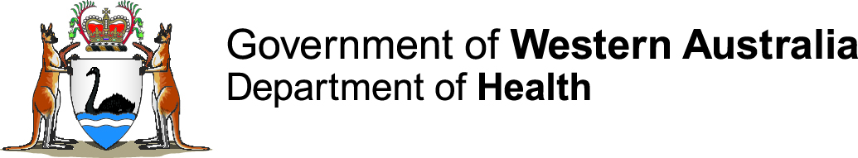

Notifiable Sexually Transmissible Infections and Blood-borne Viruses in Western Australia

Period ending 30 September 2021 Vol. 20 (4), issued November 2021

Contents

Summary 2

Chlamydia 3

Gonorrhoea 5

Infectious syphilis 8

HIV 11

Hepatitis B 11

Hepatitis C 16

**Notes:**

1. All data in this report are provisional and subject to future revision.
2. To help place the data in this report in perspective, comparisons with other reporting periods are provided. As no formal statistical testing has been conducted, some caution should be taken with interpretation.
3. Notifications for Christmas Island, Curtin, Leonora, Perth and Yongah Hill Immigration Detention Centres have been excluded from all analyses because of potential bias introduced through the inclusion of cases detected by screening of asylum seekers at these locations in previous years.

Copyright to this material is vested in the State of Western Australia unless otherwise indicated. Apart from any fair dealing for the purposes of private study, research, criticism or review, as permitted under the provisions of the Copyright Act 1968, no part may be reproduced or re-used for any purposes whatsoever without written permission of the State of Western Australia.

# Summary

Table 1 **Number and percentage change of STI and BBV notifications by reporting period, WA**



Notes: 1 Historical five-year mean (i.e. from 2016 to 2020) for the current quarter.

2 Percentage change of the number of notifications in the current quarter compared to the historical five-year mean of the same quarter. Positive values indicate an increase compared to the historical five-year mean of the same quarter. Negative values indicate a decrease compared to the historical five-year mean of the same quarter.

3 Historical five-year mean (i.e. from 2016 to 2020) for the current 12-month period.

4 Percentage change of the number of notifications in the current 12-month period compared to the historical five-year mean for the same 12-month period. For interpretation of positive and negative values, see note 2.

5 Unspecified hepatitis B and unspecified hepatitis C notifications have been analysed by specimen date as a batch of retrospective notifications were received in March 2021

6 Newly acquired hepatitis C data should be interpreted with caution as laboratory information used to determine if a case had a documented seroconversion within the past two years has not been routinely available since September 2020.

# Chlamydia

Figure 1 Number of chlamydia notifications in WA by month, for the two most recent 12-month periods



* The number of chlamydia notifications for the 12-month period from October 2020 to September 2021 was comparable to the previous 12-month period and 6% lower than the previous five-year mean, reflecting relative stability in chlamydia notifications over this period (Table 1).

Table 2 Number and proportion of chlamydia notifications in WA by sex, for the two most recent 12-month periods



Notes: N/A = Not applicable

In addition to the number of notifications above, there were three notifications among transgender people in the 12-month period from October 2020 to September 2021 and one notification among a transgender person in the 12-month period from October 2019 to September 2020

* The number of chlamydia notifications decreased by 5% among males and remained stable among females compared to the previous 12-month period.

**Table Number and proportion of chlamydia notifications in WA by age group, for the two most recent 12-month periods**



* The largest proportion of chlamydia notifications was among 20 to 24 year olds, and notifications among this age group remained stable in comparison to the previous 12-month period.

**Table Number and crude rate of chlamydia notifications in WA by Aboriginality, for the two most recent 12-month periods**



Notes: Rate = Crude notification rate per 100,000 population

N/A = Not applicable

* The chlamydia notification rate decreased by 9% among Aboriginal people and remained stable among non-Aboriginal people compared to the previous 12-month period.

**Table Number and crude rate of chlamydia notifications in WA by region, for the two most recent 12-month periods**



Notes: Rate = Crude notification rate per 100,000 population

Metropolitan = East Metropolitan + North Metropolitan + South Metropolitan

Other = Overseas residents diagnosed in WA

Unknown = Unknown residential address within WA

N/A = Not applicable

* While chlamydia notification rates declined or remained relatively stable in most regions, there was a 10% increase in the Midwest region.

# Gonorrhoea

**Figure Number of gonorrhoea notifications in WA by month, for the two most recent 12-month periods**



* The number of gonorrhoea notifications in the most recent 12-month period was 25% lower than the previous 12-month period and 18% lower than the previous five-year mean (Table 1). There has been a general downward trend in gonorrhoea notifications since January 2020.
* In the current 12-month period, 60% of notifications had a completed enhanced surveillance form provided by notifying clinicians, compared to the previous five-year mean of 72%.

**Table Number and proportion of gonorrhoea notifications in WA by sex, for the two most recent 12-month periods**



Notes: N/A = Not applicable

In addition to the number of notifications above, there were four notifications among transgender people in the 12-month period from October 2020 to September 2021 and three notifications among transgender people in the 12-month period from October 2019 to September 2020

**Table Number and proportion of gonorrhoea notifications in WA by age group, for the two most recent 12-month periods**



* Those aged 20 to 29 years comprised 41% of gonorrhoea notifications and decreased by 26% in comparison to the previous 12-month period. Notifications among 15 to 19 year olds increased by 5%.

**Table Number and crude rate of gonorrhoea notifications in WA by Aboriginality, for the two most recent 12-month periods**



Notes: Rate = Crude notification rate per 100,000 population

N/A = Not applicable

* The gonorrhoea notification rate decreased by 7% among Aboriginal people and by 34% among non-Aboriginal people, resulting in a higher rate ratio compared to the previous 12-month period.

**Table Number and crude rate of gonorrhoea notifications in WA by region, for the two most recent 12-month periods**



Notes: Rate = Crude notification rate per 100,000 population

Metropolitan = East Metropolitan + North Metropolitan + South Metropolitan

Other = Overseas residents diagnosed in WA

Unknown = Unknown residential address within WA

N/A = Not applicable

* Trends in the gonorrhoea notification rate varied between regions. Most notable was the 50% increase in the Goldfields region and 64% decrease in the South West region.

# Infectious syphilis

**Figure Number of infectious syphilis notifications in WA by region and exposure category, for the two most recent 12-month periods**



* A total of five congenital syphilis cases were reported in the current 12-month period: two in the Metropolitan region in non-Aboriginal children and one each in the Goldfields, Kimberley and Pilbara regions in Aboriginal children.
* The total number of infectious syphilis notifications was 19% higher than the previous 12-month period and 80% higher than the previous five-year mean (Table 1).
* In the current 12-month period, 79% of notifications had a completed enhanced surveillance form provided by notifying clinicians, which was 11% lower than the previous five-year mean of 90%.
* Unlike the historical trend, the number of notifications in the Perth metropolitan area categorised as heterosexual was higher than those categorised as MSM from the third quarter of 2020 onwards.
* The number of notifications in the Perth metropolitan area categorised as heterosexual increased by 25% in comparison to the previous 12-month period (n=242 vs. 194) and was almost three-times the previous five-year mean of 83 cases per 12-month period. The increase was particularly marked among females, and 11% of those of reproductive age (n=13/123) were pregnant at the time of diagnosis.

**Table** 10 **Number and proportion of infectious syphilis notifications in WA by sex, for the two most recent 12-month periods**



Notes: N/A = Not applicable

In addition to the number of notifications above, there was one notification among a transgender person in the 12-month period from October 2020 to September 2021 and two notifications among transgender people in the 12-month period from October 2019 to September 2020

* The number of infectious syphilis notifications increased by 6% among males and by 51% among females compared to the previous 12-month period.

**Table** 11 **Number and proportion of infectious syphilis notifications in WA by age group, for the two most recent 12-month periods**



* Those aged 25 to 39 years comprised 49% of infectious syphilis notifications and increased by 13% in comparison to the previous 12-month period. Notifications among 15 to 19 year olds increased by 91%, predominantly among Aboriginal people in the non-Metropolitan area.

**Table** 12 **Number and crude rate of infectious syphilis notifications by Aboriginality for the two most recent 12-month periods, WA**



Notes: Rate = Crude notification rate per 100,000 population

N/A = Not applicable

* The infectious syphilis notification rate increased by 51% among Aboriginal people and remained stable among non-Aboriginal people, resulting in a higher rate ratio compared to the previous 12-month period.

**Table** 13 **Number and crude rate of infectious syphilis notifications by region for the two most recent 12-month periods, WA**



Notes:Rate = Crude notification rate per 100,000 population

Metropolitan = East Metropolitan + North Metropolitan + South Metropolitan

Other = Overseas residents diagnosed in WA

Unknown = Unknown residential address within WA

N/A = Not applicable

* Notifications in the Kimberley, Pilbara and Goldfields regions have increased as part of a larger outbreak in northern Australia that commenced in January 2011 in the Northern Territory. Further information about the infectious syphilis outbreak affecting Aboriginal people living in northern Australia is available from: <http://www.health.gov.au/internet/main/publishing.nsf/Content/ohp-infectious-syphilis-outbreak.htm>.
* The infectious syphilis notification rate remained highest in the Kimberley region and increased by 52% in comparison to the previous 12-month period. A total of 492 infectious syphilis cases (219 male, 273 female) were notified from the beginning of the outbreak in the region in June 2014 to September 2021. Prior to 2014, there had been no infectious syphilis notifications in the region for two years.
* In the Pilbara region, a total of 327 infectious syphilis cases (152 male, 174 female) were notified from the beginning of the outbreak in the region in February 2018 to September 2021. Prior to February 2018, there had been on average two infectious syphilis notifications per 12-month period in the region.
* In the Goldfields region, a total of 81 infectious syphilis cases (39 male, 42 female) were notified from the beginning of the outbreak in the region in January 2019 to September 2021.
* The notification rate in the Midwest region more than doubled, with the increase occurring in the fourth quarter of 2020 and the first quarter of 2021.

# HIV

* The following analysis of HIV notifications data includes cases diagnosed for the first time in WA and excludes notifications of HIV cases previously diagnosed overseas.

Figure 4 Number of HIV notifications in WA by quarter, for the two most recent 12-month periods (excludes cases previously diagnosed outside WA)

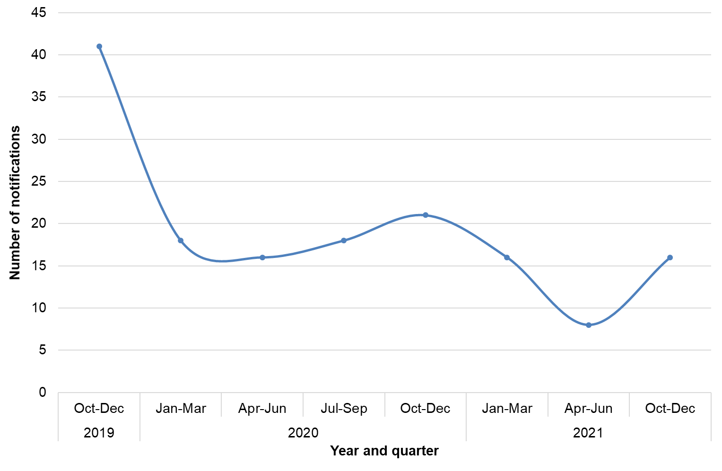

* A total of 61 HIV cases were notified in the October 2020 to September 2021 period, a 34% decrease compared to the previous 12-month period (n=93) (Table 1).
* Following a sharp decrease in the January to March 2020 quarter (n=18; 56% decrease), the number of quarterly HIV notifications remained relatively stable throughout 2020. Over the first three quarters of 2021, the number of quarterly notifications fluctuated between 8 and 16 cases (Figure 4).
* The decrease in HIV notifications in the October 2020 to September 2021 period was mainly due to a decline in male cases, which decreased by 38% compared to the previous 12-month period (79 to 49 cases). Over the same period the number of HIV notifications among females remained stable (12 vs 13 cases). Corresponding with the decrease in male cases, the male: female ratio for new HIV diagnoses decreased from 6.1:1 to 4.1:1 over the two reporting periods.

Table 14 Number and proportion of HIV notifications in WA by age group, for the two most recent 12-month periods (excludes cases previously diagnosed outside WA)



* The number of HIV notifications decreased across most age groups over the two 12-month reporting periods. The largest decrease was reported in cases aged 40 to 44 years, where the number of notifications decreased by 61% (Table 14).
* The median age of HIV notifications in the October 2020 to September 2021 period was 40 years (range: 19 to 76 years) and slightly younger than the previous 12-month period (42 years; range: 20 to 76 years).

Table 15 Number and crude rate of HIV notifications in WA by Aboriginality, for the two most recent 12-month periods (excludes cases previously diagnosed outside WA)



Note: Rate = Crude notification rate per 100,000 population

* There were two new cases of HIV among Aboriginal people in the October 2020 to September 2021 period, remaining stable compared to the previous 12-month period (n=3) (Table 15).

Table 16 Number and proportion of HIV notifications in WA by exposure, for the two most recent 12-month periods (excludes cases previously diagnosed outside WA)



* Compared to the previous 12-month period, there was a 32% decrease in the number of HIV notifications in MSM the current period (Table 16). Most MSM who were newly diagnosed with HIV in the current period had acquired their infection in Australia (79%; n=22).
* There was a 47% decrease in the number of male heterosexual HIV cases over the two reporting periods (Table 16). This decrease was largely due to a 58% decrease in the number of males reporting heterosexual acquisition in South-East Asia (19 to 8 cases).
* The number of female HIV notifications attributed to heterosexual exposures remained stable compared to the previous 12-month period (Table 16). Most of these cases had acquired HIV overseas (58%; n=7).

# Hepatitis B

**Figure Number of hepatitis B notifications in WA by disease status, for the two most recent 12-month periods**



Table 17 **Number and proportion of newly acquired and unspecified hepatitis B notifications in WA, for the two most recent 12-month periods**



* The number of newly acquired hepatitis B notifications decreased by 40% and the number of unspecified hepatitis B notifications decreased by 22% in comparison to the previous 12-month period. It should be noted that unspecified hepatitis B notifications have been analysed by specimen date as a batch of retrospective notifications were received in March 2021.

Table 18 **Number and proportion of hepatitis B notifications (newly acquired + unspecified) in WA by sex, for the two most recent 12-month periods**



Note: N/A = Not applicable

Table 19 **Number and proportion of hepatitis B notifications (newly acquired + unspecified) in WA by age group, for the two most recent 12-month periods**



* The largest proportion of total hepatitis B notifications was among those aged 60 years or older, and notifications among this age group remained stable in comparison to the previous 12-month period.

Table 20 **Number and crude rate of hepatitis B notifications (newly acquired + unspecified) in WA by Aboriginality, for the two most recent 12-month periods**



Notes:Rate = Crude notification rate per 100,000 population

N/A = Not applicable

* The total hepatitis B notification rate remained stable among Aboriginal people and decreased by 22% among non-Aboriginal people, resulting in a higher rate ratio compared to the previous 12-month period.

Table 21 **Number and crude rate of hepatitis B notifications (newly acquired + unspecified) in WA by region, for the two most recent 12-month periods**



Notes:Rate = Crude notification rate per 100,000 population

Metropolitan = East Metropolitan + North Metropolitan + South Metropolitan

Other = Overseas residents diagnosed in WA

Unknown = Unknown residential address within WA

N/A = Not applicable

* Trends in the total hepatitis B notification rate varied between regions and the small number of notifications in most non-metropolitan regions makes it difficult to interpret any changes in trends.

Hepatitis C

**Figure Number of hepatitis C notifications in WA by disease status, for the two most recent 12-month periods**



Table 22 **Number and proportion** of hepatitis C notifications in WA by disease status, for the two most recent 12-month periods



* The number of newly acquired hepatitis C notifications decreased by 39% while the number of unspecified hepatitis C notifications remained stable in comparison to the previous 12-month period. Newly acquired hepatitis C data should be interpreted with caution as laboratory information used to determine if a case had a documented seroconversion within the past two years has not been routinely available since September 2020. It should also be noted that unspecified hepatitis C notifications have been analysed by specimen date as a batch of retrospective notifications were received in March 2021.

Table 23 **Number and proportion of hepatitis C notifications (newly acquired + unspecified) in WA by sex, for the two most recent 12-month periods**



Note: N/A = Not applicable

* The number of total hepatitis C notifications decreased by 9% among males and increased by 15% among females compared to the previous 12-month period, resulting in a lower rate ratio compared to the previous 12-month period.

**Table** 24 **Number and proportion of hepatitis C notifications (newly acquired + unspecified) in WA by age group, for the two most recent 12-month periods**



* The largest proportion of total hepatitis C notifications was among 25 to 39 year olds, and notifications among this age group remained stable in comparison to the previous 12-month period. Notifications among 20 to 24 year olds decreased by 24% while notifications among those aged 60 years or older increased by 55%.

Table 25 **Number and crude rate of hepatitis C notifications (newly acquired + unspecified) in WA by Aboriginality, for the two most recent 12-month periods**



Notes: Rate = Crude notification rate per 100,000 population

N/A = Not applicable

* The total hepatitis C notification rate increased by 9% among Aboriginal people and decreased by 7% among non-Aboriginal people, resulting in a higher rate ratio compared to the previous 12-month period.

Table 26 **Number and crude rate of hepatitis C notifications (newly acquired + unspecified) in WA by region, for the two most recent 12-month periods**



Notes:Rate = Crude notification rate per 100,000 population

Metropolitan = East Metropolitan + North Metropolitan + South Metropolitan

Other = Overseas residents diagnosed in WA

Unknown = Unknown residential address within WA

N/A = Not applicable

* Total hepatitis C notification rates decreased or remained stable in most regions. Most notable was a 45% decrease in the South West region, primarily among Aboriginal people. The notification rate in the Kimberley region increased almost three-fold, primarily among Aboriginal people.

**This document can be made available in alternative formats   
on request for a person with disability.**

© Department of Health 2021

Copyright to this material is vested in the State of Western Australia unless otherwise indicated. Apart from any fair dealing for the purposes of private study, research, criticism or review, as permitted under the provisions of the *Copyright Act 1968*, no part may be reproduced or re-used for any purposes whatsoever without written permission of the State of Western Australia.