Central Referral Service
Information for Referrers

Updated: July 2023

Outpatient Referral Process to WA Public Hospitals 2
Guide to using the Central Referral Service 3
Step 1: Decide whether you need to refer via the CRS 3
Step 2: Download a referral template 4
Option A: Download to your practice management software 4
Option B: Download electronic form 4
Option C: Download to complete by hand 4
Step 3: For immediate referrals contact the hospital specialist directly 5
Step 4: Complete the referral 6
Step 5: Send the referral 7
Step 6: Acknowledgement receipt 8
Special Circumstances 9
Patient attending at a hospital outside their catchment area 9
Referrals from the WA Country Health Service (WACHS) 9
CRS follow-up 9
Appendix 1 10
Appendix 2 - Minimum Standards for Outpatient Referrals 11
Demographic Data 11
Additional Demographic Data 11
Clinical Information 11
Additional Information 12
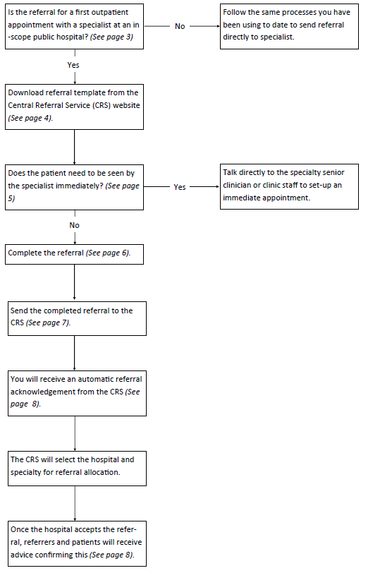

Step 1: Decide whether you need to refer via the CRS
The CRS has been set up to allocate referrals for a first specialist outpatient appointment at clinics within, or part of, a public hospital in the Perth metropolitan area and select regional services. For a list of the doctor-led specialties that the CRS accepts referrals to please see Appendix 1. For further information on the regional services currently in scope for the CRS, please refer to the CRS Scope document. If your referral meets these criteria, please refer using the CRS.

The following referrals should NOT be sent to the CRS

- Referrals to a private specialist.
- Referrals for mental health services.
- Referrals to regional outpatient services not currently in scope for CRS.
- Referrals to allied health outpatient services.
- Referrals to non-doctor led outpatient services.
- Referrals to antenatal and obstetric services

In these instances, please use your usual referral processes.

To begin, you need to download either a General Adult, Paediatric or Direct Access Gastrointestinal Endoscopy referral form. You can do this in one of three ways, depending on which is most convenient for you:

Option A: Download to your practice management software
If your practice uses Medical Director, Best Practice, Zedmed, Medtech or Genie software you can download the referral form into this software. This way, your patient’s information can automatically be uploaded to the referral form. For further instructions and to download the referral form, go to: http://ww2.health.wa.gov.au/Articles/N_R/Referral-form-templates
Once the referral form is completed electronically it can be sent to CRS via secure messaging preferably, otherwise, it can be faxed or posted (see page 7 for more information on sending options).

Option B: Download electronic form
If you do not have the above software, you can still fill out the referral form electronically. You can download the electronic referral form at: http://ww2.health.wa.gov.au/Articles/N_R/Referral-form-templates
Once the referral form is completed electronically it must be printed and sent to the CRS (see page 7 for sending options).

Option C: Download to complete by hand
If you want to complete the referral form by hand, you can download a PDF version and print it. Please note, that we would prefer the electronic form to avoid problems with interpreting handwriting. We will accept handwritten forms providing the handwriting is legible. You can download a PDF of the referral form at: http://ww2.health.wa.gov.au/Articles/N_R/Referral-form-templates

NB: If you choose to refer a patient using an alternate form, the mandatory information detailed on page 6 must be included. If the minimum required information is not included, the CRS will contact you and request that a complete referral be provided.

Telephone the specialty senior doctor or clinic staff at the nearest tertiary hospital
Arrange an appointment for the patient
Complete a referral form and clearly mark that the referral is IMMEDIATE
Send the referral form directly to the relevant hospital

Immediate referrals require you to contact the specialty senior clinician or clinic staff at the nearest tertiary hospital by telephone to arrange an appropriately timed presentation. You should complete a referral form (following the telephone discussion), clearly indicate ‘Immediate’ and include:
- The name of the clinician or clinical staff member you spoke to
- The hospital
- The telephone number of the staff member you spoke to
- The details of any telephone clinical advice received on the referral.
The referral is to be forwarded directly to the relevant hospital, not via CRS (usually by fax to the department/clinic as directed), to be available for the ‘immediate’ outpatient appointment.

To ensure patients are directed to the most appropriate level and place of care in a timely manner, WA Health has minimum standards for outpatient referrals. These standards are reflected in the fields of the referral template and include the following:
- Patient’s full name (or alias), maiden name and where appropriate (e.g. for a child) the name of parent or caregiver
- Patient’s address
- Patient’s mobile number and any alternative numbers
- Patient’s date of birth
- Next of kin/carer/guardian/local contact for paediatric referrals
- For a child, the mother’s surname at the time of birth, especially if the child was born in a public hospital
- Hospital Unit Medical Record Number (UMRN) (if known)
- Medicare number, reference number and expiry date
- Past health history including details of previous treatment, investigations including radiology, pathology, procedures and other relevant results. Copy of reports need to be included with the referral.
- Presenting symptoms, their duration and details of any associated medical conditions which may affect the presenting condition, or its treatment (e.g. diabetes)
- Physical findings (e.g. haematoma on right lower leg)
- Height and weight OR BMI (or percentile if referring infant/child with weight gain/loss issues)
- Details of current medications
- Any known allergies
- Date of referral
- Referrer name and Provider number
- Referrer Contact details including facsimile number¹
- The name of the specialty to which the patient is being referred
- GP diagnosis and urgency, where appropriate

NB: If the above information is not provided the referral will be returned.

If you are not using a WA Health referral form, you must still satisfy these minimum standards. An explanation for why each field on the referral form is significant can be found at Appendix 2.

¹ This is a requirement as a fax number is needed for practitioner to receive an acknowledgment of referral from the CRS

You can find the options for sending the referral to the CRS listed on the referral form. They are:

Mail
Print out referral form and mail to:
Central Referral Service GPO Box 2566
St Georges Terrace, WA 6831
Fax
Print out referral form and fax to 1300 365 056
Secure Messaging
Via HealthLink send to: crefserv
Via MMEx send to: central@mmex.gsmhn.com.au

Our preferred method for receiving referrals is via secure messaging as this preserves the integrity of the document sent and ensures the referral is legible. Copies of blood/radiology reports when faxed frequently require resending due to blurring in transmission which creates additional work for both CRS and GPs reception staff. Where necessary, we will accept referrals by fax or post.

When the CRS receives your referral you will be sent an automatic referral acknowledgement from CRS by secure messaging, fax or post (depending on the method your referral was sent). The CRS will then allocate your referral to the most appropriate hospital as soon as possible.

Once the hospital accepts the referral, both you and your patient will receive a notification of which hospital has accepted the referral. You will receive a secure message or fax; and your patient will receive an SMS message. If the patient does not have a mobile number, a letter will be posted instead.

The hospital will contact your patient to provide details of the date and time of their appointment closer to the time.

Once you have received notification that the referral has been accepted by a hospital, all further communication about the referral should be directed to that site.

Patient attending at a hospital outside their catchment area
Patients may receive outpatient care at a hospital that is not within their catchment area. This may occur for a variety of reasons including the patient’s need for a state-wide service, wait times, and clinical need.

A CRS Clinical Nurse will make the referral allocation decision to a particular hospital. Whilst it is preferable for a patient to be seen at the hospital that corresponds to the patient’s catchment area, the Clinical Nurse may make the decision for the patient to be seen out of catchment. In those circumstances the Clinical Nurse may contact the patient, referrer or hospital specialty for further information to facilitate the allocation decision.

Referrals from the WA Country Health Service (WACHS)
Referrals from WACHS will be accepted by the CRS from rural GPs, hospital specialists and nurse practitioners for doctor-led public metropolitan services or for select public regional services. For further information on the scope of CRS including the regional services currently in scope, please refer to the CRS Scope document.

CRS follow-up
Some referrals may require the name of a specialist on the referral for billing purposes. If this is relevant to your referral and you have not provided a name, the CRS will contact you.

Anaesthetics Adolescence Medicine Bariatric Surgery
Burns (post injury issues only) Breast Surgery
Cardiology Cardiothoracic Dermatology
Direct Access
Gastrointestinal Endoscopy
Ear, Nose and Throat Endocrinology Gastroenterology General Medicine General Surgery Genetics Gerontology Gynaecology Haematology Hepatobiliary Hyperbaric Medicine Immunology Infectious Diseases
Medical Oncology Neonatal Neurology Nephrology Neurosurgery Ophthalmology
NB: For further information please refer to the CRS Scope document via https://www.health.wa.gov.au/~/media/Files/Corporate/general-documents/Central-Referral-Service/PDF/Specilaties---Scope---Final.pdf
Oral Maxillofacial Surgery Orthopaedics
Paediatrics
Pain Management Palliative Care Plastic Surgery Radiation Oncology Rehabilitation Renal
Respiratory Medicine Rheumatology Spinal Surgery Urology
Vascular Surgery

Demographic Data
- Patient’s full name and maiden name (if applicable)
- Patient’s contact address and telephone numbers (mobile number is important for SMS)
- Patient’s date of birth, country of birth, and hospital of birth (for paediatrics)
The above details are required in order to register the patient on WA Health administration systems.

Additional Demographic Data
- Title (Mr, Mrs, Dr etc.)
- Gender
- Indigenous Status
- Residency
- Interpreter required /language spoken
- Medicare number, Sequence Number, Expiry Date
- GP Practice and location
- Next of Kin and relationship to patient
- For a paediatric referral, the mother’s surname at time of birth and at which hospital the child was born

Religion

The above details are required for registering a new patient on the Central patient Index (CPI) and the Patient master Index (PMI).

Clinical Information
- Past medical history including details of previous treatment, investigations including radiology, pathology, procedures and other relevant results.
- Presenting symptoms, their duration and details of any associated medical conditions which may affect the presenting condition or its treatment (e.g. diabetes).
- Physical findings (e.g. haematoma on right lower leg)
- Height, weight or body mass index (or percentile if referring an infant/child with weight gain or loss issues).

Current medications
- Allergies

The above details enable the CRS to determine the most appropriate hospital for your patient to be seen at and will also assist the hospital staff to triage the referral.
Limited clinical information makes it difficult to ascertain the clinical acuity and priority of the referral. If there is insufficient information to make an allocation decision, or for the hospital to triage the referral, you may be contacted by the CRS.

Additional Information
- Date of referral - some referrals are only valid for a period of time e.g. specialist three months, GP/NP 12 months. CRS processes referrals according to date received.
- Details of referring practitioner and provider number - required to ensure validity of referral and to register practitioner as a referrer on the WA Health patient administration systems.
- Contact details of referring practitioner including facsimile number - enables CRS/Hospital to contact practitioner if required.
- The name of specialty - so referral can be allocated appropriately
- GP/Practitioner diagnosis and urgency - to ensure diagnosis and specialty correlate. Urgency ensures that patient referral is appropriately triaged at the hospital.
- Hospital Unit Medical Record Number (UMRN) - if known - assists hospital to verify patient and quickly locate patients’ records.

This document can be made available in alternative formats on request for a person with a disability.

© Department of Health 2023

Copyright to this material is vested in the State of Western Australia unless otherwise indicated. Apart from any fair dealing for the purposes of private study, research, criticism or review, as permitted under the provisions of the Copyright Act 1968, no part may be reproduced or re-used for any purposes whatsoever without written permission of the State of Western Australia.

CRS Scope document available via https://www.health.wa.gov.au/~/media/Files/Corporate/general-documents/Central-Referral-Service/PDF/Specilaties---Scope---Final.pdf
CRS Scope document available via https://www.health.wa.gov.au/~/media/Files/Corporate/general-documents/Central-Referral-Service/PDF/Specilaties---Scope---Final.pdf

