Focus on Disability:
Improving the patient journey at Armadale Health Service

Disability Liaison Officer Pilot Project
Phase 2
Final Report – August 2014

South Metropolitan Health Service
Contents
Acknowledgements 3
Executive summary 4
Activities 5
Patient journey study 5
Focus on disability forum 5
Resource directory of local services relevant to supporting AHS patients with disability 5
Review of AHS patient intake and transfer documentation 5
National Standards accreditation workbook review for AHS in preparation for Australian Council of Healthcare Standards Accreditation Survey 5
Section 1 - Project overview 6
1.1 Background 6
1.2 Resources 7
1.3 Governance 7
1.4 Project objectives 7
1.5 Project deliverables 8
1.6 Armadale Health Service Advisory Group 9
Section 1 – Project outcomes 9
2.1 Patient Journey Study 9
Demographics 10
Summary of Interviews 10
Key Recommendations: Improving the Patient Journey Experience 11
2.2 File audit 12
Key recommendations: file audit 12
2.3 Focus on disability forum 13
Key recommendations: information sharing forums 14
2.4 Resource directory 14
Key recommendations: resource directory 14
2.5 Safety and quality 14
Outcomes 14
Key recommendations: safety and quality 15
Section 3 – Recommendations for further action 16
3.1 Armadale Health Service 16
Recommendations specific to Armadale Health Service 16
3.2 South Metropolitan Health Service 16
Recommendations specific to South Metropolitan Health Service 17
3.3 Disability Liaison Officer Steering Group (Disability Health Network) 17
Recommendations specific to the Disability Health Network Steering group 17
Section 4 – Links to further information and appendices 18
4.1 Clinical Senate Report: “Clinician Do You See Me?” 18
4.2 Disability Liaison Officer Phase 1 Summary 18
4.3 Armadale Health Service Clinical Handover Form (Final Draft) 18
4.4 Project officer feedback (evaluation) 18
4.5 Focus on Disability – Improving the patient journey at Armadale Health Service Forum Feedback 18
4.6 Project poster 18
Appendix 4.2 Disability Liaison Officer Phase 1 Summary 19
Background 19
Aims of a DLO role: 19
Suggested DLO personal requirements: 19
Appendix 4.3 Armadale Health Service Clinical Handover Form 22
Appendix 4.4 Collated feedback from project officer interview 24
Appendix 4.6 Project poster 30

Acknowledgements
The project team would like to acknowledge the steering committee and the advisory group for their valuable contribution to this project.
Disability Health Network - Disability Liaison Officer Pilot Project Coordination Group:
- Mark Slattery, A/Director Health Networks
- Fiona Payne, Disability Health Network Co-Lead
- Megan Burley, Senior Development Officer, Health Networks
- Tricia Dewar, Principal Disability Health Coordinator, Disability Service Commission (DSC)
- Marani Hutton, Area Allied Health Advisor, South Metropolitan Health Service (SMHS)
- Rachel Humbert, Acting Allied Health Director, North Metropolitan Health Service (NMHS)
- Kate Bullow, Team Leader, Complex Needs Coordination Team (CoNeCT)

Armadale Health Service (AHS) - Focus on Disability Advisory Group:
- Marani Hutton, Chair (Area Allied Health Advisor, SMHS)
- Dr Alison MacLean, Executive Sponsor (Director Clinical Services, AHS)
- Kate Bullow (Team Leader, CoNeCT)
- Gail Nesci (Manager, Occupational Therapy and DAIP Coordinator, AHS)
- Ivy Vukovich (Manager, Social Work Department, AHS)
- Sandra Polmear (Manager, Safety and Quality Governance Unit, AHS)
- Jessica Carroll (Local Area Coordinator, DSC Kelmscott Office)
- Khaiah Thomson (Local Area Coordinator, DSC Kelmscott Office)
- Sheila-Anne Macleod (Area Manager, DSC Kelmscott Office)
- Wayne Barrett (Consumer Representative)
- Sheryl Little (Carer Representative)
- Fiona Leverington (Project Officer, CoNeCT, AHS)
- Lana Hawkes (Project Officer, CoNeCT, AHS)
- Karina Bowden (Project Officer, Occupational Therapy Department, AHS)
- Proxy attendees

Report Authors:
- Karina Bowden
- Lana Hawkes
- Fiona Leverington
- Kate Bullow
- Marani Hutton

Executive summary
At the June 2011 Clinical Senate Debate on Disability, “Clinicians - Do you see me?”, nine recommendations were made to the State Health Executive Forum (SHEF) to improve the experience of hospital care for people with disability and their carers. Department of Health and the Disability Services Commission (DSC) agreed to work in partnership to implement the recommendations.
Following endorsement of the recommendations, the Disability Liaison Officer (DLO) Project Phase 1 commenced in May 2013 and concluded with a final report that identified Armadale Health Service (AHS) as the preferred trial site in the South Metropolitan Health Service (SMHS).
“Focus on Disability – Improving the Patient Journey at Armadale Health Service” was the title of the second phase of the DLO project for SMHS. Over a five month period, a number of quality activities were undertaken by the project team and the aims of these were:
- increasing staff knowledge of services to assist people with disability presenting at AHS
- creating opportunities for networking and information sharing between AHS and community agencies working in the local area and providing support to people with disability
- recording and understanding patients’ experiences at AHS
- suggesting recommendations to support hospital procedures and the National Safety and Quality Health Service (NSQHS) Standards to ensure ongoing improvements and support for patients with complex disability at AHS.
Findings from the project showed people with disability, their families and carers are well-supported at AHS. Some areas for improvement have been identified and these recommendations have been outlined in this report.
The project team did not find any evidence in the information gathered to support an ongoing “Disability Liaison Officer” position based at AHS but continued training and awareness-raising to maintain and improve standards are recommended.
Some of this training is currently being developed by the Disability Health Network (DHN). Further improvements could also be made to patient experience by adjusting existing systems such as identification of disability-related support needs in hospital documents and databases.
If further funding was made available to implement strategies to support and improve the hospital experience of patients with disabilities within SMHS, a larger tertiary site such as Fiona Stanley Hospital, with an expected higher volume of patients and more complex care pathways, may be more appropriate.
Short term funding may provide an opportunity to bed down policies, systems and practices to support people with a complex disability. Further consideration of possible options can be discussed with the SMHS Population Health Unit Executive Director.

Activities
The activities undertaken were:

Patient journey study
A patient journey study involving in-depth interviews directly with patients who have a disability and their carers (where applicable) commenced in April 2014. A total of 15 people (patients with disabilities and carers) participated. Key themes included the importance of listening to patients and sharing information within the team.

Focus on disability forum
A half-day community information forum was held at AHS on 28 May 2014 for hospital staff and community agencies to share information regarding hospital and community services available for people with disability. In total, 51 people attended this forum (comprised of an equal representation from hospital and community staff) and feedback was overwhelmingly positive.

Resource directory of local services relevant to supporting AHS patients with disability
This resource will be available to AHS staff via the local intranet site and will be shared with the DSC Local Area Coordination Kelmscott Office. It will be maintained and updated by the social work department at AHS.

Review of AHS patient intake and transfer documentation
Patient notes were reviewed as part of the patient journey study. Findings were reported into existing documentation review committees (facilitated by the AHS Safety and Quality Team), to clinical educators and shared at a Grand Round workshop and at a monthly Armadale Quality Awareness meeting.

National Standards accreditation workbook review for AHS in preparation for Australian Council of Healthcare Standards Accreditation Survey
Information gained in the above activities was recorded in the NSQHS Standard workbook for accreditation to provide evidence and future recommendations for:
- Standard 2 - Partnering with Consumers
- Standard 11 - Service Delivery
- Standard 12 - Assessment and Care Planning
The project team worked in collaboration with the existing AHS Safety and Quality Team and those involved will be available for interviews by Australian Council of Healthcare Standards (ACHS) surveyors as part of the health service’s organisation-wide accreditation scheduled for November 2014.
A number of recommendations outlined in the project outcomes were made for further activities and guidelines to continue to improve care for people with disability receiving care at AHS and across SMHS.
Key recommendations include:
- Community Advisory Council (CAC) patient interviews should be conducted periodically to ensure involvement of patients with disability and/or their carers.
- Encourage and support carer involvement (both formal and informal care providers) in patient care. Any policies that exist relating to their involvement should be consistent across the Health Service.
- A consistent means of identifying disability in medical forms to be developed, e.g. check box on triage and/or pre-admission forms.
- A standard communication and handover tool to be adopted for community agencies or carers to provide to the hospital for effective handover of care requirements for patients.
- It is recommended that general forums be held annually by Disability Health Network, or a region specific forum co-hosted by DSC Local Area Coordination and/or Health Service.
- Involvement of care coordinators for complex or frequently presenting patients and set management plans to meet ongoing health needs in the community and reduce frequency of avoidable presentations e.g. use of the existing CoNeCT program or care package provider coordinators where appropriate.

Section 1 - Project overview

1.1 Background
A debate of the Clinical Senate in 2011 entitled “Clinicians - Do you see me?” explored the fields of health and disability and proposed a number of recommendations for improving the delivery of health services to people with disability. The chief recommendations were the establishment of the Disability Health Network, and the development of “Disability Liaison Officer” (DLO) positions (see Section 4 for link to Clinical Senate Report).
Joint funding for DLO positions was secured through the Department of Health (Director General) and Disability Services Commission (DSC) and project scoping (Phase 1) was completed in 2013 by project officers from North and South Metropolitan Health Services.
The recommendation for SMHS was that a DLO position be based at Armadale Health Service, under the coordination and support of the SMHS Complex Needs Coordination Team (CoNeCT). The focus of the role was recommended to be a combination of consumer, clinician and organisational support. (See Section 4 for a summary of the Phase 1 report).
Funding of $110,000 was made available to SMHS in January 2014 for a one-year pilot of the DLO role. SMHS Executive reported that funding could not be rolled over into the 2014/15 financial year and the project commenced in February 2014 and was finalised by 30 June 2014.
Given the limited timeframe, it was not possible to develop and implement a “DLO role” at Armadale Health Service as envisioned by the Clinical Senate and Phase 1 of the project. Establishing a role and not continuing to fund or removing it was not seen by Armadale Health Service to be of benefit to either patients or to the health service.
It was identified that the most effective approach was one of quality improvement, specifically targeting hospital processes around the care of people with disability who are patients of Armadale Health Service. By taking this approach and aligning the project officer role with CoNeCT - an existing team that supports patients with complex needs at Armadale Health Service - many of the recommended objectives from Phase 1 could still be addressed or at least have data collected for future activities within usual hospital resources.
In line with the change of approach and narrowed scope, as well as feedback that the name “Disability Liaison Officer” was non-specific, confusing and generally interpreted as being a case managing/direct client role, the local project title was renamed “Focus on Disability : Improving the Patient Journey at Armadale Health Service”.
An information flyer alerting hospital staff to the project’s commencement was circulated in March 2014. The change was discussed within the working group, at steering committee level and with the Disability Health Network. A briefing note and discussion with Disability Services Commission regarding change of focus since the initial Memorandum of Understanding (MOU) by the Disability Health Network Steering Committee was completed.

1.2 Resources
Funding for the project was managed through the Complex Needs Coordination Team (CoNeCT) cost centre at Fremantle Hospital and Health Service. Three project officers provided a total of 1.4 FTE in conjunction with their existing roles at Armadale Health Service. These included:
- two CoNeCT coordinators (0.5 FTE)
- one Senior Occupational Therapist (0.4 FTE).
Using existing staff members with a sound working knowledge of the service and established networks with staff and departments, allowed the project to commence and undertake the planned activities more efficiently and effectively.
The project officers were supported by Marani Hutton, Area Allied Health Advisor and Kate Bullow, CoNeCT Team Leader. CoNeCT office space at Armadale Health Service was utilised for project work.
A small portion of the funds was used to meet some of the costs of hosting the successful Focus on Disability Community Forum.

1.3 Governance
The project was governed by the DLO Steering Group at DoH which reports directly to the Disability Health Network. The SMHS Area Executive Sponsor was Kate Gatti, Executive Director SMHS Population Health. Metro-wide project oversight was provided by DLO Pilot Coordinating Group.
Day to day management of project officers occurred through usual line management (CoNeCT and AHS Occupational Therapy) with the SMHS Allied Health Advisor, supporting and mediating where required. The project officers worked in collaboration with the Disability Access and Carers Recognition Committee (DA&CR), Disability Access and Inclusion Officer, and Quality and Safety team at Armadale Health Service.

1.4 Project objectives
The aim of the Disability Liaison Officer as specified in the MOU between the funding bodies was to improve the acute care experience for people with a disability who interface with the Western Australian Health system. Outcomes to be achieved in the MOU were to:
- Determine the effectiveness of a DLO in the hospital setting.
- Identify potential modifications to the role to improve effectiveness.
- Establish a business case for:
  - justification of continuation and possible expansion of the DLO roles in adult tertiary and secondary hospitals, or
  - ascertain whether the DLO functions could be integrated into normal business of staff.
- Establish, recruit, supervise and manage pilot Disability Liaison Officer positions
- Develop a project plan (including evaluation measures) for delivery of the outcomes and outputs
- Broker relationships and partnerships between services, negotiate and establish effective referral processes, including linkages between tertiary and secondary hospital, emergency departments and community services
- Establish, coordinate and deliver services within the scope of the role as per Phase 1 report (specific objectives listed in attached document “DLO Phase 1 summary”).
Due to the imposed time constraints, it was necessary to review the above objectives and target the project to aims that could be achieved within the available allocated resources and expectations, and provide the best possible enduring impact.
Following review of the Phase 1 objectives and in consultation with Armadale Health Service Executive, the following aims for the Phase 2 DLO project at Armadale Health Service (“Focus on Disability : Improving the Patient Journey at Armadale Health Service”) were determined:
- increase staff knowledge of services to assist people with disability presenting to the health service
- facilitate networking and information sharing between the health service and local community agencies working in the area of disability
- record and understand patient’s experiences at Armadale Health Service
- make recommendations to support hospital procedures and the Safety and Quality (EQuIP) for future improvements to maximise a positive inpatient experience for patients with a complex disability and their carers.

1.5 Project deliverables
The following activities were planned for the project period. Further information about each activity and the outcomes is shown in the Project Outcomes section (Section 2) of this report.
- Audit and review of existing Armadale Health Service (AHS) intake, screening and initial assessment tools used for admission and pre-admission screening of patients to be completed in the context of patient journey study as a notes audit.
- Conduct a Patient Journey Study and report on findings.
- Conduct a knowledge audit of social workers at AHS regarding disability support services and how to access these.
- Create a resource directory of local disability support services including access pathways and organise a forum of stakeholders with pre and post forum survey of knowledge and gaps.
- Report on current in-patient care pathways and experiences for patients with disability in AHS with recommendations for future quality activities.
- Review and contribute to EQuIP National Safety and Quality Healthcare Standards Workbook with emphasis on Standards 2, 11 and 12.

1.6 Armadale Health Service Advisory Group
The SMHS project advisory group for this project was led by the SMHS Area Allied Health Advisor, and includes the Project staff and representatives from Armadale Health Service Executive (Director Clinical Services and Director of Nursing), Occupational Therapy, Social Work, CoNeCT, Clinical Safety and Quality, the Community Advisory Committee (Consumer and carer representative) and Disability Services Commission Local Area Coordination).
The group met monthly to receive progress reports from the project officers, and was tasked to assess the final project report completed by July 2014. Chair role was by shared by the Armadale Director of Nursing, the SMHS Area Allied Health Advisor and project officers.

Section 1 – Project outcomes

2.1 Patient Journey Study
A “Patient Journey” study involving in-depth interviews with patients with a disability, and their formal or informal carers commenced in April 2014. All participants were required to be inpatients between the ages of 18-64 years.
For the purposes of the study a broad definition of disability was used and included any person with an ongoing impairment impacting on communication, social interaction, economic participation, learning, mobility, self-care or self-management. Carers were interviewed when they were available on the ward, or were sought out specifically when a patient was unable to complete the interview themselves due to significant cognitive impairment, or to a communication impairment that was not able to be overcome with use of communication aids.
All patients approached for interviews provided written consent to be interviewed, only one formal (attendant) carer declined due to having to seek permission from their care agency. Participants were provided with information on the purpose of the interviews and a number to contact for any further information or to withdraw their consent if they reconsidered their participation.
- 15 participants were interviewed as part of the study
- 10 patients (people with disabilities) were interviewed
- 5 carers were interviewed
- 1 of the interviews involved a patient and carer being interviewed together – all other interviews were with one person only.
The study population was taken from Dialysis Unit, Colyer (Surgical), Benson (Medical), Canning (Medical) and Carl Streich (Rehabilitation) Wards. Identification and referral of suitable study candidates was completed in collaboration with by ward staff (primarily allied health). Some participants were also identified directly by project officers via relevant data base searches (ICM and CommuniK8) accessible to clinical staff at Armadale Health Service.

Demographics
Age | Ranged from 22 – 63 years
Gender | 8 Female, 7 Male
ATSI | 1 Aboriginal patient interviewed
Group home residents | 5 participants resided in group homes
Independent living | 10 participants lived independently
Carer | 10 participants identified as having a carer, of these, 7 were carers provided through formal services

Six patients were in hospital due to issues relating to their disability at the time of interview. Nine of the patients were admitted for other medical issues. Nine of the patients interviewed had one or more chronic health conditions including asthma, diabetes, chronic pain, arthritis, renal failure, obesity, heart failure and hypertension. Three participants were known to have mental health issues (anxiety, schizophrenia and depression).

Summary of Interviews
Patients were overwhelmingly positive about their inpatient experience at Armadale Health Service in comparison to larger hospitals. “Armadale treat you like you are a person, not a number” (Patient comment). Numerous patients spoke about seeing the same staff across admissions and feeling like they were remembered, equating this to a sense of more personalised care.
73% of participants reported they were happy with the standard of care received and were overwhelmingly positive about nursing staff and staff responsiveness. While all participants reported they could ask questions of the ward staff, no patients or carers interviewed were able to identify the process of making a formal compliment or complaint.
The patient journey interviews highlighted some issues in the provision of equipment to those requiring it during their inpatient stay, suggesting a possible gap in staff knowledge of how to access available equipment on the wards – see examples below:
Patient Journey Interview Example 1
‘Alex’ reported that he felt there was a general lack of knowledge around his disability (muscular dystrophy) and that this had resulted in issues on the ward relating to his care. He reported that he required additional time to return to base-line function with transfers (slide board) and that the hoist was not available on the ward (Colyer) in the interim and need to be sourced from elsewhere.

Patient Journey Interview Example 2
The attendant carer for patient ‘Brian’ reported bringing in a bed rail guard for the bed to prevent injury, as the patient uses his feet for communication. Bed rail guards are in fact available on the ward but in this instance not provided.
Some supported/group home accommodation settings provided patient folders from facility staff detailing disability specific care needs (as opposed to medical history or medication information). Many supported/group home attendant carers felt that the files were not always read by hospital staff and that key information relating to holistic care needs were sometimes overlooked.
The interviews highlighted that the presence of carers (informal and formal) on the ward enhanced patient care and safety, particularly for patients who are unable to communicate effectively due to complex disability. Carers often completed care tasks that otherwise would have been done by nursing staff (e.g. teeth brushing, PEG feeds and some personal care). Carers were able to provide verbal handover and advice on engaging or assisting patients that may not have otherwise been detailed in medical notes (e.g. methods of communication). Inconsistencies with duties allowed to be performed by carers on the ward were apparent, e.g. some carers reported they were able to provide PEG feeds and other said they were not allowed to do this.
Interviews with carers and patients indicated that community facilities and hospitals do not share a common language, and this at times leads to a breakdown in understanding of patient’s functional ability. An example of this was given by a carer who reported that a patient with a disability had been described by care staff as having “poor mobility” when admitted to hospital. The patient was in fact wheelchair dependant and at risk of falls if mobilised. Recommendations were made to mobilise the patient with a wheeled frame and one person assist on the ward as able. Medical records showed that the patient subsequently fell later the same day when trying to access the bathroom with a visitor.
Patient Journey Interview Example 2 cont.. (Attendant carer for patient described in example above)
“When clients of the group home go to hospital, the group home medical file goes with them. It has a list of medications, conditions and says that she has poor mobility. I’m not sure if it is read by the staff?”

Key Recommendations: Improving the Patient Journey Experience
- Standard communication and handover tool to be adopted for community agencies or carers to provide to the hospital for effective hand over of patients’ care requirements. The Project Team are aware that the Disability Health Network is progressing work on this item currently.
- Ensure use and availability of appropriate equipment (e.g. hoists) and related procedural guidelines.
- Provide accessible information on how to make a formal compliment or complaint. None of the patients and carers surveyed knew how to make a formal complaint or comment. Activities are currently underway to increase awareness of this process, and there is currently a brochure (WA Health - Compliments and Complaints) made available on the wards and at patient bedsides. The possible introduction of a spoken advertisement on the television system, as has been discussed at DA&CR would increase the accessibility of this information, particularly to patients who are visually impaired or illiterate.
- Increase staff knowledge about what resources are available on the ward and how to access them through orientation for new staff to the ward and regular in-service or training.
- Continue to encourage carer involvement in patient care. Any policies that exist relating to their involvement should be consistent across the Health Service.
- Community Advisory Council patient interviews to include involvement of patients with disability and/or their carers

2.2 File audit
A review of all Patient Journey Study participants’ medical notes was undertaken at the conclusion of the inpatient stay. Nine participants presented to the hospital via the Emergency Department, the remaining six were considered planned admissions - 1 was transferred from Fremantle Hospital, four were dialysis patients and one was admitted for planned surgery.
Length of patient stay ranged between 1- 60 days with single day admission accounting for those patients admitted to the dialysis unit. Six patients were readmitted during the period of the project. Three of these were for conditions similar to their initial presentation. All discharge summaries were completed within two days of discharge.
It was noted by the project officers that thorough discharge plans enabled better communication and successful community health management, particularly for patients with complex needs. On reviewing the files, the length of stay appeared appropriate for each patient when considering their presenting complaint and individual needs, including those relating to disability and other chronic health issues.
Patient Journey Interview Example 3 (‘Jane’)
Interviews with attendant care staff involved with Jane’s care reported during previous admissions:
- Discharge had been rushed, occurring on a Friday and allowing little time to arrange staffing at the care facility.
- Insufficient information had been provided for Jane’s ongoing respiratory care in the discharge summary for community carers to confidently manage her needs.
Actions: Short involvement of a care coordination service to improve communication with key ward staff assisted to improve the level of detail provided on the discharge summary, subsequently increasing carer confidence to manage Jane’s respiratory needs.
The file audit highlighted that there was no consistent way in which disability was identified or noted in the medical forms or inpatient notes.

Key recommendations: file audit
- Timely (on day of discharge preferably or the following day) and comprehensive discharge summaries to facilitate effective transition of care. This should include a detailed plan with timeframes – e.g. see GP within 5 days, represent to hospital/attend GP if a specific issue occurs.
- Develop a consistent means of identifying disability in medical forms e.g. a check box on triage and/or pre-admission forms could be developed.
- Involvement of care coordinators for complex or frequently presenting patients to set up management plans to meet ongoing health needs and reduce frequency of avoidable presentations. E.g. use of the existing CoNeCT program or care package provider coordinators where appropriate.
- When considering length of stay, the presenting complaint as well as other factors such as concurrent disability and chronic health issues need consideration in order that hospital funding can be determined by Activity Based Funding.

2.3 Focus on disability forum
A Disability Networking Forum was held on the 28 June 2014 at Armadale Health Service (Goline House). 51 people attended, 24 from Armadale Health Service and 27 from various community organisations including: Nulsen Haven, Spina Bifida Association, City of Gosnells, City of Armadale, Anchor Home Help, Continence WA and Partners in Recovery.
Presentations were heard from the Armadale Health Service Aged Care Assessment Team, a local Disability Services Commission representative, Health Consumer Representative, Social Work Department and Regional Assessors for Home and Community Care funded services. A pre-recorded presentation from a consumer representative was delivered as the pre-nominated consumer was unable to attend the day. The Armadale Health Service Program Advisor from Carers Western Australia also presented.
Evaluation of the day was undertaken using a brief pre- and post- feedback survey. 27 paired responses were received which represents 53% of those attending the forum. 25 respondents reported finding the forum useful. Respondents reported an improved knowledge of how hospitals work and resources available for people with disability in the local area. Encompassed in the overall positive feedback, many respondents commented that a regular meeting would be of benefit and interest to the local community providers. (See Section 4 for link to Survey Results)

Fig 1. Knowledge of disability services in the local area
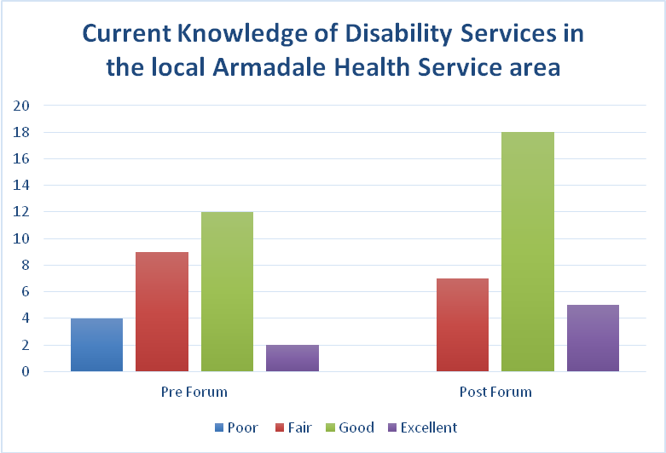

Many participants expressed an interest in a similar forum to the one held as part of the project, to be held regularly - perhaps annually or similar.

Key recommendations: information sharing forums
It is recommended that similar general forums be held annually by Disability Health Network, or alternatively a region-specific forum co-hosted by DSC Local Area Coordination and/or Health Service.

2.4 Resource directory
A comprehensive service directory of resources in the local area which assist people with disability was developed. It contains details of over 50 community organisations, their contact details including phone number and website, and a brief outline of their services.
Health Service Social Workers and Local Area Coordinators contributed content for the director, and feedback has been received that it will be well utilised in their daily role. The resource will be available to Armadale Health Service Staff via the intranet, and both hard and electronic copies will be provided to Local Area Coordinators from DSC in the Kelmscott office which services the Armadale Health Service catchment area. The Social Work Department at Armadale Health Service has agreed to take responsibility for maintaining this resource into the future and to review it annually.
Having the directory readily available and easily accessible on the intranet will enable ward staff to access information more quickly, and to use it for their further education and to provide information to people with disability, their families and carers. Initial feedback on the draft directory circulated was very positive from everyone consulted from Executive, ward staff and Local Area Coordinators.

Key recommendations: resource directory
- Social Work Department to maintain directory and regularly promote to Armadale Health Service staff including when orienting new staff to wards.

2.5 Safety and quality
The project deliverables have been incorporated into the EQuIP workbook as part of ongoing safety and quality projects and to assist in the accreditation process scheduled at Armadale Health Service in 2014.
Specifically, implementation of the project objectives was reflected in Standards 2, 11 and 12. Findings and recommendations outlined in this report have been embedded into the workbook, to be considered at accreditation and as part of the process project officers will be available to be interviewed. Given the short project time frame, project officers endeavoured to feed in recommendations for quality improvement into existing processes to ensure follow through for recommendations.

Outcomes
An outcome in this area was the inclusion of a disability subgroup in recording on the hospital representation register. As highlighted by the clinical senate report, the Australian Institute of Health and Welfare (AIHW) statistics provides a “bleak” picture around the health status of people with disabilities. They note the numbers of people with severe or profound disability (15-64 years) are more likely to report poor or fair health (46%) as opposed to people without disability (5%). People with disabilities were also found to have significantly higher rates of chronic illness such as obesity, cardiovascular disease, diabetes, osteoporosis, and arthritis. Tracking trends in this area will provide data on whether people with disability are overrepresented in cohort of patients representing to hospital and if it the presentation is associated with a related condition. This information will in turn assist with service planning for this population. This information could be used by existing discharge coordinators to enhance the discharge process and information to prevent avoidable representations.
Another outcome was the inclusion of a disability checkbox in the Clinical Handover/Intra-hospital Transfer document currently being completed as a quality activity. The form, with added recommendations, was discussed and endorsed at the Nursing and Midwifery Advisory Committee meeting and is in the process of being developed into a medical record for use by nursing staff (see Section 4). Having needs related to disability highlighted on the form will enhance communication between wards in a standard way, which this project has identified does not currently occur, and should ensure that a patient’s needs are identified and able to be met in a more timely fashion.
Other Quality Activities included a presentation to a Grand Rounds, a fortnightly information forum for improving clinical knowledge and skills attended by hospital staff including senior medical offers. The project outcomes were explained and the importance of listening to patients and carers expertise in their own health care was reinforced.
Feedback on the value of good quality discharge summaries was also provided to the Director of Clinical Training. Examples and feedback will be incorporated in ongoing training and education. The project officers presented to Armadale Quality Awareness (AQuA) meeting, highlighting the findings of the project and areas for future improvement.

Key recommendations: safety and quality
- Further review of medical record documents is required to ensure consistent recording of disability across all aspects of the inpatient stay, including the compliance to completing the new clinical handover form.
- Regular audits (e.g. a random sample assessed quarterly against set criteria) of discharge summaries by the medical team in consultation with Director of Clinical Training and Safety and Quality Team to ensure timely completion, accuracy and sufficient detail in the summary and follow up treatment required sections of the report.
Reference :
AIHW 2010. Health of Australians with disability: health status and risk factors. AIHW bulletin no. 83. Cat. no. AUS 132. Canberra: AIHW.

Section 3 – Recommendations for further action

3.1 Armadale Health Service
The project team did not find sufficient evidence for a “DLO” role at Armadale currently. Many opportunities for further improvements to services and processes were identified as outlined in the recommendations, although for the majority of these they were not issues that are specific only to Armadale Health Service and would require coordination across the area health service as outlined below.

Recommendations specific to Armadale Health Service
- Ensure use and availability of appropriate equipment (e.g. hoists) and related procedural guidelines.
- Provide accessible information on how to make a formal compliment or complaint. The possible introduction of a spoken advertisement on the television system, as has been discussed by the Disability Access and Carer Recognition Committee would increase the accessibility of this information, particularly to patients who are visually impaired or illiterate.
- Increase staff knowledge about what resources are available on the ward and how to access them through orientation for new staff to the ward, regular in-service or training.
- Community Advisory Council patient interviews to include involvement of patients with disability and/or their carers
- Timely (on day of discharge preferably or the following day) and comprehensive discharge summaries to facilitate effective transition of care.
- Social Work Department to maintain local disability services directory and regularly promote to Armadale Health Service staff including when orienting staff to wards.

3.2 South Metropolitan Health Service
The roll out of the National Disability Insurance Scheme (NDIS) may present a clear role for a DLO within both metropolitan health services. Under the new scheme, it would be beneficial to have a liaison person who has an understanding of hospital processes that can provide expertise and up-to-date information on the new funding model and services available. This could perhaps look somewhat like the Silver Chain Liaison nurse positions which service the metropolitan Health Services.
A DLO role is currently being trialled at Sir Charles Gairdner Hospital. The Patient Journey Study at Armadale indicated that there are more challenges for the larger tertiary sites in the care of patients with disabilities, and the project team recommend that SMHS also consider the larger sites for any further exploration of the DLO role. Supporting the transition from paediatric to adult tertiary services is an obvious area for further consideration.
If any future project is undertaken there needs to be either a modification in the funds allocation so that funds can be rolled over between financial years, or the project must commence at July 1, if it is to be funded for a year. The inability to do this for the current project meant significant modification from the project envisaged by the Clinical Senate Report and the Phase One DLO.

Recommendations specific to South Metropolitan Health Service
- Encourage and support carer involvement in patient care. Any policies that exist relating to carer involvement (including formal care services) should be consistent across the Health Service
- Develop a consistent approach of identifying disability in medical forms e.g. check box on triage and/or pre-admission
- Involving care coordinators for complex or frequently presenting patients to set management plans to meet ongoing health needs in the community and reduce frequency of avoidable presentations. E.g. use of the existing CoNeCT program or care package provider coordinators where appropriate.
- When considering length of stay, the presenting complaint as well as other factors such as concurrent disability and chronic health issues need consideration in order that hospital funding can be determined by Activity Based Funding
- Carry out regular audits (e.g. a random sample assessed quarterly against set criteria) of discharge summaries by the medical team in consultation with Director of Clinical Training and Safety and Quality Team to ensure timely completion, accuracy and sufficient detail in the summary and follow up treatment required sections of the report
- Undertake further review of medical record documents to ensure consistent recording of disability across all aspects of the inpatient stay.

3.3 Disability Liaison Officer Steering Group (Disability Health Network)
A delay in any further decision on the future of the DLO role is recommended until findings from the North Metropolitan Health Service (NMHS) Phase 2 project have been completed. While each project has a different focus, a lot can be learnt from seeing the successes from each. There would be benefits in retaining some common, repeatable, elements in both projects, e.g. patient journey study, to allow direct comparison across two sites differing in demographic, hospital size and project management.
If any future projects are to be jointly funded between Department of Health and Disability Services Commission, it is recommended that a senior member of the Commission be involved in the site’s project advisory group, as well as the Steering Group to ensure that objectives from both agencies are being met equally. Having the involvement of both agencies in funding, development and implementation phases is a unique opportunity to build a stronger partnership between agencies and a mutual understanding of how each service can complement the other.
In a climate of change, as has existed in the health services, introduction of a new role or project creates significant challenge. Roll out of any future projects needs to consider the timing, location and climate. The implementation of a Disability Liaison Role is a significant change to the current way in which the Hospital manages the care of people with disability. It requires significant commitment (time, funds, consistency in process and good will of existing roles/staff) to establish any new role and have it accepted into general practice. Although the climate of change may always exist to an extent, and should not be a reason to cease future projects, allowances for this should be made in the planning stages of the project.

Recommendations specific to the Disability Health Network Steering group
- A standard communication and hand over tool to be adopted for community agencies or carers to provide to the hospital for effective hand over of care requirements for patients. (current activity of the Network)
- It is recommended that general forums be held annually by Disability Health Network, or a region specific forum co-hosted by DSC Local Area Coordination and/or Health Service.

Section 4 – Links to further information and appendices

4.1 Clinical Senate Report: “Clinician Do You See Me?”
http://www.clinicalsenate.health.wa.gov.au/debates/jun11.cfm

4.2 Disability Liaison Officer Phase 1 Summary
Appended (4.2)

4.3 Armadale Health Service Clinical Handover Form (Final Draft)
Appended (4.3)

4.4 Project officer feedback (evaluation)
Appended (4.4)

4.5 Focus on Disability – Improving the patient journey at Armadale Health Service Forum Feedback
https://www.surveymonkey.com/results/SM-G2HTQMG8/

4.6 Project poster
Appended (4.6)

Appendix 4.2 Disability Liaison Officer Phase 1 Summary
(Completed by the Focus on Disability project team from Phase 1 Report)

Background
The DLO Project originated from the Clinical Senate report recommendations of the Health and Disability senate debate in June 2011 titled ‘Clinicians – Do you see me?’. The mandate for senators was to consider what they could do to improve the acute-care experience for people with a disability who interface with the Western Australian health system.
The key issues that were raised were: no access to one central point of patient information; poor awareness of and attitude towards disability; fragmented and poorly coordinated disability services across NMHS, SMHS and the community; resource limitations which impact on hospital service delivery; lack of disability education and training; and absence of disability service delivery models.
The aim of the DLO project was to scope the needs in NMHS and SMHS adult tertiary and secondary hospitals for people aged 18-65 years with complex disability and how services that support consumers with a disability can be improved, enhanced or newly implemented. Excluded were: adults aged over 65 with disability (i.e. older adult); mental health as the primary diagnosis; children with disability; transition stages (i.e. from child to adult care, adult to older adult); emergency department presentations and primary health care.

Aims of a DLO role:
- Improved quality of care for patients and families
- Supporting earlier identification of complex disability patients
- Identifying gaps in knowledge and resources to support service improvement
- Sharing successful strategies and outcomes across clinical areas and wards
- Facilitation of staff education both formal and on an “as needed” basis
- Improved patient satisfaction with the hospital experience
- Reduce complaints
- Improved length of stay and reduced readmissions (improving and supporting complex discharge planning to prevent same-diagnosis readmissions)
- Potential cost savings
- Better partnerships with the disability sector
- Better patient flow across the continuum of care

Suggested DLO personal requirements:
- Should be a health professional experienced in both the health & disability sectors
- Understands both hospital and community systems, with links and contacts throughout the disability sector
- Need advanced communication, interpersonal, negotiation skills
- Needs experience in delivering training & education
- Is a limited resource so will need a strong support system
- Needs to be in a ‘position of clout’ / have credibility / power / authority & recognition.
Deliverables/Outcome Measures suggested for the role
- The DLO consider developing a hardcopy template of a “Profile Summary” (patient passport) as a collation point of patient information, as an interim solution until an electronic options is available. Linking in with current systems and processes will reduce a siloed approach.
- The DLO considers creating a disability checklist (screening) to understand disability patient cohort complexity to better manage inpatient admission (this was identified as a strong need by consumers & clinicians alike).
- The DLO work in partnership with the Disability Health Network to achieve outcome measure(s) 1.
- The DLO will evaluate consumer satisfaction. This may be in the form of satisfaction surveys, interviews, incidence of complaints, receipt of qualitative positive feedback or other. This information will be reported informally bi-monthly and formally bi-annually.
- Develop an early identification “red flag” system in Emergency Department (ED) to flag complex disability.
- Improved holistic health care for the complex disability cohort, including integrated medical and mental health care. This will be achieved by the DLO working in alignment with multidisciplinary teams, mental health and medical teams (i.e. complex health includes complex co-morbidity and the mental health of the patient).
- Develop a pre-admission pathway (quarter 1), discharge planning pathway (quarter 2) and contribute to a multidisciplinary care plan for the disability cohort (quarter 2) of the pilot project in collaboration with other stakeholders.
- The DLO will work collaboratively with DAIP to identify hospital wards with the majority of the disability cohort and work collaboratively with the multidisciplinary team to consider one room on each of these wards is set-up to be as disability-friendly as possible e.g. ceiling hoist, sufficient room for wheelchair/essential equipment (this is a prime DAIP role that the DLO can assist with).
- The DLO will work collaboratively with hospital ward staff to audit the wards with biggest volumes of the disability cohort (see Appendix 3) and prioritise wards with greatest area of need.
- The DLO will aim to provide education and training for health care professionals, consumers and families to raise awareness of people with disabilty and their special needs in the health care setting – this may include specialist disability education for staff, general disability awareness training, bed-side education for consumers/families, information pamphlets in layman terms & resource packages.
- The DLO will aim to develop a clinical pathway for the complex disability patient cohort (see Appendix 3) within second quarter of DLO pilot project.
- Work in partnership with the Disability Health Network to contribute to developing a overarching “Disability Model of Care” (or overarching framework with principles) and Clinical Governance framework which will help support service delivery in the hospital system.
- Build strong working partnerships with Disability Services Commission (DSC) – particularly Hospital Eligibility Coordinator, My WAY Coordinators, DSC Hospital Eligibility and DSC Nursing. Aim to have bi-monthly or quarterly meetings.
- Build working partnerships with Specialist Disability Agencies and non-government
- organisations (NGO’s) e.g. TCCP, Nulsen, ILC, PwD WA, DDC, National Disability Services WA, Headwest, Brightwater, Mental Health Advisory Council (see stakeholder list for full complement). Aim to have quarterly service-wide disability sector meetings which include department of health WA.
- Work in collaboration & partnership with the Disability Health Network and Disability Access and Inclusion Plan (DAIP) hospital staff to help the DLO guide strategic direction and service planning requirements (i.e. eliminate siloed & fragmented services), with bi-monthly meetings.
- The DLO will work collaboratively with the hospital CAEP co-coordinator to review DSC CAEP data quarterly to monitor equipment costs and patient need/unmet need for the disability cohort.
- The DLO will support long stay patients with complex disability and support current health service initiatives.
- The DLO should report on LoS monthly for each category of disability in the cohort, the associated ABF revenue & those patients over the high boundary.
- Reduction in LOS for the complex disabled patient.
- The DLO work collaboratively with hospital Executives on a gap regarding transition/step-down unit options to manage the issue when patients are medically stable but stay in hospital due to lack of access to accommodation or community options. Executives have been made aware of this issue.

Appendix 4.3 Armadale Health Service Clinical Handover Form

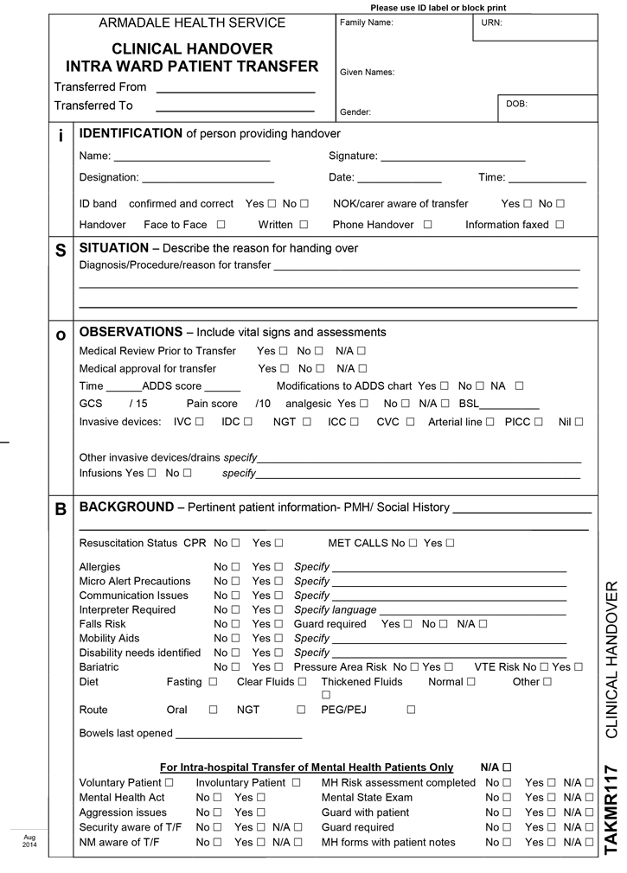
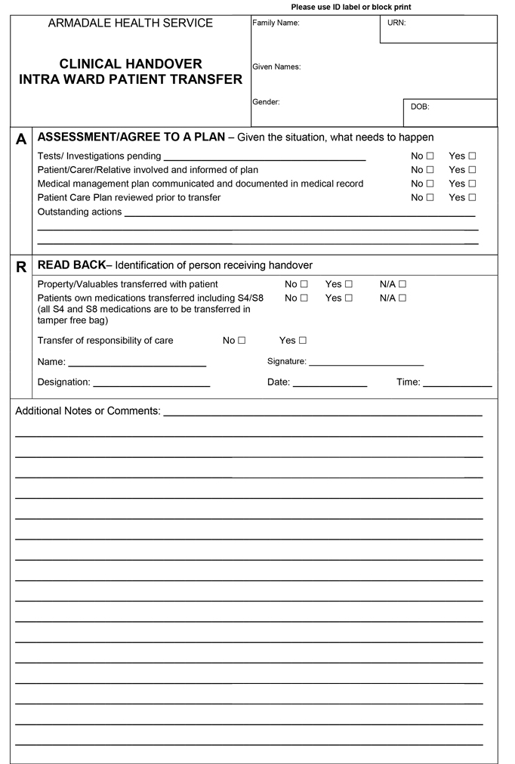

Appendix 4.4 Collated feedback from project officer interview
Interviews were conducted individually with the project officers by a representative from Disability Health Networks not involved in the project
Q 1. Did you find any of the preparatory documents useful in implementing this project? e.g. Clinical Senate report, DLO Phase 1, DAIP reports
Five documents were identified by the Disability Liaison Officer (DLO) project officers. Their comments are summarised, below.
Clinical Senate Report
- It was useful for:
  - Historical context, overview of issues for people with disability in the health sector, clarifying the vision of the DLO project, insight into the patient and family experience
- The Clinical Senate Report did not provide practical information about implementing the project
DLO Phase 1 Report
- It was useful for:
  - Understanding why Armadale Hospital (AH) as chosen as the pilot DLO project site
  - Identifying options in regard to how a DLO might integrate into the health service
- The DLO Phase 1 Report provided limited practical information about implementing the project. Confounding issues included:
  - Disharmony between recommendations and the time allocated for project planning and implementation
  - The inability to consistently identify the population of people with disability entering the hospital system
    - Identification and prioritisation of the practical issues to be addressed as priori to recommendations would have high practical value for implementing the project in the future
  - Lack of specificity within recommendations to undertake discrete project activity. For example, development of educational resources for patients and families to developing department and hospital-wide operational changes
  - Did not provide site specific barriers and limitations to implementation –scoping this out consumed time available for project implementation
Disability Access and Inclusion Plan (DAIP) Reports
- The DAIP reports were not utilised, however, there was value in attending DAIP meetings to network with project stakeholders

National Safety and Quality Health Service Standards (NSQHSS)
- The Evaluation and Quality Improvement Program (EQuIP) process was useful to ensure that the project language and work aligned with the HSQHSS, specifically: Partnering with Consumers (#2), Service Delivery (#11) and Provision of Care (#12)
Memorandum of Understanding
- The memorandum of understanding between the Disability Services Commission and the WA Department of Health was useful for project background and context
Q 2. What would you say was the main aim of this project?
There was consensus among the DLO project officers that the aim of this project was to improve the patient journey for people with disability at Armadale Health Service (AHS). The patient journey was consistently described as valuing the experience of a person with disability, their family, and carer, from arrival to discharge into the community; including all of their interactions along the continuum of care.
Q 3. Do you think the team achieved this (in part, completely or not at all)?
All DLO project officers reported that the aim was only partially achieved. Barriers included:
- Project duration – less than 12 months for project initiation, scoping, planning, recruitment, implementation and evaluation impaired the focus of the Clinical Senate Report and DLO Phase I report vision
- Funding – only one financial year
  - limited human resource – decreased ability to respond to change
- Project uncertainty and scope creep
- Buy-in from senior executive staff
  - During the life of the project the Chief Executive role at AHS was undertaken by several people, hindering knowledge transfer and long-term buy-in for the project
  - Limited due to differing expectations of the DLO role and investment of hospital resource in light of the short-term lifespan of the project
  - Disparate understanding, agreement and coordination between Executive staff at AHS and the South Metropolitan Health Service prior to implementation hindered project activity
- Buy-in from ward staff
- Lack of practical information relevant for implementation of the recommendations in the DLO Phase I report.
Q 4. What do you think was the most successful activity completed, and why? How do you think it could add value (if any) to a ‘patient’s journey’?
The DLO project officers implemented three projects for which at least one DLO project officer believed added value to the patient journey at AHS. Their reflections are summarised below for each project.

Patient journey study. This project demonstrated success through:
- Identifying specific areas of success and area for improvement at AHS
- Providing a genuine opportunity for people with disability to be heard
- Modification of existing processes within the AHS to enhance the patient journey
Networking forum. This project demonstrated success through:
- Identifying communication issues specifically between AH and the community
- Providing an opportunity for networking and information sharing between clinicians and the community
- Measured success through evaluation of the forum, before and after implementation
Resource folder. This project demonstrated success through:
- Implementation of an electronic directory resource with long-term sustainability, independent of the operation of the DLO project
- Potential for information to be utilised at other hospital sites which have access to the WA Health intranet.
Q 5. What was the least successful activity completed, and why?
Development of the project implementation plan and contribution to the Armadale Hospital EQuIP process was identified as the least successful activities conducted by the DLO project officers. Issues associated with these activities are summarised below:
Project Implementation Plan
- Scope creep – reduced project time and uncertainty
- Stakeholder buy-in
Contribution to the EQuIP Process
- It is unknown how or if the information fed into the EQuIP process will be utilised
Q 6. Did you receive adequate support from the Project Advisory Group? How do you think you could have been better supported?
There was consensus among the DLO project officers that interaction with the Project Advisory Group (PAG) was positive:
- sharing of resources, knowledge, advice, encouragement and support individually and as a group helped the DLO project officers progress and achieve their goals as quickly as possible
- Networking:
  - The Disability Services Commission (DSC), Local Area Coordinators, Consumers and Carers representatives were very useful for understanding local council, community, local business, issues, initiatives and practical solutions
The DLO project officers felt that the PAG could have been enhanced by:
  - Recruitment of a senior Executive from the DSC could facilitate
    - Align expectations between the DSC and WA Heath
    - Increased monitoring capacity to ensure partnership is not consumed by WA Health priorities
    - long term-term buy-in and planning
- Clearly articulated PAG expectations from the DLO project officers
- Consistent high-level representation from AH to facilitate buy-in at the site level.
- Inclusion of Medical and Nursing representatives to increase buy-in .I.e. doctors and nurses.
Q 7. Do you think there is a role for a DLO at Armadale Hospital? If so, what might this role look like? Who should it answer to?
The DLO project officers indicated that a DLO position was not currently necessary at AHS. This may be, in part, because a study of the patient journey among people with disability at AHS, conducted by the project officers, suggested that care for people with disability was already positive without the implementation of a DLO.
Concern however, was raised with regard to the implementation of the National Disability Insurance Scheme (NDIS) and the confusion it would cause in and between the community and AHS, potentially leading to disruption of services.
The project officers reported that a future DLO role could be described as:
- Co-funded by the DSC and WA Health
- Physically located within the hospital setting, for example, with Social Work
- A position working with or in the inpatients setting
  - A time fraction of an existing position may be advantageous, with flexibility within the role to provide advice and support ‘as needed’
  - A fairly senior and respected person in the area would encourage buy-in from ward staff
  - Alternatively, a DSC employee working within the public health setting
- Support hospital staff, non-government organisations, the community and hospital staff towards facilitating information exchange between the community and hospital
- Possess a mix of knowledge in activity based funding and management, the NDIS and skill working with and across a diverse range of internal and external government and non-government stakeholders
- Provide educational opportunities to enhance staff skills by sharing information between the community and hospital relevant to enhancing the patient journey
- Report to line manager in their working area
Q 8. Who should be considered and consulted (stakeholders) to ensure a future project based on the
Disability Liaison Officer concept receives support (internal and external)
- The Disability Service Commission and Department of Health with Executive-level buy-in
  - Makes information sharing more readily available and unifies decision-making
  - Facilitates high-level discussion between WA Heath and DSC
  - Facilitates long-term planning and strategic partnerships
  - Clarifies expectations between WA Health and the DSC
- Executive Officers at the DLO site/ hospital(s)
  - Facilitates buy-in prior to recruitment of a DLO by understanding site specific issues, priorities and opportunities
    - Detailed negotiation of a job description form could clarify the role of the DLO at the hospital site
- People with disability, families, carers and the community
  - Consult locally to identify their needs
- Existing groups and networks, such as the Disability Health Network, to target key stakeholders
- Local government
  - Facilitates information sharing, such as local initiatives
- Medical and nursing groups
  - Engage early to keep abreast of changes
  - Identify change champions within these areas who can drive change, such as Medical Training Officers
- Allied health and care coordination services
  - Develop partnerships to capitalise on commonalities between these areas
- Engage with skilled stakeholders in Activity Based Funding and Management (ABF/M) to understand the interface between primary care, tertiary care, and the long term sustainability of DLO role funding
- Facilities management to secure infrastructure for staff

Q 9. Any other comments?
- Future project activity needs to have established funding, authority, investment and time to ensure that long-term, effective changes, which align with the intention of the Clinical Senate Report and DLO Phase 1 reports, are met
- Engagement with past and present DLO project officers will help progress activity in this area by sharing knowledge and experience

Appendix 4.6 Project poster

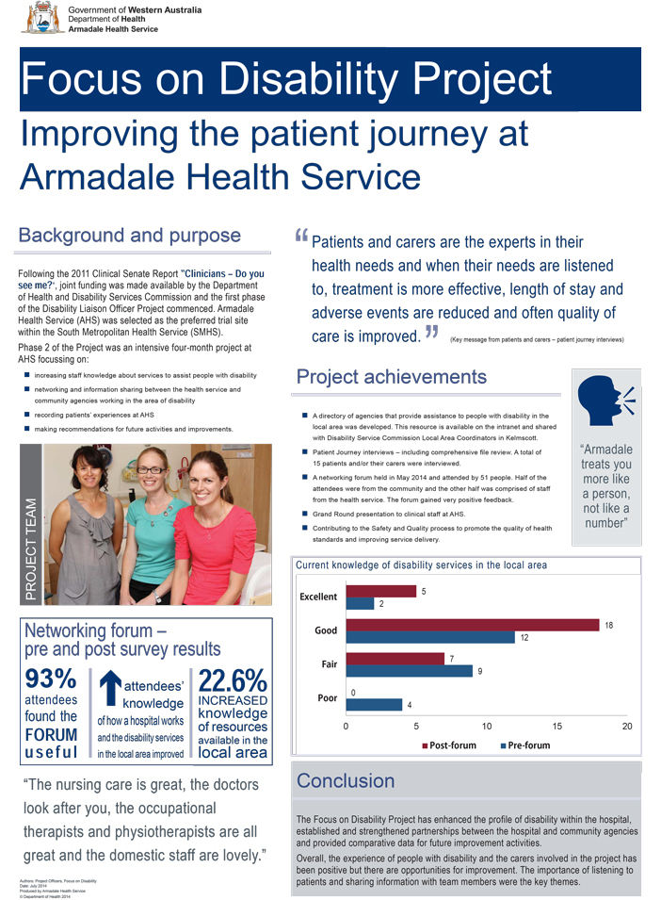
This document can be made available in alternative formats
on request for a person with a disability.
© Department of Health 2015
Copyright to this material is vested in the State of Western Australia unless otherwise indicated. Apart from any fair dealing for the purposes of private study, research, criticism or review, as permitted under the provisions of the Copyright Act 1968, no part may be reproduced or re-used for any purposes whatsoever without written permission of the State of Western Australia.

