Produced by Health Networks © WA Department of Health 2019
Copyright to this material is vested in the State of Western Australia unless otherwise indicated. Apart from any fair dealing for the purposes of private study, research, criticism or review, as permitted under the provisions of the Copyright Act 1968, no part may be reproduced or re-used for any purposes whatsoever without written permission of the State of Western Australia.
Suggested citation
Western Australian Department of Health. WA Healthy Weight Action Plan 2019-2024. Perth: Health Networks, Western Australian Department of Health; 2019.
Important disclaimer
All information and content in this Material is provided in good faith by the Western Australian Department of Health, and is based on sources believed to be reliable and accurate at the time of development. The State of Western Australia, the Western Australian Department of Health and their respective officers, employees and agents, do not accept legal liability or responsibility for the Material, or any consequences arising from its use.
Using the term Aboriginal
Within Western Australia, the term Aboriginal is used in preference to Aboriginal and Torres Strait Islander, in recognition that Aboriginal people are the original inhabitants of Western Australia. Aboriginal and Torres Strait Islander may be referred to in the national context and Indigenous may be referred to in the international context. No disrespect is intended to our Torres Strait Islander colleagues and community.
Acknowledgement
The authors acknowledge the use of several images in this document are courtesy of the World Obesity Federation.
Contact information
For further information contact Health Networks, Western Australian Department of Health on (08) 9222 0200 or healthpolicy@health.wa.gov.au.
Contents
Introduction 2
Why does WA need the WA Healthy Weight Action Plan? 3
What we heard from people with lived experience 3
The impact of obesity 4
Causes of overweight and obesity 6
Factors impacting effective action 12
Effective action is possible 17
Reframing the conversation 17
Evidence from successful healthy weight programs 19
Existing guidelines for action 21
Enablers and opportunities in WA 23
References 29
Glossary 34
Acronyms 35
Appendices 36
Appendix A: Defining overweight and obesity 36
Appendix B: Infographic references 37
Appendix C: Strategic alignment 38

Introduction
The health and wellbeing of people at-risk of and currently with overweight and obesity is important as it has far reaching impacts beyond the individual person. The WA Healthy Weight Action Plan 2019-2024 (hereafter, the Action Plan) is a map for action over the next five years to support coordinated activity that will positively impact the early intervention and management of overweight and obesity in WA (refer to Appendix A: Defining overweight and obesity).
This Companion Resource supports the Action Plan by providing the supporting information that underpins the actions. It also outlines how the health and social systems in WA impact the development and maintenance of overweight and obesity as well as the opportunities that exist to tackle the issue. This is achieved through a discussion of:
- What we heard from people with lived experience
- The impact of obesity
- Causes of overweight and obesity
- Factors impacting effective action
- Reframing the conversation
- Evidence from successful healthy weight programs
- Existing guidelines for actions
- Enablers and opportunities in WA

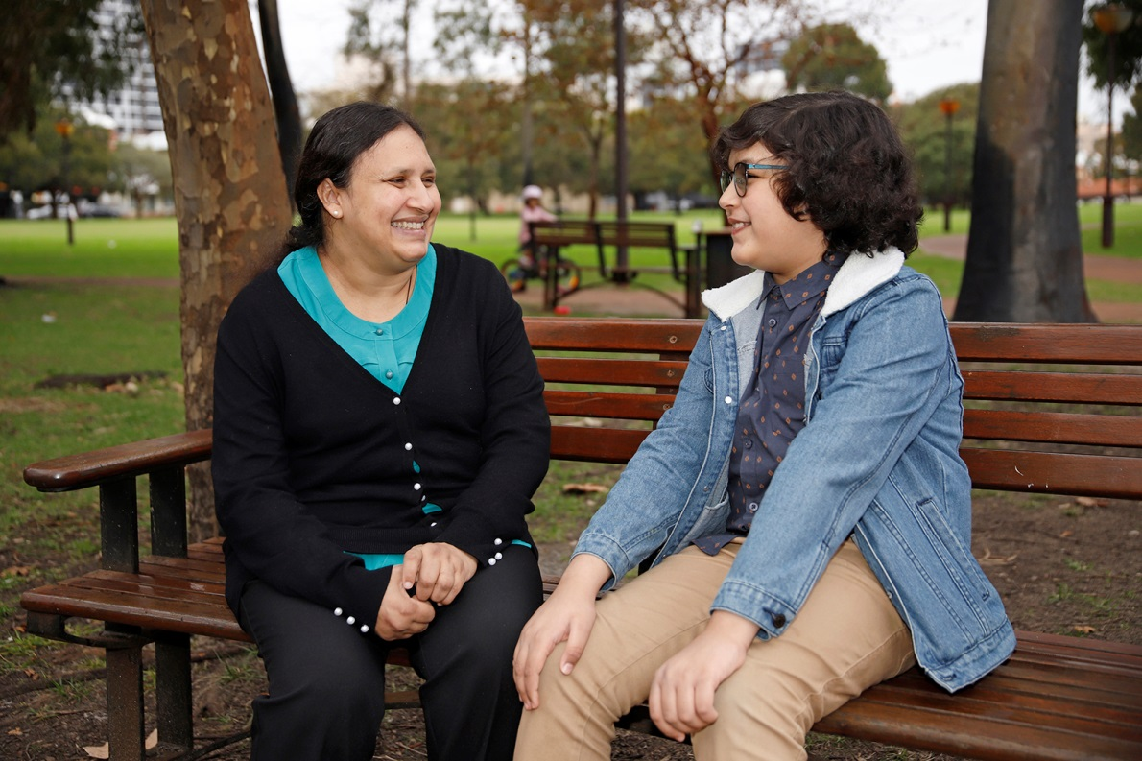

Why does WA need the WA Healthy Weight Action Plan?

What we heard from people with lived experience
Throughout consultations with over 700 consumers, people with lived experience of overweight and obesity consistently identified the complex social, emotional and health factors that impact their weight (or their attempts to lose weight) and enact healthy behaviours. However, they also acknowledged and took ownership of the factors that are within their control to change. Commonly, people want affordable services and programs that can support them as a whole person and this includes requiring changes to the governance and service levels that enable additional support, respect, and understanding from peers, social services and health professionals regarding their unique challenges and needs.
Key areas that were raised during consultations with people with overweight and obesity include:
- Their reasons for being overweight can be complex and individual to them. Many people who are overweight have tried multiple approaches to losing weight, often with little success.
- Many people did not consider using the public health system for support with losing weight. Many felt their only avenue was diet and exercise interventions through private programs or organisations irrespective of the complex factors (e.g. medication and mental health) that might be contributing to their weight.
- People struggled with the lack of definitive and reliable information about “what actually works” for weight loss.
- People need help with implementation of evidence-based approaches.
- Stigma, shame and other psychological factors can act as barriers to people seeking or getting support they need and would find valuable – this both prevents people from seeking help and prevents the support that is offered from being effective.
- Many people were surprised that no health professional had ever mentioned their weight to them, despite it being clear that they were overweight.
- Finding the “right” health professional to work with was challenging, but that it is very valuable when they found that person. A key element of being the “right” person to work with was the ability of the health professional to be on the same level as the person losing weight and work “with” them, rather than being detached and appear to be “handing down” advice and directions.
- Social networks have a significant impact on success and failure of weight loss attempts (e.g. when family and friends are not supportive, or continue to eat and drink in their usual patterns).
- Programs which continued over a period of time, including for a year or longer, were seen as valuable due to the ongoing support for maintenance of new behaviours.
We heard from people who have taken action to lose weight that they would value the following in the WA health system:
- A person-centred approach with non-judgemental staff members who have time and are willing to spend time to really understand their individual circumstances and provide them with tailored information about what might help them, based on those circumstances. However, many people recognised and understood that this would be challenging to achieve because many health professionals do not have time to get to know people and to tailor a care pathway for them.
- On-going support to help them with their motivation as they take action to lose weight and to help them develop and embed different habits.
- On-going support to include psychological (such as coaching) and social support (from friends, family and other groups) as well as information about what action to take.
The complex issue of overweight and obesity would benefit from a holistic person-centred response where public services can be tailored to the individual circumstances of the person. The community is clearly open to change and is willing to support a societal shift to a culture that makes the healthy choice, the easy and desirable choice.

The impact of obesity
Overweight and obesity is the second leading contributor to burden of disease in WA; second only to smoking.¹ Currently 67% of WA adults and 25% of children have overweight or obesity.² Childhood obesity is a strong predictor of adult obesity as children with overweight and obesity are approximately five times more likely to be obese in adulthood than their healthy weight counterparts.³ People in country WA are more likely to have overweight and obesity than their city based counterparts, particularly people living in very remote areas with 80% of the population estimated to be overweight or obese.⁴
In Australia, rates of overweight and obesity are higher for Aboriginal people:⁵
- 30% of Aboriginal children aged 2 to 14 years
- 35% of Aboriginal adolescents aged 15 to 17 years
- 69% of Aboriginal adults over 18 years
Approximately 11% of Australian adults over the age of 18 years have severe obesity (obese class II and III).⁵ For people that are in the obese class III category life expectancy is reduced by 8-10 years.³ In terms of the health of Australians with overweight or obesity, 60% of men and 66% of women aged 18 and over have a waist circumference that puts them at an increased or substantially increased risk of metabolic complications and these figures increase with age.⁵
Overweight and obesity has a significant impact on a person’s and family’s physical and mental health and wellbeing, potentially impairing their social relationships, employment and ability to participate fully in society.⁶ It also increases with the level of social and economic disadvantage that a person or family experiences. People living in economic disadvantage are more likely to have overweight and obesity than people who are not (69% quintile 1 [most disadvantaged] and 79% in quintile 2 compared to 59% in quintile 5 [least disadvantaged]).⁷ Chronic conditions are responsible for 73% of deaths in Australia and $715 million of hospital costs in WA in 2013.⁸ Many of these chronic conditions, such as mental health, cardiovascular disease, diabetes and cancer, have a strong causal relationship with obesity.⁹
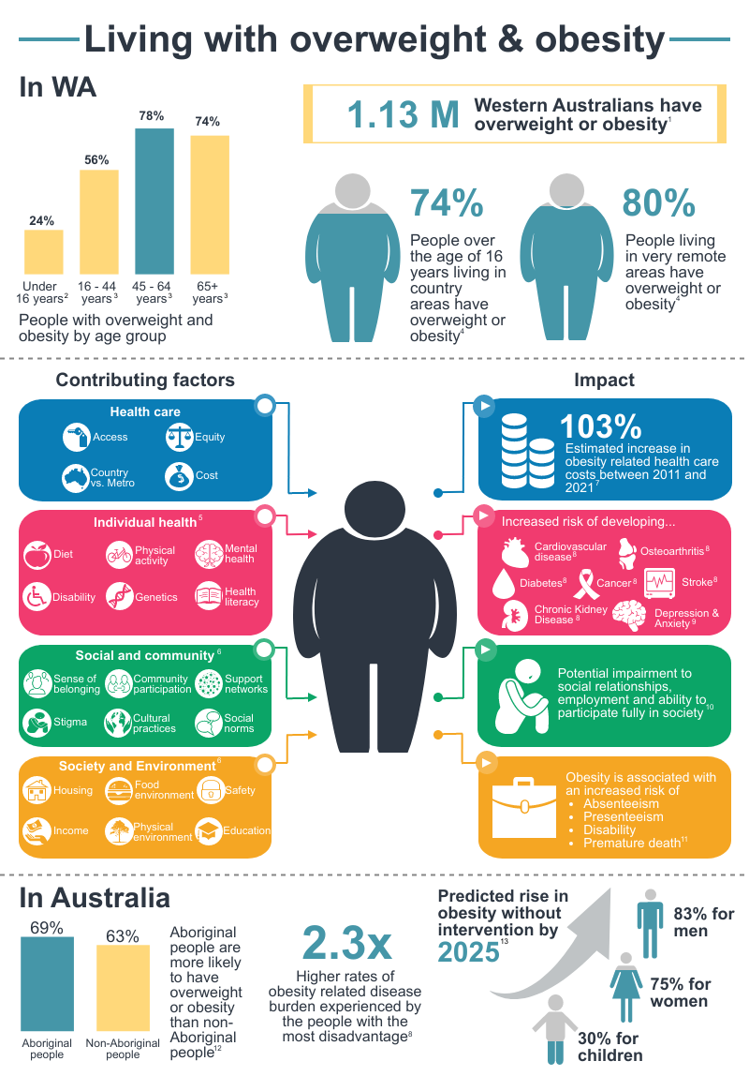
See references in Appendix B: Infographic references

Causes of overweight and obesity
There is a common misconception that the sole cause of weight gain is a simple combination of eating too many kilojoules and not being physically active.¹⁰ While these components are involved, it is no longer considered to be such a simple equation.¹¹ It is widely acknowledged that there are number of factors that impact whether a person will develop overweight and obesity, such as: ¹¹
- Genetics and epigenetics
- General health and wellbeing (e.g. other health conditions and mental health)
- Social determinants of health (e.g. social and cultural factors, the obesogenic environment, health literacy, income, education, location etc.)
- Government policies (e.g. food production, town planning, access to health care, etc.).
These factors interact to create a complex system of obesity where each factor plays a causal role in the development and increasing rate of obesity worldwide. These interactions are illustrated in the systems map in the United Kingdom’s Tackling Obesities: Future Choices – Project Report¹². It shows how each specific factor directly and indirectly impacts and reinforces others, with the individual stuck at the middle only able to directly control a small number of the factors that lead to their weight gain or difficulty in losing weight.

Understanding the system governing obesity
A system is a collection of interdependent components where the whole is greater than the sum of its parts; when one component of a system is changed other parts of the system are impacted.¹³ Figure 1 demonstrates how a simple system operates; the same concept can be applied to complex systems such as the one that governs obesity.
Figure 1: Illustrating a simple system
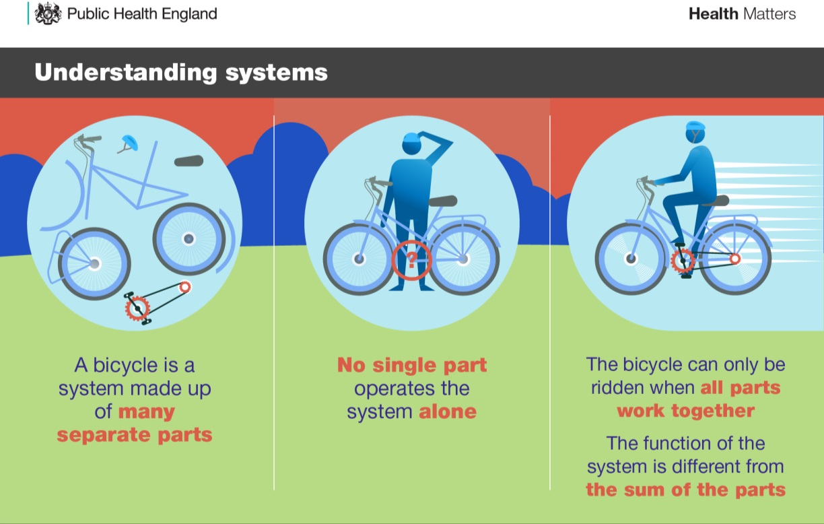
Reproduced with permission. Source: Public Health England (2019). Whole systems approach to obesity: A guide to support local approaches to promoting a healthy weight. London, Public Health England.
The systems approach to obesity relies on the understanding that there are factors at play at multiple levels of society that impact whether a person or family will become overweight or obese. Often these factors negatively reinforce weight gain; however, targeting effective action at each level can have a protective and positive influence and support people and families to improve their health and wellbeing. The levels at which action is recommended to take place are defined as:¹¹
- Governance (macro): policies, procedures and ways of working; social norms; cultural practices; laws and regulation; state-wide systems such as food production and transport, land use and urban design; and systems of governance, processes and procedures used by large organisations such as government entities.
- Service (meso): the settings in which behaviours or interactions occur such as schools, hospitals, workplaces, and public spaces and the social and cultural norms, rules, or processes that govern these settings.
- Individual and community (micro): the person or family unit, their decisions, habits and behaviours; the communities and social circles they operate within; and how these impact their points of view, behaviours, and understanding of the world and issues such as obesity.

Genetics and epigenetics
Genetic factors and the environmental conditions that influence these genes, have been shown to have a strong role in a person’s weight status.¹⁴ ¹⁵ Genetics impacts the way a person’s body processes and stores energy as well as influences their behaviours such as eating patterns and exercise.¹⁵ In addition, our environment and genes interact, particularly in developing foetuses during pregnancy, that can trigger additional biological processes to be ‘switched on’ or ‘off’, increasing a person’s likelihood of developing overweight, obesity or related co-morbidities.¹⁵, ¹⁴ Biological factors also impact how a person’s body responds to weight loss efforts. Research has demonstrated the existence of biological triggers that reduce or prevent the body from burning fat stores and even enhance weight regain when kilojoule restriction is removed.¹⁶, ¹⁷, ¹⁸ This is an evolutionary mechanism that helped conserve energy stores during times when access to food was inconsistent;¹⁶ however, this mechanism persists during times of plenty. In the modern era, this is contributing to the rise of overweight and obesity particularly when coupled with environmental factors such as the easy access to low nutrient, kilojoule dense food.

General health and wellbeing
A person’s general health and wellbeing can impact and be impacted by their weight in terms of the physical restrictions of the condition as well as the fear or anxiety a person might feel at the prospect of making themselves unwell or putting themselves in harm’s way. For example:
- People with conditions such as forms of arthritis or respiratory conditions could find exercise difficult and painful and might opt to avoid opportunities for incidental exercise such as using stairs due to pain, limitations in mobility, or fear of inflammation or difficulty breathing.
- People with diabetes must be constantly aware of the impact of energy expenditure on their health as too much exercise can result in a dramatic reduction in blood glucose levels, which if not picked up by the person or someone nearby could result in hospitalisation or death.
- People with disability that restricts their mobility or people with vision impairments might not be able to or feel confident to engage in exercise or active transport.
These factors are often complicated if services that are accessible to the general public such as gyms and exercise classes, do not cater for the needs of people with disability or certain health conditions that might impact a person’s physical ability. Additionally, having to be aware of the impact of seemingly “simple” healthy lifestyle actions on a chronic condition or disability can take an emotional and mental toll on people on top of the stressors that might be present in their day to day lives that other people do not experience or need to consider.¹⁹
Even though overweight and obesity can increase the risk of mental health problems, ²⁰ mental health issues can also lead a person to become overweight or obese, sometimes against their best efforts. Many medications used for depression, anxiety and other mental health conditions have a side effect on weight gain which is often hard to manage through health behaviour changes.²¹

Social determinants of health
The WHO describes the social determinants of health as “the circumstances in which people grow, live, work, and age, and the systems put in place to deal with illness. The conditions in which people live and die are, in turn, shaped by political, social and economic forces.”²². The role these circumstances have and the impact they have on overweight and obesity prevalence is becoming increasingly apparent ²³.
Factors which are outside of the control of the individual such as income, education, conditions of employment, power and social support act to enhance or weaken the health of people and communities.²⁴ For example, a healthy diet according to the Australian Dietary Guidelines costs low-income families up to 31% of their disposable income.²⁵ The Cost of Living 2018 report shows that families experiencing financial hardship generally spend less on recreation and health costs than the average family, suggesting that simply making ends meet took the majority of their financial resources.²⁶

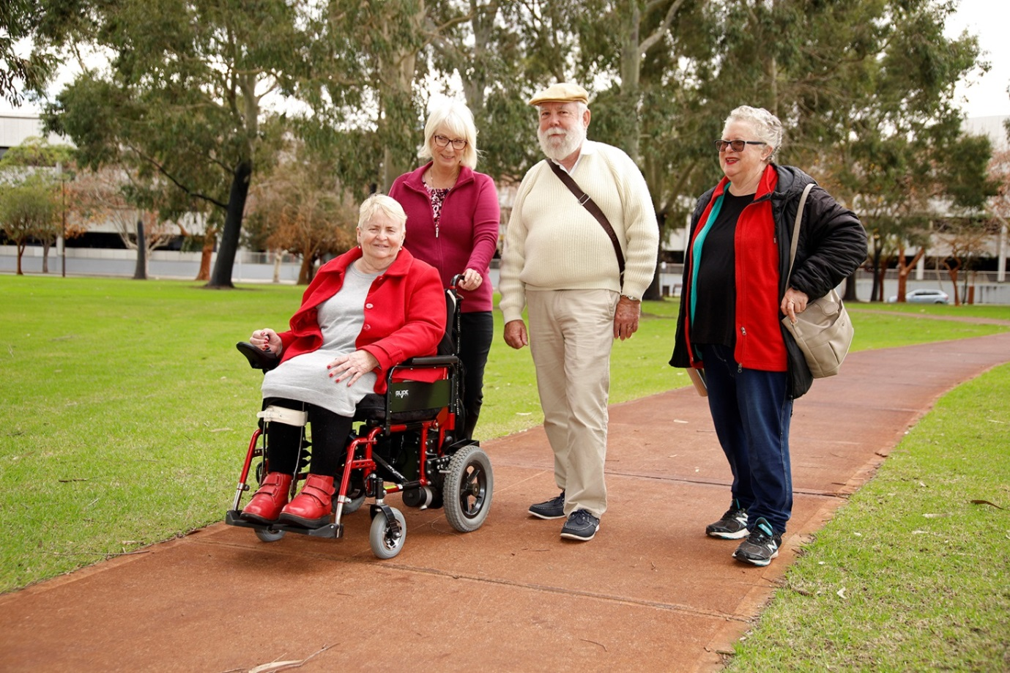

Obesogenic environment
The term ‘obesogenic environment’ has been used to describe an environment that promotes high energy intake and sedentary behaviour among individuals and populations.²⁷ Two main components of this obesogenic environment have been identified: the built environment and the food environment.
In the built environment, circumstances such as the neighbourhood layout, how safe people perceive their neighbourhoods, and access to public open space and public transport can influence people’s likelihood of having an active lifestyle.²⁸ For example, green spaces have been shown to help people maintain physical activity.²⁹, ³⁰ Additionally, evidence suggests exposure to greenspaces has beneficial effects on mental health by reducing stress and providing places for socialisation and social wellbeing among communities, all these factors can impact obesity.²⁸ However, evidence suggests that across five major cities in Australia, including Perth, there is inequitable access to green spaces with people in the lowest-income areas having the least amount of green space.³¹ This reinforces and enhances the negative impacts created by limited financial resources for people living in economic disadvantage, further increasing their likelihood of overweight and obesity.
The food environment encompasses availability and accessibility to food as well as food advertising and marketing. Workplace and school food environments are also considered part of the food environment. Associations between the food environment and its influence on eating behaviour have been established. Evidence suggests that higher proportion of healthy food stores can increase purchase of fruit and vegetable among households located in the same area.³² Likewise, associations between fast food outlet density and weight in children and adolescents are also recognised.²⁸
Socio-cultural factors
Social and cultural practices have an impact on health and wellbeing, and a person or family’s ability to maintain healthy choices. In the evolution of culture, food serves more than a biological need with almost all societies considering food as a mechanism for building community and social connections and relationships.³³ Culture influences the way people live, becoming a strong determinant of energy intake and expenditure. Therefore, an individual’s eating behaviour, activity levels and body weight are highly influenced by their social and cultural environment. ³⁴
The interlinked relationship between food and social activity has been related with both positive and negative eating behaviours. For example, studies have shown that people tend to eat more when eating together.³⁴ However, others argue that attachment to mealtime and eating in the company of others has a positive impact on individual’s overall wellbeing.³⁵ Modelling of food intake is another example of social influence with research showing that people tend to mirror and adapt their food consumption to that of their eating companions. Evidence is even stronger when eating energy-dense snack food. These finding support how norms provided by others have a strong influence on individual’s food intake and choices.³⁶ Modern times have also seen a shift in eating practices with people spending less time eating, composition of meals has been simplified, and overall consumption of take-away meals has increased, all these changes have also been associated with weight gain.³⁵
The existence of these social norms means that people who are trying to make healthy choices can often face difficult social situations where they exert significant amounts of energy on “resisting temptation” or potentially feel disconnected from their social group. This can have a negative impact on their wellbeing and physical health, particularly if they feel they “gave into temptation” and then face internal guilt over their perceived “failure”. In this context of complex and external causes, weight gain is hard to avoid and difficult to reverse for many people.³⁷ The social determinants of health demonstrate that action can and must occur at multiple levels of society (governance, service, and individual and community) for change to be successful.

Policies and economic practices
The environment that a person lives in is determined by the government policies of the day, culture and social norms of their community, and the economic practices of the place they live; all of which impact what a person is exposed to, what they have access to, and how they can utilise the resources around them. For example, modern farming practices and food distribution is governed by the market economy which involves prioritising the needs of the largest population i.e. metropolitan areas.
In Australia, food production mostly occurs in rural areas; however, the processing, manufacture, and packaging of the produce are often completed close to the largest metropolitan centre. This means that city areas often have access to a wide variety of cheaper food while rural and remote areas pay a premium for the same produce as the packaged and ready for sale items must be transported back to communities.³⁸ This is cost effective for companies as they are maximising profits in their largest markets (cities) but has a negative consequence on the health of remote and regional communities. This is particularly relevant for WA given the vast size of the State and the fact that many remote communities are only accessible by boat or plane during the wet season, further increasing transport costs. In this scenario, healthy and perishable items such as fresh fruit and vegetables are more expensive than easy to transport products with long shelf lives such as ultra-processed food that have recently been linked to excess kilojoule intake and weight gain ³⁹. In 2013, fresh fruit was 37.9% more expensive in rural areas than the Perth metropolitan area and dairy was 31% more expensive.⁴⁰ In addition, the quality of fresh fruit and vegetables was poorer in remote communities than the Perth metropolitan area. ⁴⁰
Considering health as part of urban design and planning can support the development of opportunities for regular physical activity and access to healthier food sources. Integration of urban planning, urban design, and transport policies and practices is required at both local and regional levels to reshape communities and neighbourhoods. ⁴¹ The liveable city scorecard reviewed state government urban planning policies related to liveability in Perth.⁴² Some of the main findings include:
- Perth is doing well in: creating smaller, more walkable street blocks; building a small number of walkable communities on its urban fringe; and providing good access to larger neighbourhood and district parks within 400m and 800m of residences.
- Perth is not doing as well in implementing its policies on dwelling density and access to activity centres.
- There are no measurable spatial policies about food environments or for providing walkable access to supermarkets. Only 34% of Perth’s residences are located within 1 km of a supermarket.
- Promoting health and wellbeing is not included among the state objectives of Western Australia’s planning legislation.
Policies can be powerful tools in improving the health of a community and reducing the rate of obesity. For example, the Public Health Act 2016 provides a flexible and proactive framework for the regulation of public health with key features including promoting public health and well-being in the community. Part 5 of the Public Health Act introduces the requirement for the preparation of a local public health plan prepared by each local government in which establishing objectives and policy priorities for promotion, improvement and protection of public health. ⁴³
The Department of Transport also have a team dedicated to the improvement of active transport throughout the metropolitan area to enhance Perth residents’ opportunities for incidental exercise. Your Move is a Department of Transport program that helps people find alternative, active ways to get to and from work, school and around their local community. ⁴⁴

Factors impacting effective action
Numerous factors exist at the governance and service levels that can hinder peoples’ ability to improve their health and wellbeing outcomes and reach a healthier weight. These include:
- Stigmatisation and weight bias
- Equity, access, and care coordination
- Categorising obesity
- Coordinating implementation
The presence of these factors has meant that effective actions that could curb the rise of obesity have often remained disjointed and limited to small local areas; in some cases potential solutions have remained untested or dismissed.

Stigmatisation of people who are overweight or obese
People with overweight and obesity are faced with pervasive stigmatisation and discrimination. Explicit stigma towards people with overweight and obesity is socially acceptable whereas other forms of stigma, such as racism, are publically denounced.⁴⁵ This is due to the stereotype that defines people with overweight and obesity as solely responsible for their weight due to over-eating and laziness and blames them for the resultant ill-health.⁶, ⁴⁶, ⁴⁷
People with overweight and obesity often experience weight stigma from family, friends, co-workers and even health professionals.^{48,49,50} Stigma impacts health professionals’ communication, decision making and treatment of people with overweight and obesity.^{49,50,45} This was evident during consultations where consumers mentioned:
  - “Due to my lack of success [in losing weight], I feel too ashamed to seek help anymore.”
- feeling ashamed for failing to lose weight
- that people assumed they were eating unhealthy foods
- being criticised or threatened by family including partners for not losing weight
- being accused of cheating by their health professional
- receiving simplistic advice to eat less
- feeling embarrassed to go to a gym or exercise in public.⁵¹
In some cases it is incorrectly believed that weight stigma can motivate people to change their behaviours to reduce their weight.^{6,47} However, messages which imply personal blame for excess weight are seen as stigmatising and are less likely to lead to action and risk making the problem worse.⁴⁷ Conversely messages that foster self-efficacy, positive behaviour changes and provide specific behavioural strategies to make the change (such as 2 fruit & 5 vegetables) promote more positive responses and are more likely to lead to action.⁴⁷ In addition, people who experience discrimination internalise the negative messages which increases their risk of mental health issues such as depression.^{49,46,52} Fear of experiencing weight stigma is also not limited to people who are, or perceive themselves to be, overweight or obese. Women of a healthy weight have reported being concerned about becoming overweight because they feared being subjected to weight stigma.⁵³
Stigma can be reduced or avoided and people can achieve optimum health and wellbeing outcomes when they are provided specific advice and support from a health care professional or professionals they perceived as being empathic towards them and their weight journey.⁵⁴ Empathy enhances rapport between people and their chosen health and social care professionals or support person and encourages people to feel comfortable and safe to discuss difficult issues such as obesity.
Stigma is…¹⁸
- A conscious belief or attitude a person is aware they hold
- An automatic attitude or judgement that a person is not fully aware they use to shape the way they treat people
The way stigma is enacted can be clear and obvious or more subtle¹⁸
- Clear examples of stigma include negative comments, public ridicule, portrayal as subjects of jokes in television and movies
- Subtle examples of stigma include physical barriers such as narrow chairs with arms, lack of larger sized blood pressure cuffs, negative assumptions and assertions about a person’s character or capability such as their intelligence or motivation

What does weight stigma look like?
People with overweight or obesity are assumed to lack intelligence and be less healthy, lazy, weak willed, and non-compliant with medical advice. ^{44, 45, 46}
Health professionals have been observed to do the following with people who are over a healthy weight: ^{16, 17, 18}
- Using less person centred language
- Having less respect for people who are overweight or obese
- Spending less time on educating the people they see
- Fail to refer the person to diagnostic testing and preventive screening because they over attribute health issues to a person’s weight

Impact of stigma¹⁸
- Reduced trust in health professionals
- Avoidance of health services due to fear of stigma
- Increased risk of depression, stroke, and other mental and physical health conditions as a result of chronic exposure to stress
- Avoidance of areas/activities where people feel they will be stigmatised e.g. gyms
- Less likely to engage in preventive health behaviours due to fear of stigma
- Feeling devalued as a person
- Become hyper vigilant about monitoring behaviour in public
- Expect poor treatment due to past experience of stigma
- Increase in stress, anxiety and fear

Equity, access and care coordination
There is currently no clearly defined, consistently applied care pathway for the management of overweight and obesity in WA. Services and programs in WA are limited to small, geographically isolated, often short lived programs which largely focus on education related to nutrition and exercise. The Obesity Management Services Inventory ⁵⁵ was conducted as part of the evidence gathering to develop the Action Plan to map existing services in WA. This data was analysed using the Coventry, Aberdeen & London – Refined taxonomy which is a list of behaviour change techniques specifically for weight related interventions.⁵⁶ Evidence from the analysis demonstrates that 88% of the participating programs and services focussed on changes to the individual, mainly knowledge, rather than other aspects involved in behaviour change (such as ingrained habits or psychological support) or social factors impacting weight, and few supported long term behaviour change.⁵⁵
Division of funding of health services between federal and state budgets adds an additional layer of complexity to the access and coordination of services along the continuum from primary to specialist and hospital based health care. These challenges have contributed to the siloed and uncoordinated response to obesity in WA, which has impacted the provision of services, funding models, and the lack of clear referral pathways and an integrated care framework to support the effective provision of tailored and culturally appropriate services and programs to support a person or family with overweight and obesity. For more information, see the Community Consultation Report.

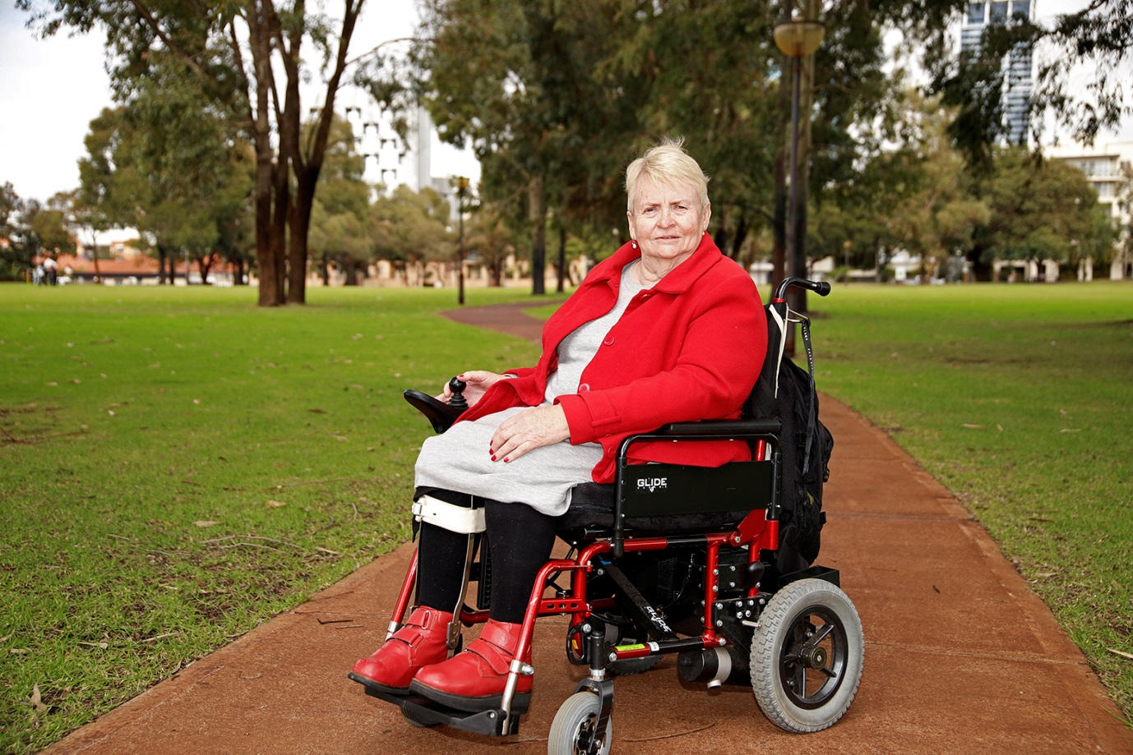

Categorising obesity
There is currently limited agreement across jurisdictions and within the academic literature as to whether obesity is a chronic condition (also referred to as chronic disease) or a risk factor for chronic conditions. Within WA Health it is simultaneously defined as a chronic condition⁵⁷ and a risk factor for chronic conditions.⁵⁸ Defining a health issue as a chronic condition can help to mobilise funding and resourcing to support action in the area.
The Australian Institute of Health and Welfare defines chronic conditions as “long lasting conditions with persistent effects. Their social and economic consequences can impact on peoples’ quality of life.”⁵⁹ The Australian Department of Health similarly identifies that “chronic conditions have complex and multiple causes; are generally long-term and persistent, and often lead to a gradual deterioration of health and loss of independence.”⁶⁰ Given the accuracy with which obesity fits both definitions and the significant impact it has on a person’s and family’s life and their life-long health, the lack of clarity at a national and state level of the status of obesity as a chronic condition can cause frustration and confusion with health and social care professionals and consumers particularly in relation to perceived limitations in funding and access to services and programs. This confusion over the status of obesity may have continued to limit coordinated and integrated care frameworks being developed to effectively address the issue.

Coordinating implementation
Failures to adequately plan, fund and coordinate implementation are often cited as the reason strategies, plans and new initiatives do not deliver on their promises. Key factors that impact the effectiveness of implementation include:
- understanding the social and cultural factors of the community
- consistency of financial support
- clear and credible leadership
- organisational culture
- the political and economic climate.¹¹
Feedback from consultations indicated that irrespective of the condition being addressed, the lack of consistent and sustainable funding was a significant barrier to:
- adequately implementing early intervention and management programs and services
- delivering programs for a sufficient amount of time to show impact
- undertaking monitoring and evaluation to prove value on investment and benefits to the community.
Effective implementation of state-wide strategies and system changes requires a combination of service level and governance level actions. Service level implementation actions ensure outcomes and deliverables are met and include elements such as monitoring of indicators of obesity and the impact of services. Governance level actions can include but are not limited to monitoring of changes such as compliance with policy and procedures to ensure accountability and transparency.¹¹

Effective action is possible
The system of obesity can be overwhelming; however, spheres of influence exist within each sector and at every level of society that allow communities and organisations to make small changes to the factors that are in their control to change. For example, a service provider could alter the type of services they provide their clients, or a government agency can work with a community to design a healthier physical environment that encourages active transport. Changes enacted within each community’s or organisation’s sphere of influence will have a flow on effect to other areas that helps to simplify and address the web of factors that cause obesity. Using this focus, change is possible; when it is coordinated and done together, it will have a broader and faster impact on the complex causes of obesity.
In addition, there are several avenues that provide valuable lessons:
- Reframing the conversation around weight
- Looking at evidence from successful programs around the world
- Reviewing existing guidelines from around the world
- Utilising enablers and untapped opportunities that already exist in WA

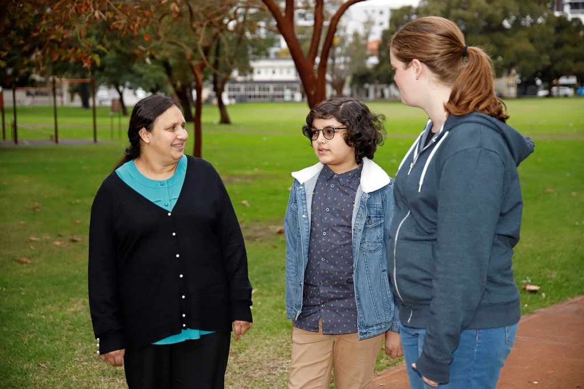

Reframing the conversation
The current momentum of Health at Every Size (HAES) offers a different approach to overweight and obesity. Traditionally, excess weight has been seen as the issue and therefore loss of excess weight has been the focus of health improvement initiatives. However, research has demonstrated that weight loss alone in people who are otherwise healthy does not prolong life.⁶¹ HAES focusses instead on health and wellbeing as the primary motivator for changing behaviours; weight loss is thus reframed as an unintentional bi-product of these changes rather than the goal.⁶², ⁶³ Studies have shown that programs based on HAES principles effectively:⁶²
- reduce psychological distress
- improve psychological indictors such as depression, self-esteem, and body image
- improve eating behaviours and metabolic fitness
- improve cardiovascular health when fitness is a component of the intervention
- improve metabolic health.
In addition, people who participated in HAES based programs maintained their positive behaviour changes longer and often continued to make additional changes in their lives compared to people who undertook a traditional program focussed on nutrition and exercise for weight loss.⁶² This is a significant insight for the future of overweight and obesity related services and programs as long-term behaviour change is difficult to maintain and maintenance of change is frequently cited as a challenge for weight related interventions.⁶⁴

HAES offers an effective alternative for conversations about weight with children and young people to help avoid or minimise the risk of eating disorders as it focusses on body acceptance and behaviour change for health, rather than change to reduce weight.⁶³ However, HAES does have its limitations as it does not acknowledge the added complexity or provide options for groups with a genetic predisposition to obesity nor does it directly acknowledge the clinically significant benefits that can be obtained for people with obesity class II and III that occur with a modest weight reduction of 5-10%.⁶² Modest weight loss has been demonstrated to improve clinical outcomes, particularly for people with diabetes, such as reduced cardiovascular risk factors,⁶⁵ improved insulin sensitivity and clearance, and improved blood pressure.⁶⁶ Acknowledging the potential health benefits is particularly important for people who are at-risk of or currently have obesity related co-morbidities such as cardiovascular disease and type II diabetes.
Instead of choosing one model over another, the value for individuals, families, and the health system will come from integrating HAES and a clinical approach as mutually reinforcing and complementary models for early intervention and weight management services and programs. Components that could be considered in WA’s approach to early intervention and management include:
- promoting body acceptance, particularly in children and young adults
- emphasising behaviour change for the purpose of improving physical and mental health and wellbeing, particularly for people with mental health issues or chronic conditions rather than for the purpose of weight loss
- promoting a modest reduction in weight of 5-10% when clinically appropriate and supporting life-long maintenance of the reduction
- matching appropriate metrics to the purpose of the intervention e.g. measuring risk factors and health outcomes as markers of intervention and participant success rather than weight loss or body mass index (BMI)
- emphasising the importance of meeting people and families where they are at in their health journey, matching interventions to their needs, circumstances, and risk factors, and staging and rewarding improvements from their individual baselines, rather than expecting all people to achieve best-practice health behaviours on their first try.

Evidence from successful healthy weight programs
Effective action to halt the rise of obesity is taking place around the world to varying degrees of success. There are a number of successful cross-jurisdictional programs that exist around the world that WA can use as a guide and learn from to develop an effective plan to address overweight and obesity. For example:
- Ensemble Prévenons l’obésité Des Enfants (EPODE) (English translation, Together Let’s Prevent Childhood Obesity) - currently running in over 500 sites across six countries⁶⁷
- Amsterdam Healthy Weight Program - achieved a 12% reduction in childhood obesity in the first five years (2012 to 2015)⁶⁸
- Henry UK – involves 33 local authorities and over 5,000 parents have participated since 2009. The program has achieved consistent reductions in consumption of high sugar and high fat foods, increases in fruit and vegetable consumption five times per day for parents (from 14% to 33%) and children (from 22% to 44%), and significant reduction in the screen time for children with 80% of children under two years watching less than two hours of television per day (14% increase from baseline).⁶⁹
- New Zealand created the Childhood Obesity Plan^{70, 71} – halted the rise of childhood obesity since 2011/12⁷¹
These programs have certain commonalities that could provide WA with valuable insight to tailoring programs for our communities, including:
- Strong political and local leadership to drive change.
- Clear and consistent evaluation of the program.
- Rigorous evidence base for action.
- Culture of continuous improvement where actions are regularly reviewed and adjusted to meet local need and improve success.
- Co-design of the program elements and methods to align to the needs of the local community.
- Focus on achievable goals around weight loss and optimising health and wellbeing outcomes.

In addition, a study of 74 intervention enablers currently being used around the world found five main principles involved in success:⁷²
- Investment in comprehensive and high impact interventions across obesity prevention and management is seen as highly cost-effective from the perspective of the community.
- Action should occur at all levels using a multipronged and multileveled approach; no single solution will succeed alone.
- The focus of interventions should be broader than community education and personal responsibility; these are components of the solution but by themselves they will not halt the rise of obesity.
- A combination of initiatives that provide quick-wins and long-term outcomes is required particularly when targeting different communities. Not all population groups can be expected to respond to interventions in the same way or in the same time frame, this is particularly true for communities that require significant investment in relationship building.
- Collaboration and coordination is essential for success in reversing the rise of obesity.
The commonalities across programs demonstrate that they are transferable to different locations, countries, cultural groups, and intervention level (prevention to management), thus making them useful guide posts for building a successful multi-levelled, multi-pronged approach to early intervention and management of overweight and obesity for WA.
Additional learning opportunities come from Healthy Together Victoria⁷³ and the Obesity Prevention and Lifestyle (OPAL) program⁷⁴ in South Australia. Both programs have many of the above commonalities; however, significant changes to the political climate and funding significantly limited the implementation of both programs.⁷³, ⁷⁴ While the initial evaluations from OPAL⁷⁴ and the structures of both programs indicate that they could have been effective, their ultimate down scaling demonstrates how fundamental and critical it is to have ongoing political support, strong champions, and sustainable funding to embed programs, create governance and service level changes, and facilitate success. This is supported by a review of the cost-effectiveness of obesity prevention strategies in Australia which stated that “effective action to prevent obesity will not be possible without strong governmental leadership and commitment” and that “successful implementation will require a whole-of-government approach with inter-departmental co-operation and co-ordination.”⁷⁵ With the release of the Sustainable Health Review Final Report, WA currently has an opportunity to establish the strong leadership and sustainable funding required to successfully embed and implement the Action Plan.

Existing guidelines for action
The National Institute for Health and Care Excellence (NICE) United Kingdom (UK) provides consistent and evidence based guidance and advice to the National Health Service to help service providers improve the health and social care they provide to their community. Extensive work has gone into the development of the Weight management: Lifestyle services for overweight or obese adults⁷⁶ and the Weight management: lifestyle services for overweight or obese children and young people⁷⁷ public health guidelines which together provide 33 recommendations for delivering effective care in the early intervention and management space. The guidelines define health services as operating across four tiers:
- Tier 1: universal services focussed on prevention and health promotion.
- Tier 2: lifestyle interventions.
- Tier 3: specialist weight management services.
- Tier 4: bariatric surgery.
Tiers 2 to 4 relate to the scope of the WA Healthy Weight Action Plan 2019-2024.
The 33 recommendations cover six key areas that the WA health system and WAPHA can apply when working to address the system barriers to change and improve early intervention and management services and programs:
- Delivering an integrated care approach that emphasises ongoing supportive conversations about weight and health between health professionals and individuals and facilitates access to services and programs across the four tiers that meet a person’s individual needs.
- Ensuring the community and service providers are aware of and know how to refer people to local services.
- Ensuring access, quality, and accountability for service delivery through:
  - established core quality criteria
  - contracting services based on outcomes measure and ability to meet local needs
  - clear monitoring and evaluation of programs and provision of services across local areas
- Providing clear and consistent information to the community, service providers, and commissioning bodies.
- Ensuring services cause no harm and are non-stigmatising.
- Providing ongoing staff training and education to ensure they are equipped to deliver successful and supportive services to the community.

Enablers and opportunities in WA

Strategic alignment
Action is currently occurring at the state and national levels to change the obesogenic environment and reduce barriers to innovation and collaboration which impact the ability of government agencies and organisations to effectively tackle wicked problems, such as obesity (see Appendix C: Strategic alignment).
The Action Plan complements the work occurring at the national and state levels, particularly the existing positive action to prevention obesity at the whole-of-population level. Population level prevention activities are essential to the success of halting the rise in obesity and supports changes in the social determinants of health. In addition, they will have a significant impact on the success of services and programs that support people at-risk of or currently with overweight and obesity to lead healthier lives. The Action Plan provides the missing link in current action as it focusses effort to change the way our public health system is able to enhance access to services for people with overweight and obesity as part of the landscape of publically to privately funded options.² Action needs to be taken to support these people and families to prevent further weight gain, reduce to a healthier weight, or reduce the impact of obesity-related co-morbidities, and physical and psychological symptoms.
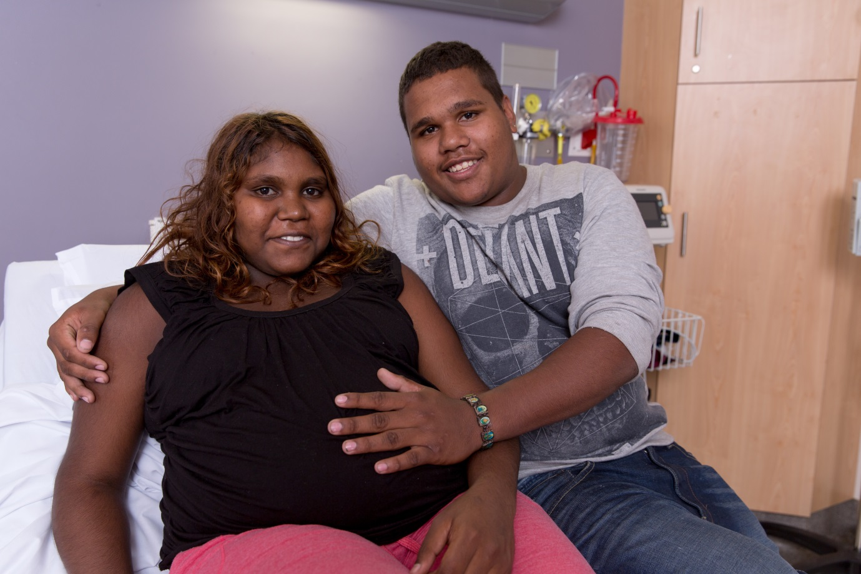
National work on obesity
Nationally, action is being progressed through the development of a National Obesity Prevention Strategy led by the Council of Australian Governments’ Health Council. This supports the actions that were highlighted at the National Obesity Summit on 15 February 2019. This work stemmed from recommendations from the Select Committee into the Obesity Epidemic in Australia’s final report which was released in December 2018.⁷⁸ The Select Committee also recommended action is taken on weight stigma (recommendations 1 and 2) and action focuses on community based interventions that target multiple areas and multiple levels of the causes of obesity (recommendations 18, 19 and 21).⁷⁸ In addition, the implementation plan for the Australian National Diabetes Strategy 2016-2020 contains numerous requirements under Goal 1: Prevent people developing type 2 diabetes that relate to improving the health of people with diabetes through mechanisms that are common to the national and state agenda to reduce obesity.⁷⁹
WA state level work to improve health services
The draft WA Outcomes Framework sets a foundation to build a culture of collaboration and accountability across government agencies.⁸⁰ This culture is essential to successfully tackling wicked and complex problems such as obesity as all areas have a role to play in change. Similarly, the Sustainable Health Review Final Report⁸ sets the framework for sustainable action to improve the way health is delivered in WA. It outlines a number of strategies related to partnerships, workforce, building capacity and co-design which all enable innovative changes to occur in how WA Health plans and delivers care-coordination, jointly funded services and works with the community to tackle obesity more effectively. The following recommendations are most relevant to obesity:⁸
- Recommendation 2a: Halt the rise in obesity in WA by July 2024 and have the highest percentage of population with a healthy weight of all states in Australia by July 2029.
- Recommendation 3: Reduce inequality in health outcomes and access to care.
- Recommendation 10: Develop a partnership between the WA Primary Health Alliance and the Department of Health, and partnerships between Primary Health Networks and Health Service Providers to facilitate joint planning, priority setting and commissioning of integrated care.
The State Public Health Plan for Western Australia outlines the activities that will be undertaken by State government agencies to support Local Government Authorities’ (LGAs) implementation of the Public Health Act 2016. ⁸¹ This Plan supports the establishment of healthy environments, reducing the risk of harm from environmental factors, and improving Aboriginal health and wellbeing by ensure equitable access to culturally appropriate and accessible services. The State Public Health Plan provides the preventive and environmental actions required the will support and complement changes in the early intervention and management space.
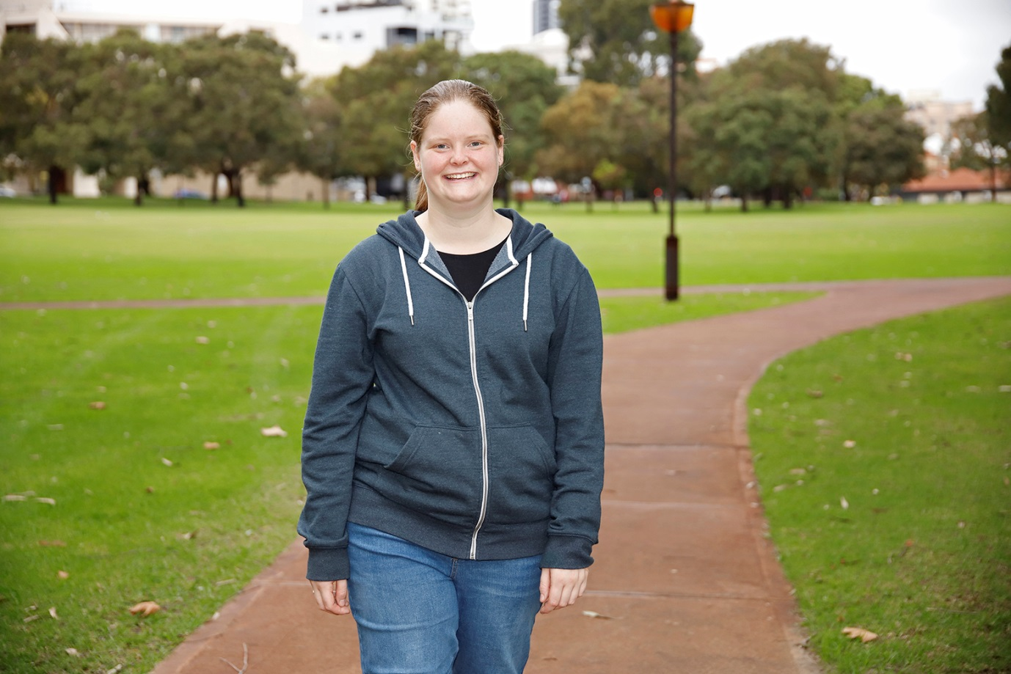
WA state work in obesity prevention
Action is currently taking place to create healthy environments in WA through the WA Health Promotion Strategic Framework 2017 – 2021⁵⁸ and outcomes from the Preventive Health Summit Summary Report.⁸² They seek to impact the obesogenic environment and build a culture of partnerships and co-design to tackle difficult health issues. These frameworks advocate for preventive actions such as:
- Changes to health policy to promote increased physical activity, healthy eating and reduce sedentary behaviour.
- Stopping the sale and promotion of unhealthy food and drink from WA hospitals and other state-owned institutions.
- Support legislative change and regulation such as reducing exposure to marketing and advertising of unhealthy food for children, improving nutrition labelling and information at point of sale.
- Creating supportive environments such as working with local government to develop local public health plans that include measures to address overweight and obesity.
- Improving public awareness and education through mechanisms such as sustained, high-quality state-wide public education campaigns that increase community understanding about the risks of overweight and obesity and motivate behaviour necessary to support achievement and maintenance of a healthy weight.
- Advocating for national level investigation of financial disincentives to reduce unhealthy food consumption such as a levy on sugary drinks.
At a local community level, the Public Health Act 2016 provides direction for LGAs to develop and report on local public health plans for their areas. These plans will cover the actions that LGAs will take to improve the health and wellbeing of their community members which could include action on obesity.⁴³ Public Health Plans could provide a future opportunity to connect work on prevention, and early intervention and management within targeted areas to support a connected health journey.
The state and local government work is supported by existing action within the community and non-government sectors both nationally and at a state level. The Collective for Action on Obesity and the Public Health Advocacy Institute of WA Obesity Advocacy Targets focus on bringing together diverse groups to work in partnership with community members to create a more person-centred and multi-pronged approach to obesity. The Collective for Action on Obesity has developed the Obesity Evidence Hub as a central portal of information for the community on the causes and impact of obesity as well as evidence on effective preventive measures from around the world. This type of community work emphasises the importance of working together as a collective, across organisations and jurisdictions, to shift the culture and social norms to one centred on health and wellbeing.

Existing avenues for action
There are numerous avenues that already exist in primary care, publically funded services, NGO and private sector, MBS items, preventive health, and existing partnerships that can be used for coordinating action on obesity. These existing avenues provide a foundation to build and improve the way services are delivered and coordinated across WA.
WAPHA manages the HealthPathways WA platform which provides General Practitioners (GPs) with evidence based and up-to-date pathways that assist the diagnosis, management and referral for hundreds of conditions. HealthPathways WA provides an existing mechanism that can be utilised to improve management and referrals for overweight and obesity. WAPHA also provides support to general practices to improve the quality of health care through monitoring clinical targets such as the rate of BMI being recorded and the improvement of diabetes indicators. This existing data capture can be leveraged to provide a more complete picture of health care delivery in WA.
Service and program provision can also be enhanced by making use of existing services and funding opportunities across primary care, public, private, and NGO sectors. WA Health directly provides or contracts organisations to provide obesity management services in the community. Current services and programs cover a range of areas including:
- Self-management of chronic conditions that contain a healthy living and weight management component.
- Nutrition and exercise programs: discreet and time limited as well as ongoing GP or nurse practitioner led support.
- Information provision via:
  - post-surgical information sessions on healthy weight, diet, and exercise
  - online resources such as LiveLighter.
- Information, advice, and training opportunities for health and social care services such as child care facilities.
- Parenting and family support through child health nurses, community health nurses, and school health nurses.
- Hospital--based multidisciplinary team service for children.
These services, as well as those that are used for other conditions such as telehealth services to country WA, provide a platform that could be adapted and expanded to support the delivery of coordinated, high quality and timely overweight and obesity management services to people living across WA.
People can also access MBS items to support mental health and chronic disease management that when combined with weight management services could enhance their success. Obesity is not considered a chronic condition under MBS and therefore not eligible for access to subsidised services via the Chronic Disease Management Plan. However, from 1 November 2019, people with anorexia nervosa or other eating disorders can obtain a management plan for up to 40 psychological and 20 dietetic services per year under MBS⁸³ and people with chronic conditions can access support such as dietitians and exercise physiologists.⁸⁴ Both avenues represent opportunities for people with overweight and obesity to access services that can provide health benefits for the management of weight, mental health and chronic conditions.

Workplaces can support their staff to be healthier by accessing support through Healthier Workplace WA. This service is funded by WA Health and delivered by Cancer Council WA to provide free services to WA workplaces to help them implement health and wellbeing programs in the workplace to assist their staff to make positive lifestyle changes.⁸⁵ These resources and services can be used by health and social care services to support staff members who are at-risk of or currently with overweight and obesity to be healthy at work. In turn this may improve their confidence to have weight related conversations with their clients.
Lastly, numerous teams across the WA health system and WAPHA have existing relationships with other government agencies, professional associations, peak bodies, non-government organisations (NGOs), and other key stakeholders that can be leveraged to support sectors to connect better to implement this Action Plan and build momentum to more extensive changes in the future. Working with existing infrastructure and established networks will improve success as well as accelerate the rate at which sustainable change can be achieved.

References
1. Australian Institute of Health and Welfare. Impact of overweight and obesity as a risk factor for chronic conditions: Australian Burden of Disease Study. Australian Burden of Disease Study series no. 11. Cat. no. BOD 12. Canberra: AIHW; 2017.
2. Australian Bureau of Statistics. 4364.0.55.001 - National Health Survey: First Results, 2017-18. Western Australia. Canberra: ABS; 2019.
3. Simmonds M, Llewellyn A, Owen CG, Woolacott N. Predicting adult obesity from childhood obesity: a systematic review and meta-analysis. Obes Rev 2016;17(2):95-107.
4. Tomlin S, Radomiljac A. Health and Wellbeing of Adults in Western Australia 2015, Overview and Trends. Perth: Department of Health, Western Australia; 2016.
5. Australian Institute of Health and Welfare. Overweight and obesity: An interactive insight [Internet]; 2019. [cited 24 April 2019]. Available from: https://www.aihw.gov.au/reports/overweight-obesity/overweight-and-obesity-an-interactive-insight/contents/prevalence
6. Puhl RM, Heuer CA. Obesity Stigma: Important Considerations for Public Health. American Journal of Public Health 2010;100(Framing Health Matters):1019-28.
7. Radomiljac MM. Health and Wellbeing of Children in Western Australia in 2017, Overview and Trends. Perth: Department of Health, Western Australia; 2018.
8. Sustainable Health Review. Sustainable Health Review: Final Report to the Western Australian Government. Perth: Department of Health, Western Australia; 2019.
9. Australian institute of Health and Welfare. Impact of overweight and obesity as a risk factor for chronic conditions: Australian Burden of Disease Study. Canberra: AIHW; 2017.
10. Australian Institute of Health and Welfare. A picture of overweight and obesity in Australia 2017. Canberra: AIHW; 2017.
11. Swinburn BA, Kraak V, Allender S, Atkins VJ, Baker P, Bogard JR, et al. The Global Syndemic of Obesity, Undernutrition, and Climate Change: The Lancet Commission report. The Lancet 2019;393(10173):791-846.
12. Butland B, Jebb S, Kopelman P, McPherson K, Thomas S, Mardell J, et al. Tackling Obesities: Future Choices - Project Report. 2nd Edition. UK: Government Office for Science; 2007.
13. Public Health England. Whole systems approach to obesity: A guide to support local approaches to promoting a healthy weight. London: Public Health England; 2019.
14. National Health and Medical Research Council. Clinical practice guidelines for the management of overweight and obesity in adults, adolescents and children in Australia - Systematic Review. Melbourne: NHMRC; 2013.
15. Thaker VV. Genetic and epigenetic causes of obesity. Adolescent Medicine: State of the Art Reviews 2017;28(2):379-405.
16. Hurtado del Pozo C, Ruiz HH, Arivazhagan L, Aranda JF, Shim C, Daya P, et al. A Receptor of the Immunoglobulin Superfamily Regulates Adaptive Thermogenesis. Cell Reports 2019;28:773-91.
17. Greenway F. Physiological adaptations to weight loss and factors favouring weight regain. International Journal Of Obesity 2015;39:1188-96.
18. MacLean PS, Bergouignan A, Cornier M-A, Jackman MR. Biology's response to dieting: the impetus for weight regain. American Journal of Physiology Regulatory, Integrative and Comparative Physiology 2011;301(3):R581-R600.
19. Duggan M. Beyond the Fragments: Preventing the Costs and Consequences of Chronic Physical and Mental Diseases. Melbourne: Australian Health Policy Collaboration; 2015.
20. Luppino FS, de Wit LM, Bouvy PF, Stijnen T, Cuijpers P, Penninx BW, et al. Overweight, obesity, and depression: a systematic review and meta-analysis of longitudinal studies. Archives of general psychiatry 2010;67(3):220-9.
21. Shrivastava A, Johnston ME. Weight-gain in psychiatric treatment: risks, implications, and strategies for prevention and management. Mens sana monographs 2010;8(1):53.
22. CSDH. Closing the gap in a generation: health equity through action on the social determinants of health. Final Report of the Commission on Social Determinants of Health. Geneva: World Health Organization; 2008.
23. Australian Institute of Health and Welfare. Australia's health 2018. Canberra: AIHW; 2018.
24. Wilkinson RM, Marmot M. Social determinants of health: The solid facts, 2nd edition. Denmark: World Health Organization; 2003.
25. Lee A, Kane S, Ramsey R, Good E, Dick M. Testing the price and affordability of healthy and current (unhealthy) diets and the potential impacts of policy change in Australia. BMC Public Health 2016;16.
26. WA Council of Social Services. Cost of living 2018. Perth: WACOSS; 2018.
27. Swinburn B, Egger G. Preventive strategies against weight gain and obesity. Obesity Reviews 2002;3(4):289-301.
28. Townshend T, Lake A. Obesogenic environments: current evidence of the built and food environments. Perspectives in Public Health 2017;137(1):38-44.
29. Lachowycz K, Jones AP. Greenspace and obesity: a systematic review of the evidence. Obesity Reviews 2011;12(5):e183-e9.
30. Sugiyama T, Giles-Corti B, Summers J, du Toit L, Leslie E, Owen N. Initiating and maintaining recreational walking: a longitudinal study on the influence of neighborhood green space. Preventive Medicine 2013;57(3):178-82.
31. Astell-Burt T, Feng X, Mavoa S, Badland HM, Giles-Corti B. Do low-income neighbourhoods have the least green space? A cross-sectional study of Australia’s most populous cities. BMC Public Health 2014;14.
32. Mason KE, Bentley RJ, Kavanagh AM. Fruit and vegetable purchasing and the relative density of healthy and unhealthy food stores: evidence from an Australian multilevel study. Journal of Epidemiology and Community Health 2013;67(3):231.
33. Rozin P. The meaning of food in our lives: a cross-cultural perspective on eating and well-being. Journal of nutrition education and behavior 2005;37:S107-S12.
34. Sobal J. Social and cultural influences on obesity. International textbook of obesity 2001:305-22.
35. Fischler C. Commensality, society and culture. Social Science Information 2011;50(3-4):528-48.
36. Cruwys T, Bevelander KE, Hermans RC. Social modeling of eating: A review of when and why social influence affects food intake and choice. Appetite 2015;86:3-18.
37. National Health and Medical Research Council. Clinical practice guidelines for the management of overweight and obesity in adults, adolescents and children in Australia. Melbourne: NHMRC; 2013.
38. National Rural Health Alliance. Food security and health in rural and remote Australia. Canberra: Rural Industries Research and Development Corporation,; 2016.
39. Hall KD, Ayuketah A, Brychta R, Cai H, Cassimatis T, Chen KY, et al. Ultra-processed diets cause excess calorie intake and weight gain: an inpatient randomized controlled trial of ad libitum food intake. Cell Metabolism 2019.
40. Pollard C, Savage V, Landrigan T, Hanbury A, Kerr D. Food Access and Cost Survey. Perth: Department of Health; 2015.
41. B Giles Corti HB, P Hooper, A Timperio, T Sugiyama, S Foster. Action area 1: Built environments. 3rd ed ed. Melbourne; 2019.
42. Paula Hooper JR, Lucy Dubrelle Gunn, Melanie Lowe, Jonathan Arundel, Carl Higgs, Rebecca Roberts, Billie Giles-Corti. Creating liveable cities in Australia: A scorecard and priority recommendations for Western Australia. Melbourne; 2018.
43. Government of Western Australia, Department of Health. Public Health Act 2016. Perth: Department of Health; 2016.
44. Department of Transport. Your Move Programs [Internet]: Department of Transport 2018 [updated 2019; cited Available from: https://www.transport.wa.gov.au/activetransport/your-move.asp.
45. Phelan SM, Burgess DJ, Yeazel MW, Hellerstedt WL, Griffin JM, van Ryn M. Impact of weight bias and stigma on quality of care and outcomes for patients with obesity. Obesity Reviews 2015;16:319-26.
46. Puhl RM, Brownell KD. Confronting and Coping with Weight Stigma: An Investigation of Overweight and Obese Adults. oBESITY 2006;14:1802-15.
47. Puhl R, Peterson JL, Luedicke J. Fighting obesity or obese persons? Public perceptions of obesity-related health messages. International Journal Of Obesity 2012:1-9.
48. Lillis J, Luoma JB, Levin ME, Hayes SC. Measuring Weight Self-stigma: The Weight Self-stigma Questionnaire. oBESITY 2010;18(5):971-6.
49. Diversi TM, Hughes R, Burke KJ. The prevalence and practice impact of weight bias amongst Australian dietitians. Obesity Science & Practice 2016:456-65.
50. Mulherin K, Miller YD, Barlow FK, Diedrichs PC, Thompson R. Weight stigma in maternity care: women’s experiences and care providers’ attitudes. BMC Pregnancy and Childbirth 2013;13(1):19.
51. Health Consumers' Council. Is weight a weight on your mind? Perth: HCC; 2018.
52. Dickins M, Thomas S, King B, Lewis S, Holland K. The Role of the Fatosphere in Fat Adults' Responses to Obesity Stigma: A Model of Empowerment Without a Focus on Weight Loss. 2011;21:1679-91.
53. Major B, Hunger JM, Bunyan DP, Miller CT. The ironic effects of weight stigma. Journal of Experimental Social Psychology 2014:74-80.
54. McVay M, Steinberg D, Askew S, Bennett GG. Provider Counseling and Weight Loss Outcomes in a Primary Care-Based Digital Obesity Treatment. J Gen Intern Med 2019;34(6):992-8.
55. Department of Health. Obesity Management Services Inventory findings report (unpublished). Perth; 2018.
56. Michie S, Ashford S, Sniehotta FF, Dombrowski SU, Bishop A, French DP. A refined taxonomy of behaviour change techniques to help people change their physical activity and healthy eating behaviours: The CALO-RE taxonomy. Psychology & Health 2011;26(11):1479-98.
57. Department of Health Western Australia. WA Morbid Obesity Model of Care. Perth: Health Networks Branch, Department of Health, Western Australia; 2008.
58. Chronic Disease Prevention Directorate. Western Australian Health Promotion Strategic Framework 2017-2021. Perth: Department of Health, Western Australia; 2017.
59. Australian Institute of Health and Welfare. Chronic disease [Internet]; 2019. [cited 30 April 2019]. Available from: https://www.aihw.gov.au/reports-data/health-conditions-disability-deaths/chronic-disease/overview
60. Australian Government Department of Health. Chronic conditions [Internet]; 2017. [cited 30 April 2019]. Available from: https://www1.health.gov.au/internet/main/publishing.nsf/Content/chronic-disease
61. Harrington M, Gibson S, Cottrell RC. A review and meta-analysis of the effect of weight loss on all-cause mortality risk. Nutrition Research Reviews 2009;22:93-108.
62. Penney TL, Kirk SFL. The Health at Every Size Paradigm and Obesity: Missing Empirical Evidence May Help Push the Reframing Obesity Debate Forward. American Journal of Public Health 2015;105(5):e38-e42.
63. National Eating Disorders Association. Size diversity and health at every size [Internet]; 2018. [cited 9 May 2019]. Available from: https://www.nationaleatingdisorders.org/size-diversity-health-every-size
64. Dombrowski SU, Knittle K, Avenell A, Araújo-Soares V, Sniehotta FF. Long term maintenance of weight loss with non-surgical interventions in obese adults: systematic review and meta-analyses of randomised controlled trials. BMJ : British Medical Journal 2014;348:g2646.
65. Wing RR, Lang W, Wadden TA, Safford M, Knowler WC, Bertoni AG, et al. Benefits of Modest Weight Loss in Improving Cardiovascular Risk Factors in Overweight and Obese Individuals With Type 2 Diabetes. Diabetes Care 2011;34:1481-6.
66. Magkos F, Fraterrigo G, Yoshino J, Luecking C, Kirbach K, Kelly SC, et al. Effects of Moderate and Subsequent Progressive Weight Loss on Metabolic Function and Adipose Tissue Biology in Humans with Obesity. Cell Metabolism 2016;23:591-601.
67. Borys JM, Bodo LY, Jebb SA, Seidell JC, Summerbell C, Richard D, et al. EPODE approach for childhood obesity prevention: methods, progress and international development. Obesity Reviews 2012;13:299-315.
68. City of Amsterdam. Amsterdam will become the Healthiest City for Children! Review 2012-2017 Part 2. 2017.
69. Willis TA, Roberts KPJ, Berry TM, Bryant M, Rudolf MCJ. The impact of HENRY on parenting and family lifestyle: A national service evaluation of a preschool obesity prevention programme. Public Health 2016;136:101-8.
70. Ministry of Health. Childhood obesity plan [Internet]; 2019. [cited 19 August 2018]. Available from: https://www.health.govt.nz/our-work/diseases-and-conditions/obesity/childhood-obesity-plan
71. Ministry of Health. New Zealand Health Survey - Key Indicators [Internet]; 2019. [cited 30 March 2019]. Available from: https://minhealthnz.shinyapps.io/nz-health-survey-2017-18-annual-data-explorer/_w_0811ceee/_w_08f54417/_w_243d8400/#!/key-indicators
72. Dobbs R, Sawers C, Thompson F, Manyika J, Woetzel J, Child P, et al. Overcoming obesity: An initial economic analysis. Discussion paper.: McKinsey Global Institute; 2014.
73. Underhill G, Sloane A, McCracken J, Hoye E, Kelly M, Longeri R, et al. Healthy together Mildura: Evaluation paper 2012-2016. Mildura: Mildura Rural City Council; 2016.
74. Bell L, Ullah S, Leslie E, Magarey A, Olds T, Ratcliffe J, et al. OPAL evaluation project final report: OPAl phase 1 and 2. South Australia: Flinders University; 2016.
75. Ananthapavan J, Sacks G, Brown V, Moodie M, Nguyen P, Barendregt J, et al. Assessing cost-effectiveness of obesity prevention policies in Australia: ACE-Obesity Policy. Melbourne: Deakin university; 2018.
76. NICE UK. Weight management: lifestyle services for overweight or obese adults. UK: NICE UK; 2014.
77. NICE UK. Weight management: lifestyle services for overweight or obese children and young people. UK: NICE UK; 2013.
78. Senate. T. Select Committee into the Obesity Epidemic in Austalia. Final Report. Canberra: Commonwealth of Australia; 2018.
79. Australian Health Ministers' Advisory Council. Diabetes in Australia: Focus on the future. Canberra: Australian Government; 2017.
80. WA Council of Social Services. Outcomes framework WA Draft [Internet]; 2019. [cited 21 March 2019]. Available from: http://www.wacoss.org.au/wp-content/uploads/2018/10/WA-Outcome-Frameworks-DRAFT.pdf.
81. Department of Health. State Public Health Plan for Western Australia: Objectives and policy priorities for 2019-2024. Perth: Department of Health; 2019.
82. Department of Health, Mental Health Commission, Healthway. WA Preventative Health Summit: Action on Obesity and Alcohol Summary Report. Perth: Government of Western Australia; 2018.
83. Australian Government Department of Health. Eating Disorders Working Group of the Medicare Benefits Schedule Review Taskforce [Internet]; 2019. [cited 30 April 2019]. Available from: https://www1.health.gov.au/internet/main/publishing.nsf/Content/MBSR-committees-eating-disorders-working-group
84. Australian Government Department of Health. Chronic Disease Management (formerly Enhanced Primary Care or EPC) — GP services [Internet]; 2014. [cited 30 April 2019]. Available from: https://www1.health.gov.au/internet/main/publishing.nsf/Content/mbsprimarycare-chronicdiseasemanagement
85. Cancer Council WA. About Healthier Workplace WA [Internet]; 2017. [cited 9 May 2019]. Available from: https://healthierworkplacewa.com.au/about-hwwa/
86. Government of Western Australia. Health Services Act 2016. Perth: Government of Western Australia; 2016.
87. World Health Organization. Body mass index - BMI [Internet]; 2019. [cited 30 March 2019]. Available from: http://www.euro.who.int/en/health-topics/disease-prevention/nutrition/a-healthy-lifestyle/body-mass-index-bmi
88. Child and Adolescent Health Service. Body Mass Index assessment - Child Health. Perth: Child and Adolescent Health Service; 2018.
89. Padwal RS, Pajewski NM, Allison DB, Sharma AM. Using the Edmonton obesity staging system to predict mortality in a population-representative cohort of people with overweight and obesity. Canadian Medical Association Journal 2011;183(14):E1059-E66.

Glossary
Early intervention | Provision of support or interventions to an individual person or family at-risk of developing overweight (at the high end of the healthy weight range) to prevent a foreseeable decline in their health.
Health at every size (HAES) | HAES acknowledges that well-being and healthy habits are more important than weight. The main components of HAES are intuitive eating, body acceptance, and physical activity for health rather than to shape the body.⁶²
Health Service Provider | A Health Service Provider is established by an order made under section 32(1)(b) of the Health Services Act 2016.⁸⁶
Management | Provision of support or interventions to a person or family with overweight or obesity that will enhance health and wellbeing outcomes, prevent further weight gain or support weight loss. Management services can incorporate a range of social, psychological, medical and surgical assistance delivered by a range of professionals and peer supports in an integrated care framework.
Obesogenic environment | Factors in the community (such as surroundings, opportunities and conditions of life) that promote obesity in individual or populations.
Prevention | Improving the health of the WA population by facilitating behaviour change and creating healthier environments across the community.
Social Determinants of Health | The WHO defines social determinants as “the circumstances in which people grow, live, work, and age, and the systems put in place to deal with illness. The conditions in which people live and die are, in turn, shaped by political, social, and economic forces.”²²
Sphere of influence | The reach of the influence of a person or organisation based on their formal authority, and social and professional networks.
System | A system is a collection of interdependent components where the whole is greater than the sum of its parts; when one component of a system is changed other parts of the system are impacted.¹³
Systems approach | Viewing a problem or issue as a system rather than the result of a single cause or isolated activity. Stakeholders working collectively to create change in the system.

Acronyms
BMI | Body mass index
EPODE | Ensemble Prévenons l’obésité Des Enfants (English translation, Together Let’s Prevent Childhood Obesity)
GP | General Practitioner
HAES | Health at every size
LGA | Local Government Authorities
MBS | Medicare benefits schedule
NICE | National Institute for Health and Care Excellence
OPAL | Obesity Prevention and Lifestyle Program
WAPHA | WA Primary Health Alliance
WHO | World Health Organization

Appendices

Appendix A: Defining overweight and obesity
A number of measures are used to determine a person’s level of overweight and obesity, including:
- BMI⁸⁷
- Growth percentile charts⁸⁸
- Waist circumference¹⁰
- Edmonton Obesity Scaling System.⁸⁹
BMI is the most common method of measuring overweight and obesity for adults and is used in combination with the growth percentile charts for children aged 2 years and above. BMI has limitations such as inability to detect between lean and fat tissue, and inability to account for differences in body composition between ethnic groups which might require different cut off points.³⁷ However, BMI is a satisfactory proxy for fat mass for the majority of the population.
For the purposes of the Action Plan, BMI is the primary classification system that has been used when defining overweight and obesity. However, it is acknowledged that BMI should be used as a guide in combination with other forms of clinical assessment and in conversation with the person or family about their broader social, economic and health circumstances that impact their health.
BMI for adults⁸⁷  BMI Classification  < 18.5 Underweight  18.5–24.9 Healthy weight  25.0–29.9 Overweight  30.0–34.9 Class I obesity  35.0–39.9 Class II obesity  ≥ 40.0 Class III obesity | Growth percentile ranges for children 2 years and above⁸⁸  Percentile Classification  < 5th Underweight  5th to <85th Healthy weight  85th <95th Overweight  ≥ 95th Obese | Waist circumference that indicates an increased risk of chronic disease in adults¹⁰  Men >94cm  Women >80cm

Appendix B: Infographic references
1. Australian Bureau of Statistics. 4364.0.55.001 - National Health Survey: First Results, 2017-18. Overweight and obesity. Canberra: ABS; 2019.
2. Epidemiology Branch. Overweight and obesity trends in WA children using the WA Health and Wellbeing Surveillance System, 2002-2016. Perth: WA Department of Health; 2018.
3. Epidemiology Branch. Obesity and perceptions of body weight in WA adults using the WA Health and Wellbeing Surveillance System, 2016. Perth: WA Department of Health; 2018.
4. Tomlin S, Radomiljac A. Health and Wellbeing of Adults in Western Australia 2015, Overview and Trends. Perth: Department of Health, Western Australia; 2016.
5. Butland B, Jebb S, Kopelman P, McPherson K, Thomas S, Mardell J, et al. Tackling Obesities: Future Choices - Project Report. 2nd Edition. UK: Government Office for Science; 2007.
6. Wilkinson RM, Marmot M. Social determinants of health: The solid facts, 2nd edition. Denmark: World Health Organization; 2003.
7. Scalley B, Xiao J, Somerford P. The cost of excess body mass to the acute hospital system in Western Australia: 2011. Perth: Department of Health, Western Australia; 2013.
8. Australian Institute of Health and Welfare. Impact of overweight and obesity as a risk factor for chronic conditions: Australian Burden of Disease Study. Australian Burden of Disease Study series no. 11. Cat. no. BOD 12. Canberra: AIHW; 2017.
9. Dickins M, Thomas S, King B, Lewis S, Holland K. The Role of the Fatosphere in Fat Adults' Responses to Obesity Stigma: A Model of Empowerment Without a Focus on Weight Loss. 2011;21:1679-91.
10. Puhl RM, Heuer CA. Obesity Stigma: Important Considerations for Public Health. American Journal of Public Health 2010;100(Framing Health Matters):1019-28.
11. Goettler A, Grosse A, Sonntag D. Productivity loss due to overweight and obesity: a systematic review of indirect costs. BMJ Open 2017;7(10).
12. Australian Institute of Health and Welfare. A picture of overweight and obesity in Australia 2017. Canberra: AIHW; 2017.
13. Haby MM, Markwick A, Peeters A, Shaw J, Vos T. Future predictions of body mass index and overweight prevalence in Australia, 2005-2025. Health Promot Int 2012;27(2):250-60.

Appendix C: Strategic alignment

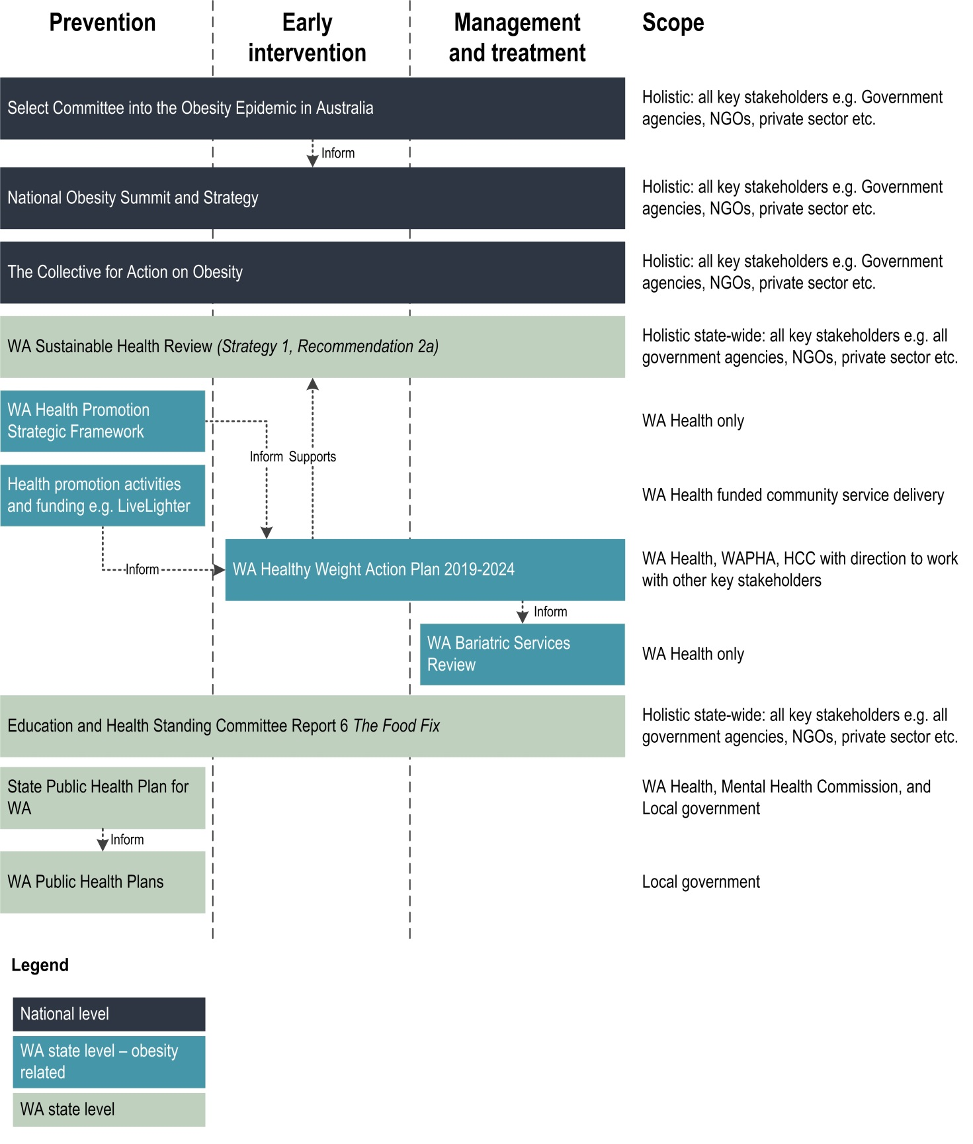

This document can be made available in alternative formats
on request for a person with disability.
© Department of Health 2019
Copyright to this material is vested in the State of Western Australia unless otherwise indicated. Apart from any fair dealing for the purposes of private study, research, criticism or review, as permitted under the provisions of the Copyright Act 1968, no part may be reproduced or re-used for any purposes whatsoever without written permission of the State of Western Australia.

