Foodborne disease surveillance and outbreak investigations in Western Australia, third quarter 2017

**Enhancing foodborne disease surveillance across Australia**



**Communicable Disease Control Directorate**



OzFoodNet, Communicable Disease Control Directorate

**Acknowledgments**

Acknowledgement is given to the following people for their assistance with the activities described in this report: the staff from PathWest Laboratory Medicine WA; Mr John Coles and other staff from the Food Unit of the Department of Health, Western Australia; Public Health Nurses from the metropolitan and regional Public Health Units; and Local Government Environmental Health Officers.

**Contributors/Editors**

Niki Foster, Nevada Pingault and Barry Combs

Communicable Disease Control Directorate

Department of Health, Western Australia

PO Box 8172

Perth Business Centre

Western Australia 6849

Email: [OzfoodnetWA@health.wa.gov.au](mailto:OzfoodnetWA@health.wa.gov.au)

Telephone: (08) 9388 4999

Facsimile: (08) 9388 4877

Web:

OzFoodNet WA Health [www.public.health.wa.gov.au/3/605/2/ozfoodnet_enteric_infections_reports.pm](http://www.public.health.wa.gov.au/3/605/2/ozfoodnet_enteric_infections_reports.pm)

OzFoodNet Department of Health

[www.ozfoodnet.gov.au/](http://www.ozfoodnet.gov.au/)

**Disclaimer**:

Every endeavour has been made to ensure that the information provided in this document was accurate at the time of writing. However, infectious disease notification data are continuously updated and subject to change.

This publication has been produced by the **Department of Health, Western Australia**.

# Executive summary

During the third quarter of 2017 (3Q17), the Western Australian (WA) OzFoodNet team conducted surveillance of enteric diseases, undertook investigations into outbreaks and was involved with ongoing enteric disease research projects. The most common notifiable enteric infections in WA were campylobacteriosis (n=852), salmonellosis (n=484), rotavirus infection (n=74) and shigellosis (n=51) (Figure 1). Notifications of campylobacteriosis were 29% higher, salmonellosis were 74% higher, and shigellosis were 254% higher than the 5-year third quarter mean (3QM). Rotavirus infections were 42% lower than the 3QM. The large increase in salmonellosis was primarily driven by the increase in *S.* Typhimurium MLVA type 03-17-09-12-523 notifications. The large increase in shigellosis was primarily due to a large increase in *Shigella flexneri* 2B with most cases of this serotype occurring in the Goldfields (35%), Pilbara (26%) and Kimberley (19%) regions. There were 13 foodborne outbreaks investigated in the third quarter, 11 of which were due to *S.* Typhimurium and six of these were associated with consumption of dishes made with eggs. The number of foodborne outbreaks in the 3Q17 was nearly fourfold higher than the third quarter 5-year mean (n=3.4). OzFoodNet also conducted surveillance of 42 non-foodborne outbreaks. Of these, the most common mode of transmission was person-to-person (35 outbreaks), with a total of 931 people ill. Norovirus was the most commonly reported pathogen in these outbreaks (identified in 17 outbreaks).

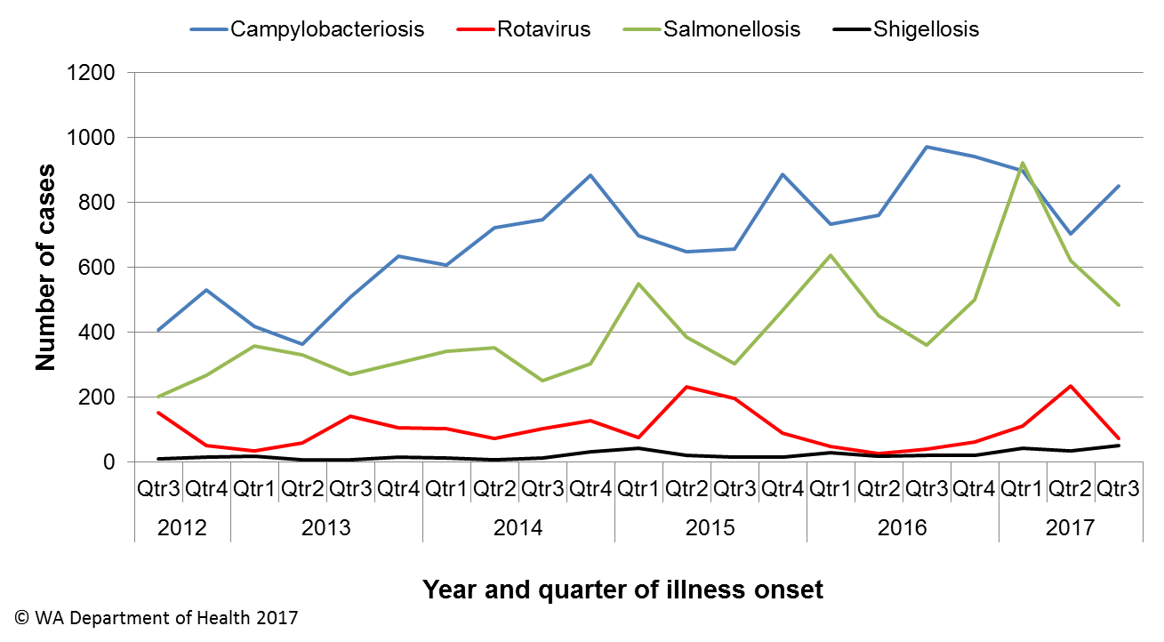

Figure 1 Notifications of the four most common enteric diseases by quarter from 2012 to 2017, WA

**Table of Contents**

Executive summary 2

1 Introduction 6

2 Incidence of notifiable enteric infections 7

2.1. Methods 7

2.2. Campylobacteriosis 7

2.3. Salmonellosis 8

2.4. Rotavirus infection 10

2.5. Shigellosis 10

2.6. Other enteric diseases and foodborne illness 11

3 Foodborne and probable foodborne disease outbreaks 13

3.1. Bakery outbreak, *Salmonella* Typhimurium (outbreak code 042-2017-022) 13

3.2. Private residence outbreak, *Salmonella* Typhimurium (outbreak code 042-2017-023) 14

3.3. Takeaway outbreak, unknown pathogen (outbreak code 07/17/MDJ) 14

3.4. Place of worship outbreak, *Salmonella* Muenchen (outbreak code 042-2017-024) 15

3.5. RCF outbreak, *Salmonella* Typhimurium (outbreak code 042-2017-026) 15

3.6. Childcare centre outbreak, *Salmonella* Typhimurium (outbreak code 042-2017-025) 15

3.7. Bakery outbreak, *Salmonella* Typhimurium (outbreak code 042-2017-027) 16

3.8. Ethnic group community function outbreak, *Salmonella* Typhimurium (outbreak code 042-2017-028) 16

3.9. Hospital outbreak, *Salmonella* Typhimurium (outbreak code 042-2017-029) 17

3.10. Café outbreak, *Salmonella* Typhimurium (outbreak code 042-2017-030) 18

3.11. Restaurant outbreak, *Salmonella* Typhimurium (outbreak code 042-2017-031) 18

3.12. Burger restaurant outbreak, *Salmonella* Typhimurium (outbreak code 042-2017-032) 18

3.13. Restaurant outbreak, *Salmonella* Typhimurium (outbreak code 042-2017-033) 19

4 Cluster investigations 19

4.1. *Salmonella* Typhimurium PFGE 0001, PT 9 19

4.2. *Salmonella* Typhimurium MLVA 03-17-09-12-523 21

4.3. *Shigella flexneri* 2Bin the Goldfields region 23

5 Non-foodborne disease outbreaks and outbreaks with an unknown mode of transmission 24

5.1. Person-to-person outbreaks 25

5.2 Outbreaks with unknown mode of transmission 25

5.3 Animal-to-person outbreaks (outbreak code 081-2017-005) 26

6 Site activities 26

7 References 27

**List of Tables**

Table 1 Number of campylobacteriosis notifications, 3rd quarter 2017, WA, by region 8

Table 2 Number of salmonellosis notifications, 3rd quarter 2017, WA, by region 9

Table 3 Number of rotavirus notifications, 3rd quarter 2017, WA, by region 10

Table 4 Number of shigellosis notifications 3rd quarter 2017, WA, by region 11

Table 5 Summary of number of notified cases of enteric notifiable diseases in WA in the third quarter 2017 compared to historical means 13

Table 6 Outbreaks with non-foodborne transmission, 3rd Quarter 2017, WA 24

**List of Figures**

Figure 1 Notifications of the four most common enteric diseases by quarter from 2012 to 2017, WA 2

Figure 2 Notifications of *Salmonella* Typhimurium PFGE 0001 in WA, 2013 to September 2017 21

Figure 3 Notifications of *Salmonella* Typhimurium MLVA 03-17-09-12-523 in WA, 2016 to Sep 2017 23

Figure 4 Notifications of *Shigella flexneri* 2B in WA, Jan to Sep 2017, by public health regions 24

**Notes:**

1. All data in this report are provisional and subject to future revision.
2. To help place the data in this report in perspective, comparisons with other reporting periods are provided. As no formal statistical testing has been conducted, some caution should be taken with interpretation.

Copyright to this material is vested in the State of Western Australia unless otherwise indicated. Apart from any fair dealing for the purposes of private study, research, criticism or review, as permitted under the provisions of the Copyright Act 1968, no part may be reproduced or re-used for any purposes whatsoever without written permission of the State of Western Australia.

# Introduction

It has been estimated that there are 5.4 million cases of foodborne illness in Australia each year at a cost of $1.2 billion per year1. This is likely to be an underestimate of the total burden of gastrointestinal illness as not all enteric infections are caused by foodborne transmission. Other important modes of transmission include person-to-person, animal-to-person and waterborne transmission. Importantly, most of these infections are preventable through interventions at the level of primary production, commercial food handling, households and institution infection control.

This report describes enteric disease surveillance and investigations carried out during the third quarter of 2017 by OzFoodNet WA, other WA Department of Health (WA Health) agencies and local governments. Most of the data are derived from reports by doctors and laboratories to WA Health of 16 notifiable enteric diseases. In addition, outbreaks caused by non-notifiable enteric infections are also documented in this report, including norovirus, which causes a large burden of illness in residential (mostly aged) care facilities (RCF) and the general community.

OzFoodNet WA is part of the Communicable Disease Control Directorate (CDCD) within WA Health, and is also part of the National OzFoodNet network funded by the Commonwealth Department of Health2. The mission of OzFoodNet is to enhance surveillance of foodborne illness, including investigating and determining the cause of outbreaks. OzFoodNet also conducts applied research into associated risk factors and develops policies and guidelines related to enteric disease surveillance, investigation and control. The OzFoodNet site based in Perth is responsible for enteric disease surveillance and investigation in WA.

OzFoodNet WA regularly liaises with staff from: Public Health Units (PHUs); the Food Unit in the Environmental Health Directorate of WA Health; and PathWest Laboratory Medicine WA.

PHUs are responsible for a range of public health activities, including communicable disease control, within their respective administrative regions. The PHUs monitor RCF gastroenteritis outbreaks and provide infection control advice. The PHUs also conduct follow-up of sporadic cases of important enteric diseases including typhoid, paratyphoid and hepatitis A.

The Food Unit liaises with Local Government (LG) Environmental Health Officers (EHO) during the investigation of food businesses. PathWest Laboratory Medicine WA provides public health laboratory services for the surveillance and investigation of enteric disease.

# Incidence of notifiable enteric infections

## Methods

Enteric disease notifications were extracted from the Western Australian Notifiable Infectious Diseases Database (WANIDD) by optimal date of onset (ODOO) for the time period 1st July 2012 to 30th September 2017. The ODOO is a composite of the ‘true’ date of onset provided by the notifying doctor or obtained during case follow-up, the date of specimen collection for laboratory notified cases, and when neither of these dates is available, the date of notification by the doctor or laboratory, or the date of receipt of notification, whichever is earliest. Rates were calculated using estimated resident population data for WA from Rates Calculator version 9.5.5 (WA Health, Government of Western Australia), which is based on 2011 census data. Rates calculated for this report were annualised (rates for the quarter multiplied by four) and have not been adjusted for age.

## Campylobacteriosis

Campylobacteriosis was the most commonly notified enteric disease in WA during the third quarter of 2017 (3Q17), with 852 notifications and a rate of 126 cases per 100 000 population per year (Table 1). There was a 29% increase in campylobacteriosisnotifications in the 3Q17 compared with the 5-year third quarter mean (3QM) of 658 notifications. The increase appeared to be due to sporadic disease, as there were no identified *Campylobacter* outbreaks during the 3Q17. At least some of the increase is likely to be due to the introduction by one large private pathology laboratory of polymerase chain reaction (PCR) testing of faecal specimens, which has greater sensitivity than culture techniques.

The place of acquisition of infection was reported for 54% (n=457) of cases, of which 74% (n=340) were locally acquired and 25% (n=114) were acquired overseas.

Table 1 Number of campylobacteriosis notifications, 3rd quarter 2017, WA, by region



**\***Percentage change in the number of notifications in the current quarter compared to the historical 5-year mean for the same quarter. Positive values indicate an increase when compared to the historical 5-year mean of the same quarter. Negative values indicate a decrease when compared to the historical 5-year mean of the same quarter. Percentage change should be interpreted with caution when the number of cases is small.

## Salmonellosis

Salmonellosis was the second most commonly notified enteric disease in WA in the 3Q17, with 484 notifications and a rate of 71 cases per 100 000 population per year (Table 2). The number of salmonellosisnotifications in the 3Q17 was 74% higher than the 3QM (n=278), with substantial increases seen in most PHUs.

Place of acquisition of infection was reported for 80% (n=387) of cases, of which 70% (n=272) were locally acquired, 29% (n=113) were acquired overseas and 0.5% (n=2) were acquired interstate.

The most commonly reported *Salmonella* serotype was *S*. Typhimurium (STM) (n=239, 49%), and of those cases with information on place of acquisition (n=207, 87%), 96% of cases (n=198) were locally acquired. Pulsed-field gel electrophoresis (PFGE) was previously used for subtyping of STM in WA, but as of the beginning of 2016, multi locus variable number tandem repeat analysis (MLVA) has replaced PFGE. The most common MLVA types for 3Q17 were 03-17-09-12-523 (n=88, 37%, PFGE type 0043), 03-12-11-10-523 (n=20, 8%, PFGE type 0039), 03-14-09-11-523 (n=15, 6%, PFGE type 0039), 03-17-10-12-523 (n=12, 5%, PFGE type 0043) and 03-25-19-11-523 (n=10, 4%, PFGE type 0001). The MLVA type 03-17-09-12-523 emerged in the 4Q16 and has been associated with a number of point source outbreaks (Sections 3 and 4). The MLVA type 03-14-09-11-523 emerged in this quarter and was associated with a point source outbreak (Section 3).

Table 2 Number of salmonellosis notifications, 3rd quarter 2017, WA, by region



**\***Percentage change in the number of notifications in the current quarter compared to the historical 5-year mean for the same quarter. Positive values indicate an increase when compared to the historical 5-year mean of the same quarter. Negative values indicate a decrease when compared to the historical 5-year mean of the same quarter. Percentage change should be interpreted with caution when the number of cases is small.

NA: not applicable as there is a 0 value in the calculation for the 3rd quarter % change

*S*. Enteritidis was the second most common *Salmonella* serotype (n=54, 11%), with most (n=50, 92%) cases acquired overseas, primarily after travel to Indonesia (n=42, 84%), and almost exclusively to Bali.

*S.* Paratyphi B bv Javawas the next most common serotype (n=25), and of those cases with known place of acquisition, 25% of cases were acquired in WA and 75% were acquired overseas. There were 20 notifications of *Salmonella* that had no serotype. Most (60%) of these notifications were from one laboratory that first uses PCR screening for enteric pathogens. Specimens that are subsequently culture-negative remain as a “PCR only” notification. Eighteen cases of *S.* Stanley were notified in the 3Q17, and of those cases with known place of acquisition, 62% were acquired overseas and 38% were locally acquired.

## Rotavirus infection

In the 3Q17 there were 74 notifications of rotavirus infection (11 cases per 100 000 population per year), a 42% decrease compared with the 3QM (Table 3). Notifications were predominantly seen in the metropolitan area. There were decreases in notifications in most public health regions with the greatest proportional decreases occurring in the Kimberley and Pilbara regions. Of the cases with known Aboriginality status, 96% of cases were non-Aboriginal people and 4% were Aboriginal people. The median age was 4 years old (range <1 years to 87 years).

Table 3 Number of rotavirus notifications, 3rd quarter 2017, WA, by region



*Percentage change in the number of notifications in the current quarter compared to the historical 5-year mean for the same quarter. Positive values indicate an increase when compared to the historical 5-year mean of the same quarter. Negative values indicate a decrease when compared to the historical 5-year mean of the same quarter. Percentage change should be interpreted with caution when the number of cases is small.

NA: not applicable as there is a 0 value in the calculation for the 3rd quarter % change

## Shigellosis

In the 3Q17 there were 51 culture-positive shigellosis notifications (8 cases per 100 000 population per year), 254% higher than the 3QM (n=14.4) (Table 4). The place of acquisition of infection was reported for 75% (n=38) of cases, and of these, 74% (n=28) were acquired in WA.

*Shigella flexneri* was the most commonly notified species (34/51; 67%), with 31 cases of *S. flexneri* 2B, one case of *S. flexneri* 4A, and two cases where serotyping was not performed. There were also 17 cases of *S. sonnei*, including 12 *S. sonnei* biotype G, three *S. sonnei* biotype A, and two *S. sonnei* biotype F.

Of the 51 notified cases, 30 (59%) were Aboriginal people and 21 (41%) were non-Aboriginal people. Cases in the Goldfields region accounted for 27% (n=14) of *Shigella* cases in 3Q17; this cluster investigation is detailed in Section 4.3. The public health regions with the next highest number of cases was the North Metropolitan region (n=9) and the Pilbara region (n=8).

Table 4 Number of shigellosis notifications 3rd quarter 2017, WA, by region



**\***Percentage change in the number of notifications in the current quarter compared to the historical 5-year mean for the same quarter. Positive values indicate an increase when compared to the historical 5-year mean of the same quarter. Negative values indicate a decrease when compared to the historical 5-year mean of the same quarter. Percentage change should be interpreted with caution when the number of cases is small.

NA: not applicable as there is a 0 value in the calculation for the 3rd quarter % change

## Other enteric diseases and foodborne illness

During the 3Q17, other enteric disease notifications included:

* **Cryptosporidiosis:** There were 39 cryptosporidiosis notifications in 3Q17, an 11% increase compared to the 3QM (Table 5). The place of acquisition of infection was reported for 79% (n=31) of cases of which 77% (n=24) were locally acquired.
* **Hepatitis A infection:** Three hepatitis A cases were notified in 3Q17, with one case each acquiring their infection overseas in Indonesia, India and Pakistan.
* **Yersiniosis:** There were three cases of culture-positive yersiniosis notified in 3Q17.
* **Shiga toxin *E. coli* (STEC):** Thirteen cases were notified in 3Q17 compared to the 3QM of 2.2 cases. Prior to 2016, STEC was only diagnosed in one laboratory and this was by culture. The increase in cases in 3Q17 was likely due to the introduction in 2016 of PCR testing for STEC on stool samples with bloody diarrhoea at that laboratory and PCR testing of any stool sample on request at another laboratory. The thirteen cases included 9 females and four males, ranging in age from 3-87 years (median 43 years). Eleven cases had an acute illness with a specific onset date, with four cases reporting bloody diarrhoea. Two cases had no acute illness, with one case having abdominal pain for the month prior to specimen collection and the other case had pruritus ani but no diarrhoea prior to specimen collection. Six cases with acute illness were overseas acquired, with two cases travelling to Bali, and one case each reporting travel to Thailand, Cambodia, Costa Rica and Iran. The remaining five cases were locally acquired.
* **Typhoid fever:** Four cases, all acquired overseas. Two cases had travelled to India and a single case each had travelled to Indonesia and Estonia.
* ***Vibrio parahaemolyticus*:** Four *V. parahaemolyticus* cases all acquired overseas. Three cases had gastrointestinal infections acquired in Vietnam (n=1) or Indonesia (n=2). One case had a wound infection acquired in the Philippines.
* **Hepatitis E:** One case that had travelled to Singapore during their incubation period.
* **Cholera:** One case of *V. cholera* O1 Ogawa var El Tor that had travelled to Thailand. Case required massive rehydration.
* **Listeriosis:** One case in an 88 year old female. No immunocompromising conditions or medications noted. Case had eaten a small number of high risk foods during their incubation period.

There were no notifications for HUS, paratyphoid fever or botulism in the third quarter.

Table 5 Summary of number of notified cases of enteric notifiable diseases in WA in the third quarter 2017 compared to historical means



NA: not applicable as there is a 0 value in the calculation for the 3rd quarter % change

# Foodborne and probable foodborne disease outbreaks

There were 13 foodborne or probable foodborne outbreaks investigated in this quarter. The number of foodborne outbreaks in the 3Q17 was nearly fourfold higher than the third quarter 5-year mean (n=3.4).

## Bakery outbreak, *Salmonella* Typhimurium (outbreak code 042-2017-022)

Five cases of STM MLVA 03-17-09-13-523 had independently eaten foods from a bakery in common during their incubation period. Two cases were from the same family and the other three cases were from separate households. There were three males and two females, with a median age of 80 (range 13-82 years). Onsets of illness were from 2/6/17 to the 12/6/17 and median duration of diarrhoea was seven days. Two cases had eaten custard cannoli, one had an apple turnover with cream, one case reported eating pies and a few unspecified cakes and one cases reported eating a custard tart with fruit. Bakery items were cooked in a factory and delivered to the bakery. The EHO did not find any significant non-compliances at either food premises. The implicated food items from a batch later than what was eaten by cases were negative for *Salmonella*. This MLVA type is very similar to MLVA 03-17-09-12-523 which has been associated with other point source outbreaks and implicated foods were egg dishes. Two brands of eggs were used to make the custards. Mode of transmission was probable foodborne.

## Private residence outbreak, *Salmonella* Typhimurium (outbreak code 042-2017-023)

All three members of a family from two households fell ill with gastroenteritis symptoms and were diagnosed with STM MLVA 03-17-10-12-523 after eating raw muffin mix at a residence on 10/7/17. All cases were male, aged 4-31 years. The parent of two cases was interviewed. The third person could not be contacted. Symptoms included diarrhoea (2/2), bloody diarrhoea (1/2), fever (2/2), abdominal pain (2/2), lethargy (2/2), vomiting (2/2) with duration of diarrhoea 7 days and onsets 6 pm 10/7/17 and very early morning 11/7/17. All three cases were hospitalised. A formal environmental investigation was not conducted because the outbreak setting was a private residence. However, the remaining eggs from the carton and sections of the carton containing dried egg fragments were collected for testing. Both samples were positive for the outbreak strain of *Salmonella*. No further information could be obtained regarding how the muffin mix was prepared. Mode of transmission was foodborne.

## Takeaway outbreak, unknown pathogen (outbreak code 07/17/MDJ)

Of 53 people attending a birthday party at a restaurant on the 17/7/17, nine developed gastroenteritis. Two staff who were working at the restaurant also developed gastroenteritis. The median incubation period was 33 hours with 90% of cases reporting vomiting, 60% had diarrhoea, and a median duration of diarrhoea of 24 hours. One patron was diagnosed with norovirus. Food consumed at the restaurant included burgers (either beef, chicken or mushroom), hotdogs, macaroni and cheese croquettes, chicken wings, chips, squid, water, soft drinks and alcohol. Doughnuts were purchased by the birthday person and served at the party. The two staff members became ill 7.5 hours and 28 hours after the start of the function. The only food that was statistically associated with illness was eating the doughnuts (Odds Ratio not defined, lower confidence interval 2.48, upper confidence interval not defined, P value=0.006). All ill patrons ate the doughnuts and 7/17 (41%) of well people ate the doughnuts. It is unclear who handled the doughnuts prior to them being eaten. One ill staff member reported eating a beef burger on the 17/11/17 and no doughnuts and the other ill staff reported eating no food at the restaurant. Transmission was probable foodborne for the people who attended the birthday party.

## Place of worship outbreak, *Salmonella* Muenchen (outbreak code 042-2017-024)

Six cases of *S.* Muenchen were notified in July. PFGE analysis identified 5 cases with an indistinguishable profile. These five cases were interviewed. All cases were of the same religion and 4/5 cases were strict vegetarians. 4/5 cases attended the same place of worship, with 3/4 attending on the same day, with food served after prayers. One case attended the place of worship the following week, but didn't eat food. 4/5 cases ate fresh ginger during incubation period, which was unusual compared to historical WA *Salmonella* cases. The EHO inspection of the food preparation areas at the place of worship did not identify any concerns. Mode of transmission was probable foodborne.

## RCF outbreak, *Salmonella* Typhimurium (outbreak code 042-2017-026)

In a RCF, 10 of 59 residents became ill with gastroenteritis and eight were diagnosed with STM MLVA 03-17-09-12-523. No staff were ill. The onsets of illness were from 21-24/8/17, with four residents hospitalised and one diagnosed resident death. This *Salmonella* type is the most common type in WA and the hypothesis for the cause of illness is eating egg dishes. The menu for residents was examined for dishes that may have caused illness. The RCF manager reported that there was a strong likelihood that ill residents and other well residents ate scrambled eggs on the 20/8/2017. The scrambled eggs were prepared from shell eggs (WA egg producer) and pasteurised eggs (non-WA egg producer). This WA egg producer has been implicated in three other outbreaks due to this *Salmonella* type associated with egg dishes and the non-WA-egg producer has been implicated in one other outbreak due to this *Salmonella* type associated with an egg dish. An environmental investigation at the facility found that the reported cooking temperatures should have been sufficient to kill any *Salmonella* in scrambled eggs. The *Salmonella* transmission was probable foodborne.

## Childcare centre outbreak, *Salmonella* Typhimurium (outbreak code 042-2017-025)

There were 12/50 children (babies and toddlers) and 3/10 staff from a childcare centre ill with gastroenteritis, and in total 11 were diagnosed with STM MLVA 03-14-09-11-523. Onset of illness for one staff member who worked in the babies room was the 31/7/17. There were also nine children and two staff (one was the cook) with onsets from 11-14/8/17 and three children had onsets on 23/8/17, 1/9/17 and 19/9/17.

The nine children and two staff who were ill between 11-14/8/17 indicated a point source outbreak and transmission was probable foodborne. The day in common that the nine children attended was Wednesday 9/8/17. The incubation period was 3.4 days. One of the staff ill during this period was the centre cook. On that Wednesday, the implicated food served was pikelets, as the frying pan was not operating properly (either too hot or too cold), the pikelets sat on the bench for 7 hours prior to eating, the pikelets contained eggs and the cook ate the same batch of pikelets that were served to the toddlers and babies. Another batch of pikelets was served to the kindy children and they were not ill. The exposure was unknown for the staff member who was ill 31/7/2017 and person-to-person transmission was suspected for the three children ill between the 23/8-19/9/17.

## Bakery outbreak, *Salmonella* Typhimurium (outbreak code 042-2017-027)

Three cases of STM MLVA 03-12-11-10-523 had independently eaten croissant type pastries, with two purchased from a bakery in common on 25/7/17 and 27/7/17. One case described the food as a croissant and the other as a cruffin (a cross between a croissant and a muffin) and filled with custard. These two cases were both female and aged 34 and 35 years. The incubation period was one day. One other case, a 22 year old male, purchased a custard filled croissant from another retail outlet on the 30/7/17 and reported a one day incubation period. The croissants served at the bakery were also sold at the other retail outlet. Two cases had bloody diarrhoea and one case was hospitalised. Eggs were used to make the custard which was reported to be cooked to 80oC. The eggs used in the preparation of the custard were from a WA egg producer also implicated in other outbreaks due to the same type of *Salmonella*. More recent batches of custard filled croissant and eggs were tested and were negative for *Salmonella*. The transmission was probable foodborne.

## Ethnic group community function outbreak, *Salmonella* Typhimurium (outbreak code 042-2017-028)

At least five people out of 80 became ill after eating at a home-catered ethnic group community function on 5/8/17. Of these five people, two were diagnosed with STM 03-17-09-12-523. The diagnosed cases were not known to each other. All five ill people were females, with a median age of 39. All cases had diarrhoea, vomiting, fever, nausea, and abdominal pain, and one had bloody diarrhoea. None were hospitalised. The median incubation period was 1 day. A list of dishes that were served was obtained from the organiser. This included pork, fish, chicken, beef, goat, and offal dishes, dried anchovies, a variety of vegetable dishes, nshima, rice, a potato dish, and cassava leaves. There were no desserts served and no dishes contained eggs. The chickens served (n=50) were spent layer chickens that were purchased live from a WA egg producer. Eggs from this farm had been used by food businesses in three previous point source outbreaks of this MLVA type. The chickens were slaughtered and prepared for cooking at a private residence by a group of approximately 12 people the day before. These chickens contained eggs which were discarded. The chickens were cooked by boiling then frying the following morning. The other dishes were also prepared at this time. The food was eaten at this residence and served at a second residence at 3 pm. Ill people were not confined to the group who prepared the chickens nor the group that prepared the dishes. A structured questionnaire was completed by 17 people who attended the function, including five people who developed gastroenteritis symptoms. No food was statistically associated with illness. All cases and 92% of controls ate the chicken dish and the beef dish. People who helped prepare the food (60%) were no more likely to have been ill than people who did not (83%). An environmental investigation was not conducted because the outbreak setting was a private residence. Mode of transmission was probable foodborne.

## Hospital outbreak, *Salmonella* Typhimurium (outbreak code 042-2017-029)

3/8 residents at an aged care facility attached to a hospital were ill with diarrhoea. Case age ranged from 90 to 95 years and all cases were female. Two cases with onset on 11/9/17 were positive for STM MLVA 03-25-17-11-523 and one of these cases died. The remaining case, whose onset was 1/9/17, tested negative for *Salmonella*. This case was in respite care from 29-30/8/17. Two of the ill residents had a normal diet and the third had a pureed diet. An environmental investigation of the kitchen was conducted 20/9/17. Two food samples and seven environmental samples were negative for *Salmonella*. No significant deficiencies were noted during inspection. This MLVA type is analogous with PFGE 0001, an STM subtype causing an ongoing outbreak in WA over the last couple of years (Section 4.1). PFGE 0001 has been strongly associated with eating raw or undercooked eggs, particularly with eggs from a specific WA egg producer. The environmental investigation observed that the hospital purchased eggs from this WA egg producer and eggs were used by the kitchen to make bread and butter pudding, scrambled eggs, and fish patties served during the incubation period. The vehicle for this outbreak was unknown. The mode of transmission was probable foodborne.

## Café outbreak, *Salmonella* Typhimurium (outbreak code 042-2017-030)

Four people, including three diagnosed with STM 03-17-09-12-523, became ill with diarrhoea in August 2017 after eating food from the same café during their incubation period. Two cases were female and two were male. Median age was 39 years. Onset dates were between 7/8/17 and 20/8/17. Median duration of diarrhoea was 8 days. One person was hospitalised as a result of their illness. The cases were from three independent groups that dined at the café on 4/8/17 and 19/8/17. Foods eaten included a chicken roll, ham and cheese focaccia, and Caesar salad with runny egg. Local government inspected the food business but no suspect foods were available for sampling. The EHO could not find evidence that raw egg sauces were made at the premises. The egg brand used at the café was unknown. The vehicle for this outbreak was unknown. The mode of transmission was probable foodborne.

## Restaurant outbreak, *Salmonella* Typhimurium (outbreak code 042-2017-031)

Two diagnosed cases of STM MLVA 03-26-16-12-523 from two independent groups ate food from the same restaurant during their incubation period. The first case was the only one ill from a group of four who ate takeaway food from the restaurant on 25/8/17 and leftovers on 26/8/17. This case had the omelette. The second case had chicken chow mien, satay beef and fried rice on 31/8/17. This was shared with their mother who did not become ill. Onset dates were 28/8/17 and 3/9/17, respectively. Duration of diarrhoea was 11-17 days. Both cases reported bloody diarrhoea. Neither case was hospitalised. This outbreak was referred to local government for investigation whereby food processing compliance matters were noted. Samples of food preparation surfaces, containers and utensils were collected and tested negative for *Salmonella*. In addition, local government investigated the egg supplier to the food business since eggs were provided in used cartons, and the food business reported that the eggs were not stamped, were dirty and had thin shells. The seller was confirmed as a registered seller for a WA egg producer. The egg producer was subsequently inspected by the local government and a list of improvements was provided to the business. The restaurant was advised to ensure the source of their food was from a reputable supplier, and to ensure high safety standards whilst handling high risk product, including eggs. Mode of transmission was probable foodborne.

## Burger restaurant outbreak, *Salmonella* Typhimurium (outbreak code 042-2017-032)

Two diagnosed cases of STM MLVA 03-17-09-12-523 from two independent groups ate food from the same burger bar during their incubation period. The first case dined in a group of four at the restaurant on 4/8/17. Two people became ill (second case not tested) with illness onset on 6/8/17. The two ill people had not dined together in the week prior to this meal. They were the only people in the group who had egg in their burgers. The second diagnosed case dined with work colleagues at the restaurant on 31/7/17, with onset of illness on 8/8/17. This case could not recall whether they had an egg in their burger. No others in this group reported illness. This outbreak was referred to local government. The local government confirmed the venue made their own raw egg sauces, but denied serving eggs with their burgers, contradicting information from a case. The brand of eggs used by the food business at the time was not recorded by the business so is unknown. Samples of raw egg aioli and Caesar sauces were collected and tested negative for *Salmonella*. The food business was advised to substitute raw egg sauces with pasteurised egg. Mode of transmission was probable foodborne.

## Restaurant outbreak, *Salmonella* Typhimurium (outbreak code 042-2017-033)

Four cases of STM MLVA 03-12-11-10-523 in two groups had eaten at a restaurant in common. Median incubation period was 22 hours, with one person hospitalised. In one group, four friends who had not met for some time had lunch at the restaurant on 13/9/17. The food eaten in common with the three ill persons was a shared runny chocolate soufflé. The fourth person who was not ill had no dessert. The case from another group of five people was at the restaurant for lunch on the 17/9/17 and the other four did not become ill. The case and another person of the group were served fish with salad and raw egg mayonnaise. The EHO reported that the chocolate soufflé was served with ice cream and was cooked to order in an oven at 185oC for 20 minutes. No internal temperature checks were conducted by the chef and it is unlikely that this was sufficiently cooked as the centre was quite molten. Eggs used in the soufflé were from a WA egg producer. The transmission was probable foodborne.

# Cluster investigations

There were two ongoing and one new cluster investigations during the third quarter of 2017.

## *Salmonella* Typhimurium PFGE 0001, PT 9

Since the beginning of 2014, there has been an ongoing investigation of a community-wide outbreak in WA of notifications of MLVA types analogous to STM PFGE 0001 (Figure 2). PFGE 0001 includes multiple MLVA types. This has been the largest *Salmonella* outbreak ever investigated in WA. From January 2014 to June 2017 there were 1054 cases notified, which includes 35 cases with onset dates in the 3Q17. Of the 35 cases, six were part of three point source outbreaks (see sections 3.9, 3.11, and 5.2 [outbreak 042-2017-034]). The remaining 29 cases, comprising 59% males and 41% females, ranged in age from 1-86 years (average 34 years), and most (97%) resided in the Perth metropolitan area.

From January 2015 there have been 21 point source outbreaks due to STM PFGE 0001 and of these, egg dishes have been the implicated food in 17 outbreaks. Raw or undercooked eggs were part of the implicated dishes for 12 outbreaks, and in five outbreaks, eggs such as fried/poached eggs were served as part of the meals. In 13 of these outbreaks, the egg producer was known. In seven outbreaks, eggs were from a single WA egg producer, and in one outbreak each, eggs were from three separate WA egg producers and two non-WA egg producers. Eggs from these producers are available in WA retail outlets.

Independent of the outbreak investigations, samples have been collected from eggs, egg laying chickens and retail chicken meat. STM PFGE 0001 has been isolated on five occasions (between October 2015 and November 2016) from eggs or egg laying chickens from one WA egg producer, twice from another WA egg producer (June 2014 and June 2016) and twice from a third WA egg producer (May 2015 and January 2017). Eggs from all three of these egg producers have been implicated in outbreaks. Retail chicken meat sampled in September 2014 was also positive for PFGE 0001.

From February 2015 to March 2016, non-point source outbreak cases (community cases) were investigated as part of a case-control study of STM PFGE 0001 illness. Final analysis of the case control data showed that eating raw eggs was statistically associated with illness.

This evidence suggests eating raw/runny eggs is the cause of STM PFGE 0001 point source outbreaks in WA and it is very likely the cause of many of the community cases.

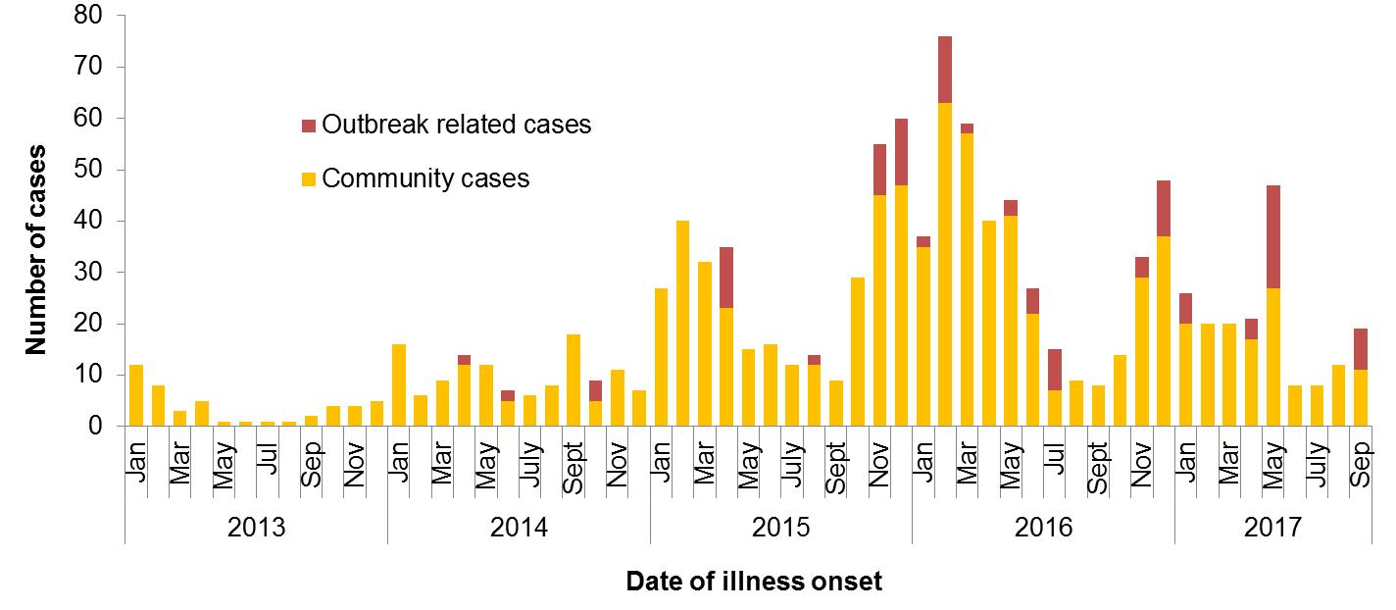

Figure 2 Notifications of *Salmonella* Typhimurium PFGE 0001 in WA, 2013 to September 2017

## *Salmonella* Typhimurium MLVA 03-17-09-12-523

STM MLVA 03-17-09-12-523 has been under investigation since the type emerged in 2016 following a single case in September (see 4Q16 report). From September 2016 to September 2017 there were 595 cases notified including 88 cases in 3Q17 (Figure 3). This MLVA type was the single most common MLVA type in 3Q17 constituting 37% of STM notifications for the quarter. Of the 88 cases, 14 (16%) were part of four point source outbreaks. These outbreaks are detailed in Section 3. The remaining 74 cases, comprising 45% males and 55% females, ranged in age from <1-79 years (median 19 years), and most (86%) resided in the Perth metropolitan area. Hospitalisation data was confirmed for 63 community cases; 24% were hospitalised.

Since September 2016, egg dishes were the implicated food vehicle in eight of 13 point source outbreaks of STM 03-17-09-12-523. In 3Q17, the food vehicle was unknown for two outbreaks, and chickens and burgers were the implicated food vehicles for the remaining two outbreaks. In one of the outbreaks where the vehicle could not be determined, scrambled eggs using a previously implicated egg brand were available to RCF residents during their incubation period. In the outbreak where chickens were implicated, these had been sourced live from a laying farm. Eggs from this farm had been used by food businesses in three previous point source outbreaks of this MLVA type. In the outbreak where burgers were implicated, raw egg sauces were used at the restaurant, however the brand of eggs used was unknown.

Of the 74 3Q17 cases not part of these point source outbreaks, 63 were interviewed regarding egg consumption; 73% reported consuming eggs in their incubation period, 19% had not and 8% were unsure. Of the 37 interviewed cases that ate eggs at home, 54% could not recall the egg brand they ate during their incubation period. Several different egg brands were reported by the remaining cases including the brands of eggs implicated in the point source outbreaks.

In 3Q17, a representative sample of 26 isolates related to this investigation was submitted to NSW reference laboratory ICPMR for whole genome sequencing and single nucleotide polymorphism (SNP) analysis. This included clinical isolates from ten point source outbreaks of STM 03-17-09-12-523 and closely related MLVA types (03-20-09-12-523, 03-17-09-11-523 and 03-16-09-12-523), eight community cases of STM 03-17-09-12-523 who reported a variety of egg brands or egg sources and one case who did not recall eating eggs during their incubation period, and four non-clinical isolates (three of STM 03-17-09-12-523 and one of STM 03-20-09-12-523) . All isolates were the same SNP type, defined by the laboratory as ≤10 SNPs difference between isolates, suggesting a recent common ancestor. This supports the hypothesis that community cases and point source cases are related and that illness is very likely due to a common exposure (e.g. egg consumption) or exposure to products with a common source of contamination. The results also support the interpretation of these different MLVA types as genetically closely related.

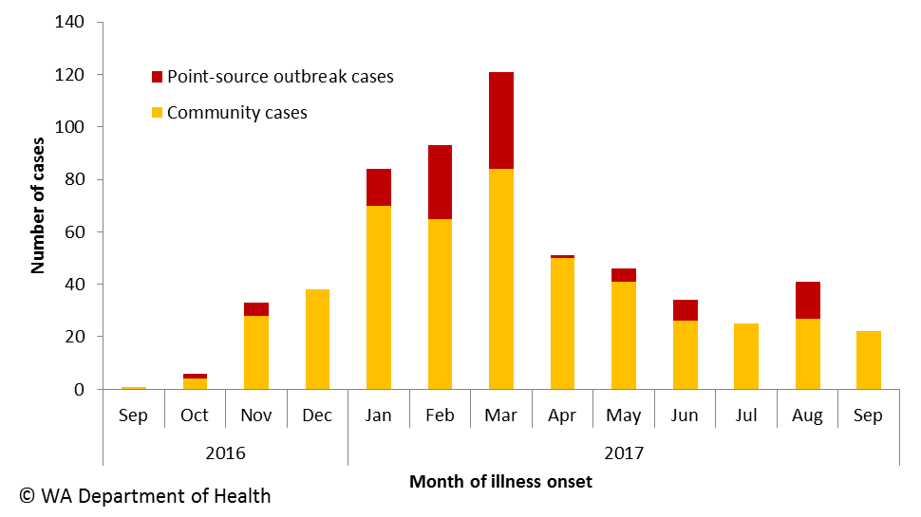

Figure 3 Notifications of *Salmonella* Typhimurium MLVA 03-17-09-12-523 in WA, 2016 to Sep 2017

## *Shigella flexneri* 2Bin the Goldfields region

In 3Q17 there were 31 cases of *Shigella flexneri* 2B notified (Figure 4). These occurred primarily in the Goldfields region (11 cases), the Pilbara region (8 cases) and the Kimberley region (6 cases). This followed 9 cases of *S. flexneri* 2B in WA (four in Goldfields and five in Kimberley) in 2Q17 and none in 1Q17. Three of the Goldfields cases in 2Q17 were in the same town where it was common for people from the community to visit the Northern Territory. The Northern Territory and South Australia also reported increases in *Shigella*, including *S. flexneri* 2B, in 2Q17 and 3Q17.

Of the 11 cases of *S. flexneri* 2B in the Goldfields in 3Q17, all (100%) were Aboriginal people including 45% males and 55% females. The median age was 13 (range 2-63 years). The place of acquisition was known for 6 (55%), and of these cases, all were acquired in WA. Cases were from several towns or communities across the region. Limited information was obtained regarding exposures as cases could not be contacted by the PHU. Transmission was likely person-to-person. Both the Goldfields and Kimberley PHUs engaged local EHOs for health promotion efforts, and circulated an alert to local clinicians encouraging testing of symptomatic patients, treatment of diagnosed cases, exclusion of cases from school, childcare and workplaces until diarrhoea-free for 24 hours, and promoting hand hygiene and appropriate waste disposal.

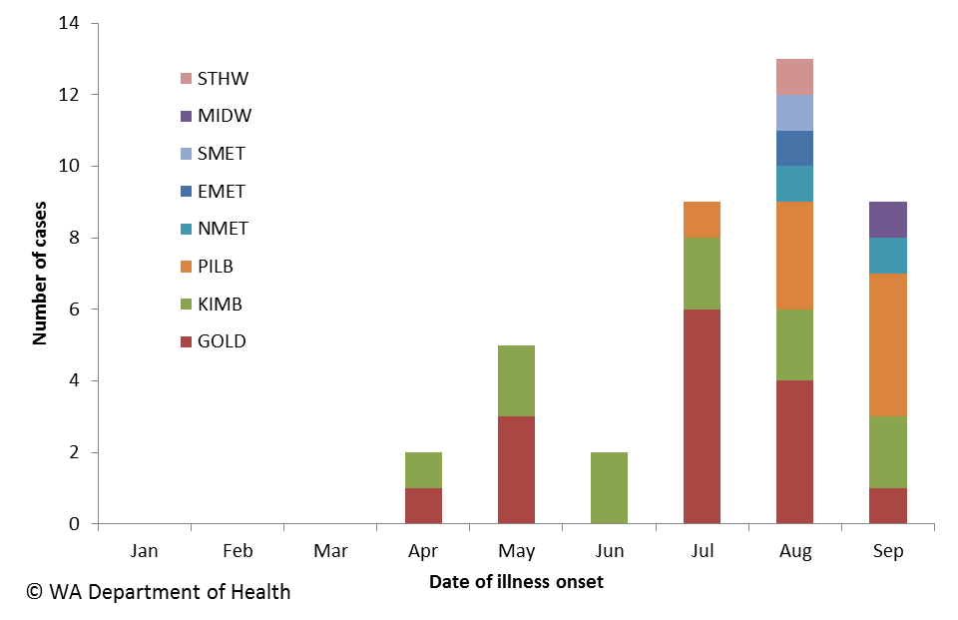

Figure 4 Notifications of *Shigella flexneri* 2B in WA, Jan to Sep 2017, by public health regions

# Non-foodborne disease outbreaks and outbreaks with an unknown mode of transmission

There were 42 outbreaks of enteric disease in this quarter that appeared to be non-foodborne (Table 6). Of these, 35 outbreaks were ascribed to person-to-person transmission, 6 outbreaks had an unknown mode of transmission and one outbreak was due to animal-to-person transmission. A total of 971 people were affected in these 42 outbreaks, with 14 reported hospitalisations.

Table 6 Outbreaks with non-foodborne transmission, 3rd Quarter 2017, WA



1 Deaths temporally associated with gastroenteritis, but contribution to death not specified

## Person-to-person outbreaks

In the 35 non-foodborne outbreaks that were suspected to be due to person-to-person transmission, 23 (66%) outbreaks occurred in RCFs, eight (23%) were in child care centres, three (8%) were in hospitals and one (3%) was in a school. The causative agent for 17 (48%) outbreaks was confirmed as norovirus. The remaining 18 (52%) outbreaks were of unknown aetiology as specimens were either not collected (n=11), were negative for common bacterial and viral pathogens (n=6), or were negative for common bacterial pathogens but no viral tests were done (n=1).

A total of 931 people were affected in these 35 outbreaks, with 12 people hospitalised. The number of person-to-person outbreaks in the 3Q17 was comparable to the third quarter 5-year mean (n=32).

## 5.2 Outbreaks with unknown mode of transmission

There were six outbreaks in this quarter with an undetermined mode of transmission, with 38 people ill and one reported hospitalisation. Three of these outbreaks were in RCFs, where the predominant or only symptom was diarrhoea. These outbreaks were unlikely to be caused by norovirus due to no or limited vomiting reported. In two of the three outbreaks, the specimens collected were negative for common bacterial and viral pathogens; in one outbreak no specimens were collected.

Two of these outbreaks were in child care centres.

1. Two cases of *S*. Typhimurium MLVA 03-25-19-11-523 at a common childcare centre with illness onsets on 31/8/17 and 14/9/17 (outbreak code 042-2017-034). Both had bloody diarrhoea with median diarrhoea duration of 6.5 days. There were no other children or staff reporting gastroenteritis during this period. One of the cases attended five days per week and the other attended Tuesday to Thursday. Prior to the children’s illness the facility had egg laying chickens that roamed the facility. The chickens first arrived in July 2016 and were removed on 19/9/17. The local council EHO recommended the removal of the chickens after the facility manager reported the *Salmonella* illness to the EHO. This *Salmonella* type has been associated with two point source outbreaks and the implicated foods were egg dishes. The case with the first date of onset ate well cooked eggs.
2. Eleven children and one staff member were predominantly ill with vomiting. Onset dates ranged from 16/7/17 to the 17/7/17. While one case with diarrhoea was diagnosed with STM MLVA 03-12-11-10-523, this may not have been related to the centre outbreak.

One outbreak was in a hospital where five patients and one staff member were ill with diarrhoea. Onset dates ranged from 7/9/17 to the 10/9/17. Specimens collected were negative for common bacterial and viral pathogens.

## 5.3 Animal-to-person outbreaks (outbreak code 081-2017-005)

Two cases of *Cryptosporidium* were diagnosed in university students who attended an animal husbandry practical. One case had a co-infection with STEC. The course co-ordinator was provided with fact sheets for distribution to students on risk of disease transmission while handling animals.

# Site activities

During the third quarter of 2017, the following activities were conducted at the WA OzFoodNet site:

* Ongoing surveillance of foodborne disease in WA.
* Replied to media enquiries following an article about Cryptosporidiosis associated with waterparks published in Communicable Diseases Intelligence Volume 41 Issue 2, June 2017.
* Replied to media enquiries into the increase in enteric disease notifications in 2017.
* Monitoring culture-independent nucleic acid amplification diagnostic testing in private laboratories and impact on notification rates.
* Investigation of 13 foodborne or probable foodborne outbreaks.
* Investigation and monitoring of 35 person-to-person gastroenteritis outbreaks, one outbreak with animal-to-person transmission and six outbreaks with unknown mode of transmission.
* Ongoing investigation of community-wide increases in STM PFGE 0001 and MLVA 03-17-09-12-523, and investigation of a cluster of *Shigella flexneri* 2B.
* Interviewing *Salmonella* Enteritidis cases regarding travel status and attempting to identify risk factors in locally acquired cases.
* Participation in the Foodborne Illness Reduction Strategy Across-Government Advisory Group
* Participation in combined Food Unit, OzFoodNet and PathWest meetings to help improve surveillance and investigation.
* Participation in monthly national OzFoodNet teleconferences.
* Provided information on diarrhoea-only outbreaks of unknown aetiology to PathWest for use in development and validation of a new viral PCR panel.
* In Perth in September, presentation of a talk on “Epidemic *Salmonella* Typhimurium in WA” at the 71st Annual State Environmental Health Conference.
* Lectured on foodborne pathogens to Masters students at University of Western Australia in September.
* Assisted PHUs with distribution of shigellosis information in response to increase in regional areas and neighbouring jurisdictions.
* Organisation and hosting of the OzFoodNet National Face-to-Face Meeting in Perth in July, including presentation of a talk on “*Salmonella* Typhimurium increase in WA”.

# References

1. Hall G, Kirk MD, Becker N, Gregory JE, Unicomb L, Millard G, et al. Estimating foodborne gastroenteritis, Australia. Emerg Infect Dis 2005;11(8):1257-1264.
2. OzFoodNet Working Group. A health network to enhance the surveillance of foodborne diseases in Australia. Department of Health and Ageing 2013. www.ozfoodnet.gov.au/internet/ozfoodnet/publishing.nsf/Content/Home-1 [14/03/2012].

This document can be made available in alternative formats on request for a person with a disability.

© Department of Health 2017