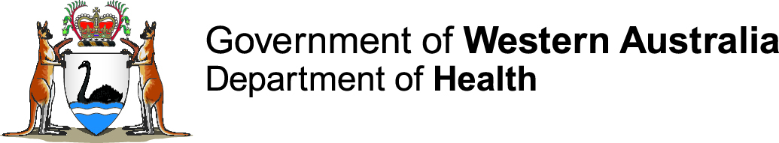

Public Health Emergency Coordination Centre

Communique
Security | Public
Distribution | WA Health corporate website, WACHS Chief Executive, WACHS Regional Directors, Assistant Director General Public Health and Aboriginal Health Division, Director General of Health, Minister of Health
Target audience | High level stakeholders and general public

Incident Name: Targeted Regional WA MenW Outbreak Response

Communique. 1 (covers period 09.10.2017-17.10.2017).

Day, date and time: Friday, 20 October 2017

This communique has been authorised by: Dr Paul Armstrong

Background
- Invasive meningococcal disease (IMD) due to meningococcal serogroup W (MenW) has risen rapidly across Australia since 2014.
- A statewide MenACWY vaccination program for 15-19 year olds commenced in April 2017 and is still continuing.
- An outbreak of MenW in central Australia started in July 2017. Aboriginal people living in communities across a broad area in the Central Australia, Barkly, and Katherine regions of the Northern Territory (NT) and the Anangu Pitjantjatjara Yankunytjatjara (APY) Lands of South Australia (SA) have been affected. There has been one related case reported in WA.
- Meningococcal ACWY (MenACWY) vaccination programs have been introduced in the NT and the APY Lands in response to this outbreak.
- To prevent further transmission and cases of MenW, WA Health will offer free MenACWY vaccination to all people aged 2 months and over living in Aboriginal communities that have strong cultural links with central Australian communities affected by the outbreak, i.e. the Ngaanyatjarra Lands and Tjuntjuntjara (Goldfields); Balgo, Bililuna, Kundat Jaru (Ringer Soak) and Mulan (Kimberley); and Punmu, Kunawarritji, Parnngurr (Cotton Creek), and Jigalong (Pilbara).
- The estimated target population is 3,620 people.
- The targeted vaccination program will be implemented from 18 October to 17 December 2017.

Current situation
Cases
- 1
Deaths
- Nil.

Map: Communities included in the Targeted Regional WA MenW Outbreak Response

Summary of vaccine doses administered and estimated coverage as of 15.10.2017
 | Goldfields |  | Kimberley |  | Pilbara
Aboriginality | 2-11 months | 12 months and over | 2-11 months | 12 months and over | 2-11 months | 12 months and over
Aboriginal
Non-Aboriginal
Total vaccine doses administered
Total population* | 1769 |  | 798 |  | 714
Estimated coverage by region
Overall estimated coverage
*Australian Bureau of Statistics (ABS) 2016 census

Further communiques
- The next communique will be issued on 27.10.2017
WebEOC Incident Name: 20171012 Remote WA MenW surge response
Communique prepared by: Donna Mak
T: +61 8 9388 4801 (0800-1700) | F: +61 8 9388 4801 | E: pheoc@health.wa.gov.au | I: www.health.wa.gov.au
The contents of this e-mail transmission are intended solely for the named recipient(s), may be confidential, and may be privileged or otherwise protected from disclosure in the public interest. The use, reproduction, disclosure or distribution of the contents of this e-mail transmission by any person other than the named recipient(s) is prohibited. If you are not a named recipient please notify the sender immediately.

