Development of the Falls Risk Assessment and Management Plan
Falls Prevention Community of Practice and the Falls Prevention Health Network
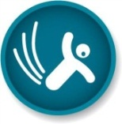Preventing falls and harm from falls

Suggested citation
Western Australian Department of Health. Development of Falls Risk Assessment and Management Plan. Perth: Health Strategy and Networks Branch, Western Australian Department of Health; 2015.

Important disclaimer
All information and content in this Material is provided in good faith by the WA Department of Health, and is based on sources believed to be reliable and accurate at the time of development. The State of Western Australia, the WA Department of Health and their respective officers, employees and agents, do not accept legal liability or responsibility for the Material, or any consequences arising from its use.

Contact information
For further information contact the Falls Prevention Health Network, Health Strategy and Networks, WA Department of Health on (08) 9222 0200 or healthpolicy@health.wa.gov.au.

Contents
1. Introduction 4
2. Background 4
2.1 Falls Prevention Community of Practice 4
2.2 Falls Risk Management Tool 5
3. Development process 5
3.1 Working Group 5
3.2 Review of the Falls Risk Management Tool 5
3.3 Drafting and trialling the Falls Risk Assessment and Management Plan 6
3.4 Developing the Falls Risk Assessment and Management Plan Operational Directive 8
4 Implementation 8
References 8
Appendices 10
Appendix 1: Falls Risk Assessment and Management Plan 10
Appendix 2: Falls Risk Management Tool (superseded by FRAMP) 12
Appendix 3: 2013 Falls Risk Management Tool (FRMT) staff survey questions 13
Appendix 4: 2014 Falls Risk Assessment and Management Plan (FRAMP) trial survey questions 15

1. Introduction
The Falls Risk Assessment and Management Plan (FRAMP) (see Appendix 1) is a bi-fold document designed for use in the general adult inpatient population in WA Health hospitals.
It summarises the key practices outlined by both the:
- National Standard 10 (external site)
- Australian falls prevention best practice guidelines (external site)
The document is set out in a simple, logical format that guides staff through the essential falls screening, assessment and management processes.
Features of the plan include:
- a screening process in flow chart format
- specific interventions targeted to the individual
- a place for multidisciplinary input
- space to easily record the involvement of the patient and, where required, the carer in their falls risk management plan
- a mechanism to record most of the patient’s falls related information in the one form reducing the number of places staff have to look for information about the patient’s falls risk and management.
The FRAMP was developed by the Falls Prevention Community of Practice for hospital settings and was based on the first version of the tool, known as the Falls Risk Management Tool (see Appendix 2).
This document outlines the process for the development of the FRAMP.

2. Background

2.1 Falls Prevention Community of Practice
The WA Falls Prevention Community of Practice for hospital settings commenced in 2009 and provides a support network to a variety of staff involved in falls prevention. This open, informal group works collaboratively to standardise key processes at a statewide level.
Anyone with an interest in falls prevention in hospitals settings is welcome to join. Membership consists of clinicians, researchers and health administrators involved in falls prevention throughout WA, spanning the public and private sectors.
The group meets quarterly and communicates via email out of session. Small time limited working groups are formed as needed to work on particular projects. For instance, a working group was formed to drive the review of the FRMT and the development of the FRAMP.

2.2 Falls Risk Management Tool
Prior to the introduction of the FRAMP, all WA public hospitals were using the Falls Risk Management Tool (FRMT) (see Appendix 2). Different versions of the FRMT were being used for quite some time and this created inconsistencies between hospital sites across WA. In an attempt to minimise variability between FRMT versions, provide an opportunity for data collection, and introduce governance for a single and agreed version of the FRMT, the Falls Prevention Community of Practice created a single version of the tool in 2010. The FRMT was used to help assess and manage patients at risk of falling in an inpatient setting. This project was driven by a small working group of members from the Community of Practice.

3. Development process

3.1 Working Group
In 2013 a multidisciplinary, multisite working group comprised of members from the Community of Practice commenced the review of the FRMT. The working group members included:
Khye Davey Project Lead Physiotherapist, Royal Perth Hospital
Tina Williamson A/Clinical Nurse Coordinator, Falls Prevention Program, Royal Perth Hospital
Diane Connor Patient Safety Project Officer, Fremantle Hospital
Zi Foo Physiotherapist, Bentley Hospital
Anne Matthews Clinical Nurse Specialist, Sir Charles Gairdner Hospital
Su Kitchen Clinical Nurse Specialist/Clinical Practice Improvement, Sir
Charles Gairdner Hospital
Michelle Stirling Project Officer, Safety & Quality, Armadale Health Service
Nicole Deprazer Senior Policy Officer, Health Strategy and Networks, Department
of Health WA
Dr Nicholas Waldron Clinical Lead, Falls Prevention Health Network
Malcolm Hare Clinical Review Audit Analyst, South Metropolitan Health Service
Katie Burr Physiotherapy, Royal Perth Hospital
Nik Booker A/District Manager, Busselton District Hospital, WACHS South
West
The working group had regular face-to-face meetings as well as out of session communication via email throughout the FRMT review and FRAMP development process.

3.2 Review of the Falls Risk Management Tool
The first task of the working group was to commence the review of the FRMT. The aim of the FRMT review was to have significant multi-site consultation with clinical staff to gather information that would guide the:
- integration of the National Standards for accreditation
- updating of assessment and interventions that reflected the latest evidence-based, best practice
- development of a more comprehensive but more easily communicated falls management plan for individuals.
The review commenced with an online survey of the FRMT in December 2012 to find out what aspects of the FRMT and falls management were working and what were challenging. See Appendix 3 for a list of the FRMT survey questions. A total of 479 responses were received from medical, nursing and allied health staff across WA Health.
Some of the key findings from the survey included:
- The majority of respondents (69%) had received specific education on how to utilise the FRMT.
- Of those who had received education, the most common source was formal ward education by a staff development nurse or other senior nurse (56%).
- The most common time the respondents indicated they would refer to a patient’s FRMT was on admission to the ward (79%). This was followed by a change in status (70%) and post fall (67%).
- 51% of people did not think there were any barriers in using the FRMT to help manage a patient’s risks for falling. However of those who did think there were barriers, the most common reported barrier was that they don’t think other people will follow it (46%).
- Helping identify patients that are at risk of falling was reported as the most useful aspect of the FRMT. Whilst documentation of strategies was found to be the least useful aspect of the FRMT.
- The majority of respondents did not think the management strategies on the back of the FRMT were difficult to implement (64%).
- Of those that did think the strategies were difficult to implement, follow-up podiatry referral was the most commonly selected strategy as being difficult (68%).
The results from the FRMT survey then formed the basis of the FRAMP development.

3.3 Drafting and trialling the Falls Risk Assessment and Management Plan
Early on in the drafting process, the working group decided to change the name of the FRMT to the Falls Risk Assessment and Management Plan (FRAMP) as this name was deemed to be more descriptive and would help to clarify the purpose of the tool.
The results from the FRMT survey were considered, discussed and analysed by the working group in order to determine what implications the feedback would have on the structure, content and format of the FRAMP.
The content of the original FRMT was largely informed by the Australian Commission On Safety and Quality in Health Care Preventing Falls and Harm From Falls in Older People: Best Practice Guidelines for Australian Hospitals 2009¹. This resource, along with more contemporary literature², was reviewed to ensure the changes made throughout the document were a reflection of evidence based best practice. The working group also took into consideration new policies³ in WA Health and the required actions outlined by the National Standards for accreditation⁴ to ensure the FRAMP would align with key documents at both a state and national level.
Clinicians from a variety of specialties were continually consulted throughout the process to ensure the form was pragmatic and could be applied in a broad number of clinical areas.
The Falls Risk Assessment and Management Plan (FRAMP) Evidence Table outlines in more detail the evidence and decision making processes that were used to revise or develop each component of the FRAMP. Refer to the page linked above for the Evidence Table.
Once the working group had developed the draft FRAMP, the document was trialled across several wards at Bentley Hospital, Sir Charles Gairdner Hospital, Fremantle Hospital and Royal Perth Hospital. The trials took place in June to August 2014 and varied in length from 4 to 6 weeks. It should be noted that a regional site was not included in the trial of the FRAMP as the working group had been informed that the WA Country Health Service (WACHS) did not intend to use the final FRAMP at that stage. This was due to the fact that during the development of the FRAMP, a process had begun to roll out a WACHS version of the FRAMP across several of the regions. The WACHS FRAMP had been in development prior to the review of the FRMT commencing and had already been trialled in a regional setting.
Staff working on the wards where the FRAMP was trialled were invited to complete a survey at the end of the trial. See Appendix 4 for a list of the FRAMP survey questions. 149 Staff responded and some of the key findings from the trial were:
- The majority of respondents (78%) reported they were given specific education on how to use the FRAMP.
- The most common time the respondents indicated they would refer to a patient’s FRAMP was on admission to the ward (84%). This was followed by when staff were required to sign the FRAMP for the shift (74%) and after a fall (68%).
- The majority of respondents believed the FRAMP was extremely or very useful for the following purposes:
  - providing an intuitive process to follow for screening, assessment and management of falls (58%)
  - prompting staff when to perform a re-screen of a patient’s falls risk (55%)
  - providing appropriate intervention options (59%)
  - monitoring the implementation of falls interventions (54%).
- 43% of respondents reported the risk screening on the FRAMP was ‘about the same’ as the FRMT, and 42% reported it as much easier or easier to use.
- 49% of respondents reported that the space for other disciplines to collaborate and document interventions made no difference, and 45% reported it was very helpful or helpful.
- Majority of respondents reported that signing the FRAMP shift by shift made them look at the FRAMP more than they did with the FRMT (58%).
- Having a place to record communication to patients/carers prompted majority of the respondents to discuss falls planning with their patients/carers more often (62%).
- Overall, most respondents reported that the FRAMP was much easier, easier or about the same as using the FRMT (83%).
Following the trial, minor amendments were made to the FRAMP in response to staff feedback before it was finalised by the working group.

3.4 Developing the Falls Risk Assessment and Management Plan Operational Directive
In order to achieve standardisation in relation to the screening, assessment and management of falls risk in inpatients, the Falls Prevention Health Network Executive Advisory Group and the Falls Prevention Community of Practice agreed to release the new FRAMP as an operational directive. The Falls Prevention Health Network led the development of the operational directive in consultation with the Community of Practice. Following consultation across WACHS, they decided to also use the new version of the FRAMP in order to achieve a standard approach across the entire state. Therefore, the operational directive (due for release in late 2014) mandates the use of the FRAMP for the general adult inpatient population across WA Health sites.
The Falls Prevention Health Network developed a template for the FRAMP. Sites must use this artwork when printing their local version of the FRAMP for use at their site. Minor changes to the FRAMP by hospitals and health services are permitted if required to suit local settings, policies, circumstances and available resources. The operational directive provides further advice on the types of changes that are permitted.

4 Implementation
Members of the Falls Prevention Community of Practice continue to collaborate to develop tools that will assist in the implementation and monitoring of the FRAMP. These tools include:
- an e-learning package for staff on falls prevention and management in hospital settings
- a step-by-step presentation outlining how to use the FRAMP
- an audit tool to monitor compliance with the FRAMP.
These tools will be accessible via the Falls Prevention Health Network website as they become available.

References
1. Australian Commission on Safety and Quality in Health Care. Preventing falls and harm from falls in older people: Best practice guidelines for Australian hospitals 2009: Commonwealth of Australia; 2009.
2. Cameron ID, Gillespie LD, Robertson MC, Murray GR, Hill KD, Cumming RG, et al. Interventions for preventing falls in older people in care facilities and hospitals. Cochrane Database Syst Rev 2012;12:CD005465.
3. Australian Commission on Safety and Quality in Health Care. National Safety and Quality Health Service Standards (September 2012). Sydney. ACSQHC, 2012.
4. Department of Health, Western Australia. Falls Prevention Model of Care. Perth: Health Strategy and Networks, Department of Health, Western Australian; 2014.

Appendices
Appendix 1: Falls Risk Assessment and Management Plan
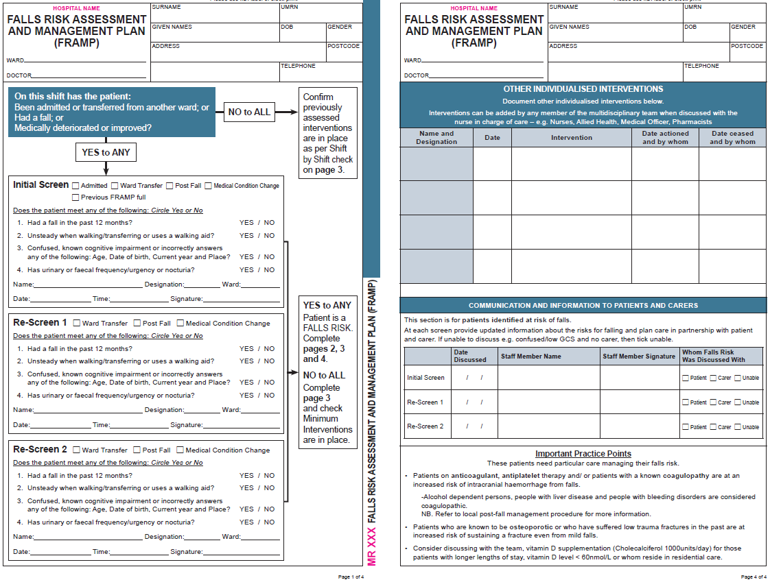
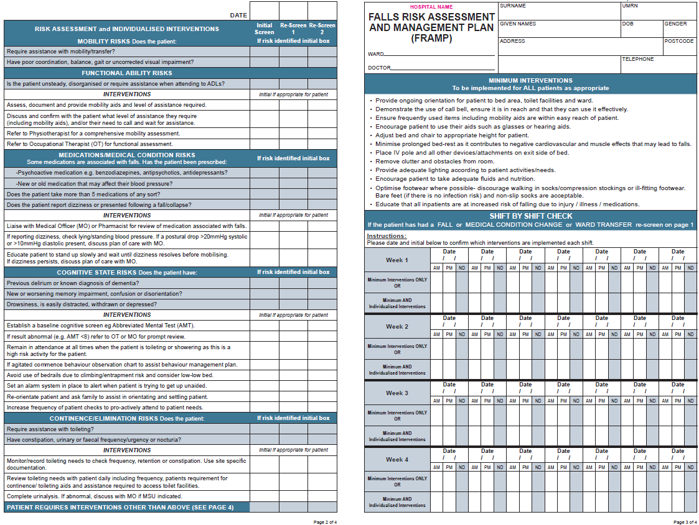

Appendix 2: Falls Risk Management Tool (superseded by FRAMP)
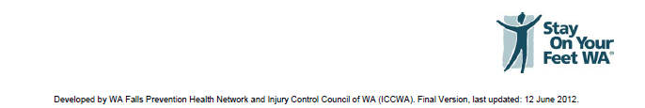
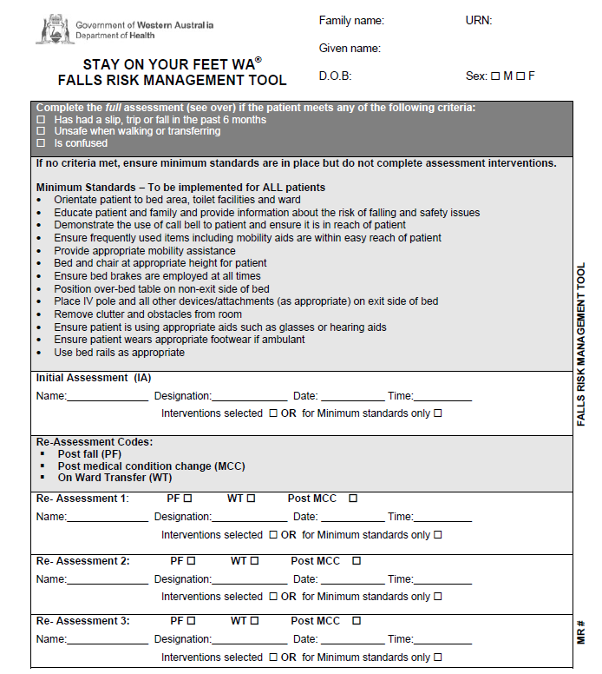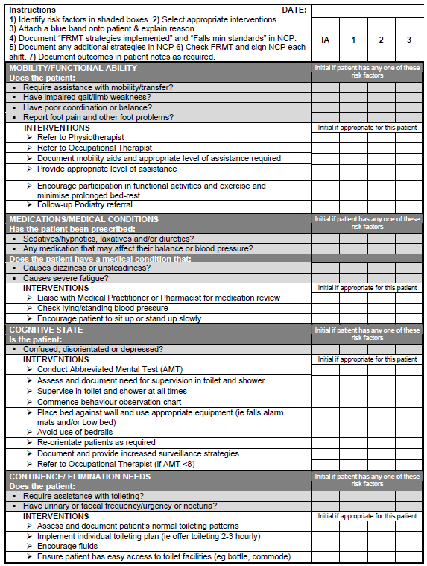

Appendix 3: 2013 Falls Risk Management Tool (FRMT) staff survey questions
Question 1: What area of health do you work in?
- North Metropolitan Health Service (NMHS)
- South Metropolitan Health Service (SMHS)
- WA Country Health Service (WACHS)
- Child and Adolescent Health Service (CAHS)
- Agency
- Other Please specify
Question 2: What speciality do you currently work in?

- Medical
- Surgical
- Rehabilitation
- Cancer and Neurosciences
- Critical Care
- Adult Mental Health
- Older Adult Mental Health
- General ward
- Aged Care
- Other, please specify

Question 3: Have you had specific education on how to utilise the FRMT to manage patient fall risks?
- Yes or No
Question 4: If yes, what were the source/s of education?
- Formal ward education by staff development nurse or other senior nurse
- Hospital wide education
- Falls champion or falls team
- eLearning
- Informal 1:1 with a colleague
- Other (please specify)
Question 5: During a patient’s admission how often would you refer to a patient’s FRMT?

- At the beginning of the shift
- On admission to the ward
- When there is a change in status
- After a fall
- No specific time
- When signing the nursing care plan
- Other (please specify)

Question 6: Do you think there are any barriers in using the FRMT to help manage a patients' risks for falling?
- Yes. Please proceed to question 7. No. Please skip to question 8.
Question 7: What do you feel are some of the barriers?
Question 8: What 3 aspects of the FRMT are most useful?
- Helping identifying patients that are at risk of falling
- Information and prompts on the minimum standards
- Identifying specific areas of risk for a patient
- Identifying specific strategies to put in place
- Documentation of strategies
- Knowing when a patient needs to be reassessed
- Other. Please describe:
Question 9: What 3 aspects of the FRMT are least useful?
- Helping identifying patients that are at risk of falling
- Information and prompts on the minimum standards
- Identifying specific areas of risk for a patient
- Identifying specific strategies to put in place
- Documentation of strategies
- Knowing when a patient needs to be reassessed
- Other. Please describe:
Question 10: Do you feel any of the management strategies on the back of the FRMT are difficult to implement or not very useful when put in place?
- Yes. Please proceed to question 11. No. Please skip to question 12.
Question 11: Please Indicate which of the following management strategies on the back of the FRMT are difficult to implement or not very useful when put in place. Please comment on the reason for your choices below.

- Refer to physiotherapist
- Refer to occupational therapist
- Follow-up Podiatry referral
- Check lying/standing blood pressure
- Conduct Abbreviated Mental Test
- Avoid use of bedrails
- Commence behaviour observation chart
- Implement individual toileting plan
- Encourage fluids
- Re-orientate patients as required
- Provide appropriate level of assistance

- Document mobility aids and appropriate level of assistance required
- Encourage participation in functional activities and exercise and minimise bed rest
- Liaise with Medical Practitioner or Pharmacist for medication review
- Encourage patients to sit up or stand up slowly
- Assess and document need for supervision in toilet and shower
- Supervise in toilet and shower at all times
- Place bed against wall and use appropriate equipment
- Document and provide increased surveillance strategies
- Refer to Occupational Therapist (if AMT <7)
- Assess and document patient's normal toileting patterns
- Ensure patient has easy access to toilet facilities
Question 12: How would you change the FRMT or documentation in the Nursing Care Plan to help communicate management of a patient’s fall risks from shift to shift?
Question 13: Any final comments on changes you would like to see made to the FRMT to help make management of falls easier?

Appendix 4: 2014 Falls Risk Assessment and Management Plan (FRAMP) trial survey questions

Question 1: What site did you use the FRAMP at?

- Bentley Hospital Ward 1
- Bentley Hospital Ward 3
- Bentley Hospital Ward 4
- Fremantle Hospital Ward B7 South
- Fremantle Hospital Ward B9 South
- Fremantle Hospital Amity Ward
- Sir Charles Gairdner Hospital GRU
- Sir Charles Gairdner Hospital Ward G74
- Sir Charles Gairdner Hospital Ward G61
- Royal Perth Hospital Ward 5H
- Royal Perth Hospital Ward 9C
- Royal Perth Hospital Ward SPC1

Question 2: Did you receive specific education on how to utilise the FRAMP to help manage patients risk of falling?
- Yes or No
Question 3: Generally speaking, when did you find yourself referring to a patient’s FRAMP? Answer all that apply to your practice.
- At the beginning of the shift
- On admission to the ward
- When there was a change in the patients status
- After a fall
- When signing the FRAMP for the shift
- No specific time
- You're supposed to refer to it?
- Other (please specify)
Question 4: To what extent do you believe the FRAMP is useful for:
- Providing an intuitive process to follow for screening, assessment and management of falls
- Prompting staff when to perform a re-screen of a patient’s falls risk
- Providing appropriate intervention options
- Monitoring the implementation of falls interventions
Rate each statement on the scale of: Extremely useful/ Very useful/ Moderately useful/ Slightly useful/ Not at all/ Useful
Question 5: Compared to the FRMT, risk screening on page 1 of the FRAMP was:
- Much Easier/ Easier/ About the same/ More difficult/ Much more difficult
Question 6: Compared to the FRMT, Risk Assessment and Individualised Interventions on page 2 of the FRAMP were:
- Much easier to understand/ Easier to understand/ About the same/ More difficult to understand/ Much more difficult to Understand
Question 7: I found the space on page 3 for other disciplines to collaborate and document interventions:
- Was very helpful/ Was helpful/ Made no difference/ Was unhelpful/ Was very unhelpful
Question 8: I found signing the FRAMP shift by shift made me look at the FRAMP:
- More than I did with the FRMT About the same that I did with the FRMT
- Less than I did with the FRMT
Question 9: I found having a place to record communication to patients/carers:
- Prompted me to discuss falls planning more often with them
- Did not prompt me to discuss falls planning with them
Question 10: Overall compared to the FRMT, using the FRAMP was:
- Much Easier/ Easier/ About the same/ More difficult/ Much more difficult
Question 11: Is there anything particular about the FRAMP that makes you feel that way?
Question 12: Are there any changes to the FRAMP that you think would improve the management of patient falls?

This document can be made available in alternative formats
on request for a person with a disability.
© Department of Health 2015
Copyright to this material is vested in the State of Western Australia unless otherwise indicated. Apart from any fair dealing for the purposes of private study, research, criticism or review, as permitted under the provisions of the Copyright Act 1968, no part may be reproduced or re-used for any purposes whatsoever without written permission of the State of Western Australia.

